Agriculture, Ecosystems and Environment

A predator in need is a predator indeed: generalist predators (spiders and ladybeetles) specialize in pest consumption at the late growth stage of rice

--Manuscript Draft--

|  |  |
| --- | --- |
| Manuscript Number: | AGEE38266R1 |
| Article Type: | Research Paper |
| Keywords: | Biocontrol; generalist predators; rice paddy; organic and conventional farms |
| Corresponding Author: | CHUAN-KAI HO  National Taiwan University Taipei, TAIWAN |
| First Author: | Gen-Chang Hsu |
| Order of Authors: | Gen-Chang Hsu |
| Jia-Ang Ou |
| Min-Hsuan Ni |
| Zheng-Hong Lin |
| CHUAN-KAI HO |
| Manuscript Region of Origin: | TAIWAN |
| Abstract: | Biocontrol, using natural enemies for pest control, has a long history in agriculture. It has received a surge of interest in the recent Anthropocene because of its potential as a valuable tool for sustainable agriculture. To solve a long-standing puzzle in biocontrol—how well the ubiquitous generalist arthropod predators (GAPs) function as biocontrol agents—this study aimed to 1) quantify the diet composition of GAPs (spiders and ladybeetles) at different crop stages using stable isotope analysis, 2) examine the consistency of GAPs in pest consumption over years, and 3) investigate how abiotic and biotic factors affect pest consumption by GAPs. Specifically, we sampled arthropod prey and GAPs in sub-tropical organic and conventional rice farms over crop stages (seedling, tillering, flowering, and ripening) in three consecutive years. Among our field-collected samples, 352 arthropod predator and 828 prey isotope samples were analyzed to infer predator-prey interactions. Our results show the following: a) The proportion of rice pests in GAPs’ diets in both organic and conventional rice farms increased over the crop season, from 21-47% at the tillering stage to 80-97% at the ripening stage, across the three study years. The high percentage in pest consumption at late crop stages (flowering and ripening) suggests that GAPs can function as specialists in pest management during the critical period of crop production. Regarding individual predator groups, spiders and ladybeetles exhibited distinct dietary patterns over crop stages. b) The high pest consumption by GAPs at late crop stages was similar across years despite variable climatic conditions and prey availability, suggesting a consistency in GAP feeding habits and biocontrol value. c) The proportion of rice pests in GAPs’ diets varied with farm type and crop stage (e.g., higher in conventional farms and during flowering/ripening stages). By quantifying the diet composition of GAPs over crop stages, farm types, and years, this study reveals that generalist predators have potential to produce a stable, predictable top-down effect on pests in rice agro-ecosystems. As sustainable agriculture has become increasingly important, incorporating the ubiquitous generalist predators into pest management will likely open a promising avenue towards this goal. |
| Suggested Reviewers: | James Pryke  Associate Professor, Stellenbosch University [jpryke@sun.ac.za](mailto:jpryke@sun.ac.za)  Expertise: entomology, agroecology, landscape ecology |
| Nickson Otieno Stellenbosch University [neotieno@yahoo.com](mailto:neotieno@yahoo.com)  Expertise: agroecology, stable isotope analysis |
|  |

|  |  |
| --- | --- |
|  | Stano Pekár  Professor, Masaryk University [pekar@sci.muni.cz](mailto:pekar@sci.muni.cz)  Expertise: spiders in biocontrol |
| Elinor Lichtenberg  Assistant Professor, University of North Texas [elichten@unt.edu](mailto:elichten@unt.edu)  Expertise: plant-insect interactions, agroecology |
| Zsofia Szendrei  Associate Professor, Michigan State University [szendrei@msu.edu](mailto:szendrei@msu.edu)  Expertise: biocontrol, agroecology |
| Eve Roubinet  Swedish University of Agricultural Sciences [eve.roubinet@slu.se](mailto:eve.roubinet@slu.se)  Expertise: predator-prey interactions in agroecosystems |

Cover Letter

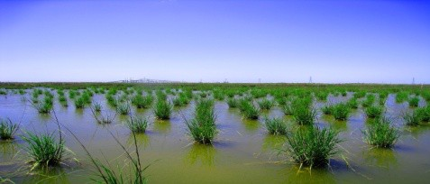

Chuan-Kai Ho Professor

Institute of Ecology and Evolutionary Biology, National Taiwan University

December 4, 2023

**Dear Dr. Audrey Alignier and Editorial Board Members,**

Thank you for inviting us to submit a revised version of our manuscript (AGEE38266R1) to *Agriculture, Ecosystems and Environment*. We appreciate the constructive comments from you and the reviewers. We have carefully considered each comment, and our point-by-point responses are provided in this letter.

For clarity, each reviewer’s comment is attached below (in gray highlight) and followed by our reply. Line numbers in our reply refer to the revised version with tracked changes unless otherwise mentioned. Besides the official files submitted to the AGEE website, we also provide these two files with tracked changes in our Google Drive for your information. For clarity, AGEE Editorial Office asked us to remove these files from the submission system:

1. *Manuscript to AEE 2023-1204 Main text (track changes)* The main text with tracked changes. https://drive.google.com/file/d/1jxhhAUpNpQaKifmllrzuVncRqg7LfNuT/view?usp=sharing
2. *Manuscript to AEE 2023-1204 Highlights (track changes)* The highlights with tracked changes. https://drive.google.com/file/d/1zPLhBU3VTbUEHYa8rhQluLx8KyEub1ST/view?usp=sharing

Our study helps solve a long-standing puzzle (the role of generalist predators such as spiders and ladybeetles in pest management) by using stable isotopes to quantify arthropod predators’ diet composition over crop stages, farm types, and years. Therefore, our findings should be of interest to a wide range of ecologists, agricultural practitioners, and policy makers. We believe that the revisions based on review comments have improved the quality of this manuscript, and we hope that the manuscript is now suitable for publication in *Agriculture, Ecosystems and Environment*.

Sincerely,

Chuan-Kai Ho Professor

Institute of Ecology and Evolutionary Biology National Taiwan University

Revision Notes



Chuan-Kai Ho Professor

Institute of Ecology and Evolutionary Biology, National Taiwan University

December 4, 2023

**Dear Dr. Audrey Alignier and Editorial Board Members,**

Thank you for inviting us to submit a revised version of our manuscript (AGEE38266R1) to *Agriculture, Ecosystems and Environment*. We appreciate the constructive comments from you and the reviewers. We have carefully considered each comment, and our point-by-point responses are provided in this letter.

For clarity, each reviewer’s comment is attached below (in gray highlight) and followed by our reply. Line numbers in our reply refer to the revised version with tracked changes unless otherwise mentioned. Besides the official files submitted to the AGEE website, we also provide these two files with tracked changes in our Google Drive for your information. For clarity, AGEE Editorial Office asked us to remove these files from the submission system:

1. *Manuscript to AEE 2023-1204 Main text (track changes)* The main text with tracked changes. https://drive.google.com/file/d/1jxhhAUpNpQaKifmllrzuVncRqg7LfNuT/view?usp=sharing
2. *Manuscript to AEE 2023-1204 Highlights (track changes)* The highlights with tracked changes. https://drive.google.com/file/d/1zPLhBU3VTbUEHYa8rhQluLx8KyEub1ST/view?usp=sharing

Our study helps solve a long-standing puzzle (the role of generalist predators such as spiders and ladybeetles in pest management) by using stable isotopes to quantify arthropod predators’ diet composition over crop stages, farm types, and years. Therefore, our findings should be of interest to a wide range of ecologists, agricultural practitioners, and policy makers. We believe that the revisions based on review comments have improved the quality of this manuscript, and we hope that the manuscript is now suitable for publication in *Agriculture, Ecosystems and Environment*.

Sincerely,

Chuan-Kai Ho Professor

Institute of Ecology and Evolutionary Biology National Taiwan University

**The following includes our replies to these four sections of comments:**

* + Editor’s comments
  + Reviewers’ comments
  + Reviewer 1’s comments
  + Reviewer 2’s comments

**Editor’s comments**

Thanks for your submission of a manuscript AGEE38266 titled ‘A predator in need is a predator indeed: generalist arthropod predators function as pest specialists at the late growth stage of rice’ The manuscript has been reviewed by two independent experts. As you will see from their comments copied below, reviewers find the topic of interest for AGEE readership. However, Reviewer#1 raised major concerns that I agree with especially about a better presentation of data on which tests were performed. Please consider presenting data in form of tables of medians and credible interval rather than means d and standard errors; and for figures in form of posterior density plots rather than linear graphs. You must also better argue for the approppriateness of MixSIAR models. I also suggest to carefully edit the manuscript (l.219 : tillering ? and l.247 : tilling instead of tillering ?). Avoid to call for figures in the discussion section (main figures are more commonly associated with results). When revising your manuscript, please consider all issues mentioned in the reviewers' comments carefully. Outline every change made in response to their comments and provide suitable rebuttals for any comments not addressed.

.

**[Reply]** We thank the constructive comments from the editor and reviewers. We briefly summarize our responses below. More details are provided in our point-by-point responses to reviewers’ comments.

1. *Table of posterior estimates* As suggested, we now provide a table of posterior means, posterior SDs, posterior medians, and 95% credible intervals for the proportion of prey sources in predators’ diet (Appendix B). Note that this table includes 711 rows of data (with rice herbivores, tourist herbivores, and detritivores as prey sources) and will result in 237 posterior density plots (figures). Below we just list six posterior density plots from this study as examples.

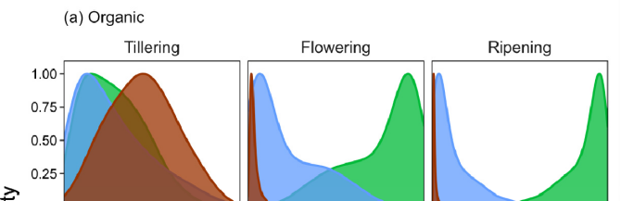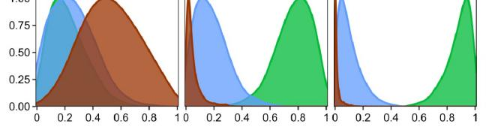

1. *Posterior density plots vs. linear graphs* It may not be easy for our readers to digest 237 posterior density plots and generate a conclusion. To solve this issue and demonstrate the most important results, we extracted the posterior medians (a key suggestion from the last round of review) from the Bayesian stable isotope mixing models, calculated the SEs for the posterior medians, and presented the results (e.g., Figure 1). While there might be other ways to present the results, linear graphs (e.g., Figure 1) offer a good option to summarize hundreds of posterior density plots in a simple way and also reflect the time series survey in this study (i.e., different crop stages).
2. *Appropriateness of MixSIAR models* Thanks for asking this question. We are confident about the MixSIAR models in this study because of these reasons: a) We actually consulted one of the MixSIAR creators, Dr. Brian Stock, during our data analysis. b) The MixSIAR model estimation in this study is suitable because the three prey sources exhibit distinct isotope signatures in the isotopic space (Appendix A: Fig. S1). c) Our model convergence is assessed via Gelman-Rubin and Geweke diagnostics (Line 198). The diagnostics show that all of our mixing models have converged, further suggesting the appropriateness of the MixSIAR models in this study.
3. *Tillering vs. tilling* a) Thanks for raising this issue. Tillering is the appropriate term in this study. “Tillering” refers to the stage when plants start to branch rapidly. “Tilling” means to prepare the land for growing crops. b) We have checked the manuscript thoroughly and corrected one typo in Line 254.
4. *Figures in Discussion* Originally we provided figure and table numbers in Discussion to facilitate our readers to locate relevant results. As suggested, we now remove this information except for Appendix figures and figure comparisons.

**Reviewers’ comments**

1. Are the objectives and the rationale of the study clearly stated? Please provide suggestions to the author(s) on how to improve the clarity of the objectives and rationale of the study. Please number each suggestion so that author(s) can more easily respond.

Reviewer #1: Yes. More clear now Reviewer #2: Yes.

**[Reply]** We appreciate the positive comments.

2. If applicable, is the application/theory/method/study reported in sufficient detail to allow for its replicability and/or reproducibility? Please provide suggestions to the author(s) on how to improve the replicability/reproducibility of their study. Please number each suggestion so that the author(s) can more easily respond.

Reviewer #1: Mark as appropriate with an X: Yes [] No [X] N/A []

Provide further comments here:

2.1) The Bayesian mixing model MixSIAR works primarily within the framework of comparing relative importance of various food source options in consumers’ diets. While the model would work well for the herbivore food sources in predator diets (since we have multiple herbivores in the study), it is hard to see how it worked for herbivores as consumers given that only rice was considered as a source for herbivores.

**[Reply]** Yes, if a study aims to analyze the diet composition for herbivores (e.g., generalist herbivores), it will need to include multiple plant sources.

2.2) The authors also need to state the sources of the means and standard deviation values of the various food sources (usually mandatory) that they applied to the MixSIAR models, and why they think these were appropriate for their particular study context

**[Reply]** Please find this information in the stable isotope biplot (mean and 95% CI) for the three prey sources of this study (Appendix A: Fig. S1). Our models should be appropriate because a) the three prey sources exhibit distinct isotope signatures in the isotopic space (Appendix A: Fig. S1), and b) our models pass the Gelman-Rubin and Geweke’s convergence diagnostics.

2.3) In disputing the suggestion that a 1-km buffer is too large for most low-mobility arthropods with regards to trophic linkages, the authors refer to Rusch 2016 and Karp 2018 to maintain their stance. However, the two references relate to landscape-scale rather that plot-level or farm-level contexts which is the case for the present study. Also the full reference for Karp is not included in the bibliography

**[Reply]**

* 1. Thank the reviewer for pointing out this. We now add Karp et al. (2018) to our reference. Therefore, both Rusch et al. (2016) and Karp et al (2018) are included in our reference:

Rusch, A., Chaplin-Kramer, R., Gardiner, M.M., Hawro, V., Holland, J., Landis, D., Thies, C., Tscharntke, T., Weisser, W.W., Winqvist, C., 2016. Agricultural landscape simplification reduces natural pest control: A quantitative synthesis. Agriculture, Ecosystems & Environment 221, 198-204.

Karp, D.S., Chaplin-Kramer, R., Meehan, T.D., Martin, E.A., DeClerck, F., Grab, H., Gratton, C., Hunt, L., Larsen, A.E., Martínez-Salinas, A., 2018. Crop pests and predators exhibit inconsistent responses to surrounding landscape composition. Proceedings of the National Academy of Sciences 115, E7863-E7870.

* 1. We agree that there is no universal consensus on the buffer zone. The 1-km radius in this study was based on previous studies (Rusch et al., 2016; Karp et al. 2018). In fact, Rusch et al. (2016) stated in their methods section that “The 1 km spatial extent was selected because it has been identified as a relevant scale to understand trophic interactions and population

dynamics for a range of organisms including natural enemies of crop pests (Thies and Tscharntke, 1999, Thies et al., 2005)”. Therefore, we decided to use a 1-km radius to evaluate the effect of surrounding forest cover on each study farm.

2.4) Like Reviewer#1 pointed out, and so did I in my initial review, the role of years on observed trends seems irrelevant, given that, firstly, agronomic practices on rice-fields of Taiwan are the same always and, secondly, years are not ecological variables such as habitat characteristics. The influence of years thus needs to be omitted completely, and instead use samples per year as replicates on the temporal scale. Implying observed trends across years to be indicators of potential use for climate tracking (as laid out in the Highlights) is too far- fetched. As the presented data from the GLM test show, year was not important as a factor anyway.

**[Reply]**

1. As mentioned in our introduction and discussion sections, many abiotic and biotic factors (e.g., precipitation and pest population, respectively) can change from year to year. Therefore, it is interesting and important to examine whether pest consumption patterns vary with years. While the statistical analysis shows that year per se is not statistically significant, this result is meaningful to the field of predator-prey interactions and pest management.
2. That beings said, we understand the reviewer’s concern about the conclusions based on three years of climatic data. Therefore, we have toned down our conclusions and revised the highlight, abstract, and conclusion sections accordingly.

2.5) In response to the query regarding use of spiders and lady beetles to generalize for all generalist predators, the authors argue that these two are considered common and thus representative of all generalist predators. This is not only wrong, given the diversity in foraging patterns amongst farmland predator groups, but also is compounded in this study by the various dimensions of explanatory factors: different farming systems; across multiple year; crop stages; vegetation structure; temperature etc. A further potential confounding element is, as reviewer# pointed out, the phenomenon of intra-guild predation, which many spiders are known for. In any case if the criterion was commonness, than ants are far more ubiquitous in all farming habitats than spiders and beetles, both on spatial as well as temporal scales. Why were ants left out?

**[Reply]** Thanks for the comments. We address each concern below:

1. *Spiders and ladybeetles* This study haphazardly sampled arthropods in rice farms and analyzed the most abundant generalist predators, rice herbivores, tourist herbivores, and detritivores. Spiders and ladybeetles (7 families in total) were found to be the most abundant generalist arthropod predators in our study farms (Line 171). Other arthropod predators (lacewings, assassin bugs, earwigs, ground beetles, etc.) were rare or absent. This pattern (spider and ladybeetle dominance) is also supported by an independent study conducted by the Hualien District Agricultural Research and Extension Station in Taiwan (*personal communications*). To avoid over-generalizing our results, we have clarified that the results

are based on spiders and ladybeetles in this manuscript. If there is still a room to improve, we welcome any constructive suggestions.

1. *Ants* While ants are important in some ecosystems, they were rare in our rice farms, likely due to rice irrigation practices. We consulted an ant expert in Taiwan (Dr. Feng-Chuan Hsu) and learned that *Nylanderia yaeyamensis, Tapinoma melanocephalum, Pheidole megacephala* and *Paratrechina longicornis* may be found occasionally at low population densities in rice paddies in Taiwan. These ant species do not prefer irrigated habitat.
2. *Intraguild* We speculate that intraguild predation (IGP) may not be a major concern in our study system because rice plants grow in dense clumps and form a complex structure that could substantially reduce IGP pressure (Line 393). However, we do acknowledge this limitation (i.e., IGP absence in MixSIAR models) in the *Potential caveats of this study* section of our discussion.

2.6) In categorizing detritivores, the authors list some grasshopper groups, but leave out crickets. This is a bit worrying, given that crickets are among the most common detritivores (they are also omnivores) in rice farming systems. It is not reasonable for the authors to argue that crickets were excluded because they were rare in the farms studied

**[Reply]** Thanks for asking this question. We haphazardly sampled arthropods and did not leave any species intentionally. Crickets were rarely found in our rice paddies likely because these paddies were irrigated frequently.

2.7) Also stating (retroactively) that only Hemiptera that consumed plant material were combined with grasshoppers for stable isotope analyses, without specifying which these were (after earlier stating that such combinations was done indiscriminately) only serves to raise suspicion about the data and analytical soundness for this study.

**[Reply]** a) The stable isotope samples of Hemiptera (*Nephotettix*, *Nilaparvata, Pachybrachius,* and *Scotinophara*) and Orthoptera (*Atractomorpha* and Acrididae) were analyzed separately. b) They belong to either rice herbivores or tourist herbivores in our MixSIAR models. Please see details in Appendix A (Table S1).

Reviewer #2: Mark as appropriate with an X:

Yes [] No [x] N/A []

Provide further comments here:

2.8) L. 156. It is unclear how were the samples for the isotopic analyses made. Were all collected arthropods included in the samples or it was representative sub-samples that mirrored the composition proportionally?

**[Reply]** Thanks for raising this issue. Yes, we used sub-samples that mirrored the arthropod community composition in the field. We now add this information in Methods (*2.2. Stable isotope analysis of arthropod samples*).

3. If applicable, are statistical analyses, controls, sampling mechanism, and statistical reporting (e.g., P-values, CIs, effect sizes) appropriate and well described? Please clearly indicate if the manuscript requires additional peer review by a statistician. Kindly provide suggestions to the author(s) on how to improve the statistical analyses, controls, sampling mechanism, or statistical reporting. Please number each suggestion so that the author(s) can more easily respond.

Reviewer #1: Mark as appropriate with an X:

Yes [] No [] N/A []

Provide further comments here:

3-1) Good that beta regression with logit link function is now included in the analysis (Table 1).

This is ok for the present purposes, even though beta regression would usually be most elegant for binary datasets. It is ok for here due to the use of logit (rather than log) link. Still, it is curious why, according to results of GLM analyses, Year was an important variable driving leady beetle predation rate.

**[Reply]** We appreciate the comments. Honestly, we do not know why year played a role in ladybeetles’ diet composition. A possibility is that ladybeetles may prefer certain preys that happened to vary with years.

3-2) If the authors have significant challenges handling MixSIAR modeling tools, it may be reasonable for them to call in technical support, or consider analyzing their data using alternative tools such as those involving molecular markers, specifically DNA meta- barcoding. However, while this will provide a thoroughly detailed resolution of trophic linkages (including at specie level), it will not estimate relative importance of food items in consumer diets the way MixSIAR can. Furthermore, DNA meta-barcoding would involve re-testing all the samples in the laboratory, with the obvious cost and time implications.

**[Reply]** Thanks for this suggestion. As mentioned in our reply to the editor, we consulted one of the MixSIAR creators, our prey sources exhibited distinct isotope signatures, and our models passed the Gelman-Rubin and Geweke’s convergence diagnostics. Therefore, we are confident about the appropriateness of our MixSIAR models. We agree that molecular gut content analysis will be another approach to study trophic interactions, although it has its limitation (e.g., a “snap- shot” technique) and may not serve the purpose of this study (Line 129).

3-3) Like Reviewer#1, I have concerns as to why conclusions are drawn on observations from 4 crop stages yet results are presented inconsistently for 3 or 2 crop stages only growth stages. Was there anything wrong with data sets?

**[Reply]** We collected arthropod samples at four crop stages over the rice growth season and prepared isotope samples for all crop stages. However, there were not enough data points at the seedling stage for stable isotope mixing model estimation. Therefore, we excluded this stage in the subsequent diet composition and beta regression analyses (Line 192). This is why there are only three crop stages (tillering, flowering, and ripening) in Table 3 (Tukey’s post-hoc tests for pest consumption among crop stages), Fig. 1 (diet composition of predators over the crop season),

and Fig. 2 (pest consumption by predators over the crop season), but four crop stages (seedling, tillering, flowering, and ripening) in Fig. 3 (relative abundance of prey sources over the crop season).

3-4) With reference to Table 2 and Table 3: Tukey post-hoc tests are supposed to be POST-HOC tests of some original analytical procedures to resolve which factors has the greater weights than some other(s) one(s) in determining results obtained in ANOVA etc. Where are these original test results? Besides, Tukey post-hoc test results should return test statistics, p- values and degrees of freedom. Where are these in Table 2 and Table 3 results here?

**[Reply]** The original beta GLM model results were shown in Table 1. Because farm type and crop stage were significant (for “Both predators”), we proceeded to conduct Tukey’s post-hoc comparisons of the predictor levels using the R package “emmeans”. We used a critical value approach with α = 0.05 for the post-hoc tests, and therefore no degrees of freedom and p-values were returned. Instead, the level differences were evaluated based on the confidence intervals adjusted for multiple comparisons (as shown in Table 2 and 3).

Reviewer #2: Mark as appropriate with an X:

Yes [] No [x] N/A []

Provide further comments here:

3-5) The authors state that the design was paired (L. 132-136), nevertheless they did not account for the paired design in their statistical analyses as GLMs were used (L. 199). Instead GLMMs should be used with the pair ID as the random effect. Moreover, for me it is unclear whether the same fields or different fields were sampled across the three years. If the same fields were used, then the random effects should be field id nested within pair id.

**[Reply]** Thanks for this constructive suggestion. We have re-run the beta regression models with farm ID nested within pair ID as random effects and updated the methods (Line 206) and results (Line 258-273) accordingly. Note that this does not change our conclusions.

4. Could the manuscript benefit from additional tables or figures, or from improving or removing (some of the) existing ones? Please provide specific suggestions for improvements, removals, or additions of figures or tables. Please number each suggestion so that author(s) can more easily respond.

Reviewer #1: The current tables and figures present results of means and standard errors and line graphs yet for food proportions, these should be changed to median and credible intervals for tables, and probability density plots for figures. At least 1 table with isotopic signature values for consumers and food sources is also necessary at least as a supplementary material

Reviewer #2: No.

**[Reply]**

1. As suggested, we now provide a table of posterior means, posterior SDs, posterior medians, and 95% credible intervals for the proportion of prey sources in predators’ diet (Appendix B).
2. Note that the aforementioned table includes 711 rows of data (with rice herbivores, tourist herbivores, and detritivores as prey sources), which will generate 237 posterior density plots (figures). To summarize this large number of plots, we extracted the posterior medians from the Bayesian stable isotope mixing models (suggested in the last round of review), calculated the SEs for the posterior medians, and presented the results in linear graphs (e.g., Figure 1). This should be a good way to help readers visualize the model results compared to browsing hundreds of posterior density plots.
3. We provide a stable isotope biplot (Appendix A: Fig. S1) to show the stable isotope signatures of different prey sources in this study. Their distinct isotope signatures in the isotopic space support the use of MixSIAR models in this study. Since there are hundreds of predator signatures for different species-year-farm-crop stage combinations, predator data are now shown in this biplot. However, if anyone requests, we are more than happy to provide the raw data for stable isotope signatures.
4. If applicable, are the interpretation of results and study conclusions supported by the data? Please provide suggestions (if needed) to the author(s) on how to improve, tone down, or expand the study interpretations/conclusions. Please number each suggestion so that the author(s) can more easily respond.

Reviewer #1: Mark as appropriate with an X:

Yes [] No [] N/A []

Provide further comments here:

* 1. Spiders and ladybirds should not be construed to represent all generalist predators even if they are very common in rice-fields. Ants are more common that all the rest, yet they are not included here

**[Reply]** We agree with the reviewer that spiders and ladybeetles do not represent all generalist predators. We have revised the manuscript accordingly to avoid over-generalization. Regarding ants, please see our reply above (Reviewers’ comment 2.5).

5.2) Observed yearly trends in the results should not be taken to imply corresponding climatic trends

**[Reply]** We agree that three years of climatic data may not be enough to provide conclusive evidence. Therefore, we now avoid this inference in our highlights and manuscript.

Reviewer #2: Mark as appropriate with an X: Yes [x] No [] N/A []

Provide further comments here:

6. Have the authors clearly emphasized the strengths of their study/theory/methods/argument? Please provide suggestions to the author(s) on how to better emphasize the strengths of their study. Please number each suggestion so that the author(s) can more easily respond.

Reviewer #1: 1. the main strength of the study is in the use of stable isotopes to quantify trophic linkages in arthropods of rice-fields, which is novel, and in the characterization of the role of crop stages. But the authors seem t emphasize only the predation specialization aspect, which was not strongly supported by the study design and anlytical procedures

Reviewer #2: Yes.

**[Reply]** Thanks for the positive comments. As suggested, we have updated our analysis and avoided over-generalization. Please see our reply above for more details.

7. Have the authors clearly stated the limitations of their study/theory/methods/argument? Please list the limitations that the author(s) need to add or emphasize. Please number each limitation so that author(s) can more easily respond.

Reviewer #1: Yes

Reviewer #2: Yes.

**[Reply]** We appreciate the positive comments.

8. Does the manuscript structure, flow or writing need improving (e.g., the addition of subheadings, shortening of text, reorganization of sections, or moving details from one section to another)? Please provide suggestions to the author(s) on how to improve the manuscript structure and flow. Please number each suggestion so that author(s) can more easily respond.

Reviewer #1: Generally yes, Reviewer #2: No.

**[Reply]** Thanks for the positive comments.

9. Could the manuscript benefit from language editing?

Reviewer #1: No

Reviewer #2: No

**[Reply]** Thanks for the positive comments.

**Reviewer 1’s comments**

Title

The authors have made no attempt to modify any part of the title, in light of changes earlier suggested, and in light of their own admission that they focused on two predator groups

rather than all generalist predators. Suggested title: "Spiders and lady-beetles consume higher proportions of rice pests at late growth stages regardless of farming system"

**[Reply]** We have modified the title to include the reviewer’s feedback (spiders and ladybeetles as key words for clarification) and keep the focus of this study (generalist arthropod predators). The new title is “A predator in need is a predator indeed: generalist predators (spiders and ladybeetles) specialize in pest consumption at the late growth stage of rice”.

The Highlights

* The authors have made no changes to the here, in light of changes earlier suggested for study design, data analyses and results or conclusion.
* Observations across the three years cannot reasonably be used to imply the role of climate change in Taiwan

**[Reply]** As suggested, we have updated the highlights, data analysis, results, and conclusions.

Abstract

The authors have made absolutely no changes to the abstract, in light of changes earlier suggested for study design, data analyses and results or conclusion

**[Reply]** As mentioned above, we have revised our manuscript accordingly.

**Reviewer 2’s comments**

L. 207. Why only forest habitats and not also other habitat types?

**[Reply]** This is because the landscape types surrounding our study farms are mostly farmlands and forests. Therefore, we examined the forest habitats to understand their potential effect on our study farms.

L. 211. Spiders can use the sit-and-move and active hunting too. For example, oxyopids and clubionids that were included in the analyses (TableS1) do not use sit-and-wait. Oxyopids use sit-and-move strategy while clubionids use active hunting. Just use different justification.

**[Reply]** Thanks for pointing this out. As suggested, we now remove the “sit-and-wait vs. active hunting” here. Please note that long-jawed orb-weavers (*Tetragnatha*) were the most abundant genus in our spider samples. Therefore, we mentioned their sit-and-wait foraging behavior vs. ladybeetles’ active hunting behavior in Discussion (Line 322).

L. 270. Paddy fields instead of agro-ecosystems

**[Reply]** For clarify, we now use “rice agro-ecosystems” instead of “agro-ecosystems”.

L. 283. Forest cover instead of surrounding landscape.

**[Reply]** We now use “percent forest cover” instead of “surrounding landscape”.

L. 380-381. Actually spiders are very effective in suppressing pests in rice fields in comparison to other crops and this study shed some light on why. See the meta-analysis Michalko et al. 2019, Glob. Ecol. Biogeogr. 28(9): 1366-1378.

**[Reply]** Thanks for the positive comments. We also cited a similar work from Dr. Michalko in this manuscript (Line 69).

Highlights (for review)

# Highlights

* We analyzed arthropod isotope samples in organic and conventional rice farms
* Generalist arthropod predators (GAPs) (spiders and ladybeetles) specialize in pest consumption at late crop stages
* The high pest consumption by GAPs is consistent across years and farms
* The results lend support to applying GAPs as biocontrol agents in agroecosystems

Figure 1 [Click here to access/download;Figure;Figure 1.tiff [](https://www2.cloud.editorialmanager.com/agee/download.aspx?id=1207427%26guid=004d72ac-ae1e-4ef2-ba47-d6bf723b7a4e%26scheme=1)](https://www2.cloud.editorialmanager.com/agee/download.aspx?id=1207427&guid=004d72ac-ae1e-4ef2-ba47-d6bf723b7a4e&scheme=1)

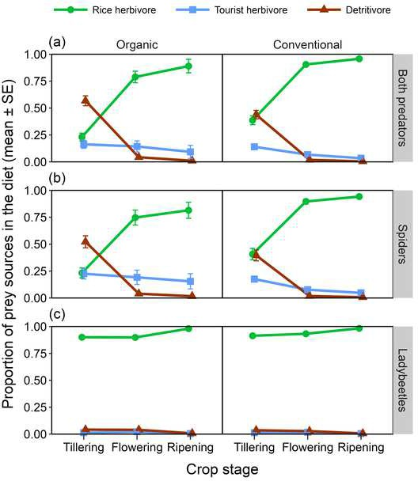

Figure 2 [Click here to access/download;Figure;Figure 2.tiff [](https://www2.cloud.editorialmanager.com/agee/download.aspx?id=1207429%26guid=c25b3e1b-c606-4b65-bd12-59d04c0b272c%26scheme=1)](https://www2.cloud.editorialmanager.com/agee/download.aspx?id=1207429&guid=c25b3e1b-c606-4b65-bd12-59d04c0b272c&scheme=1)

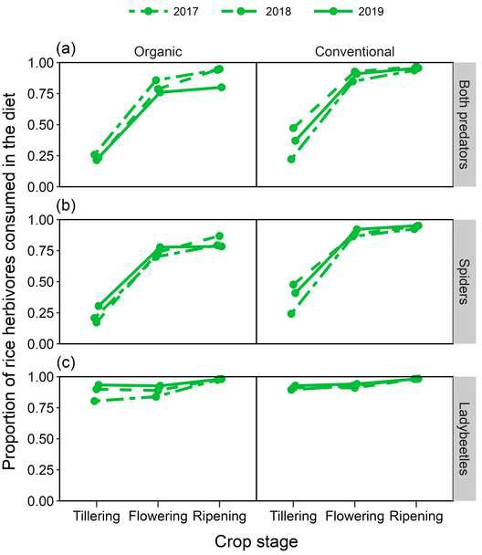

Figure 3 [Click here to access/download;Figure;Figure 3.tiff [](https://www2.cloud.editorialmanager.com/agee/download.aspx?id=1207431%26guid=af91c5f9-85dc-42f5-b388-3f8a0332032b%26scheme=1)](https://www2.cloud.editorialmanager.com/agee/download.aspx?id=1207431&guid=af91c5f9-85dc-42f5-b388-3f8a0332032b&scheme=1)

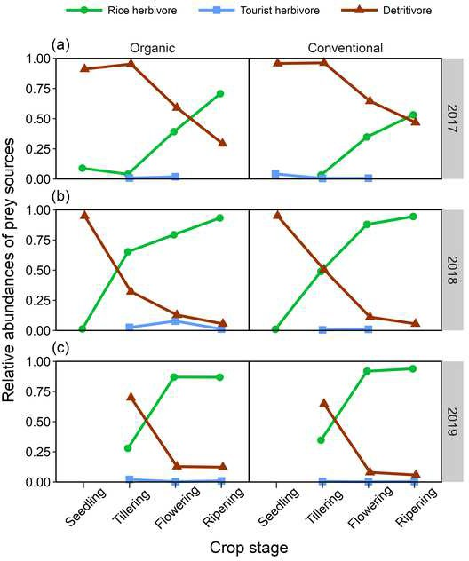

Figure S1 [Click here to access/download;Figure;Figure S1.tiff [](https://www2.cloud.editorialmanager.com/agee/download.aspx?id=1207432%26guid=23133b18-4fbe-42fe-8804-1453199271a4%26scheme=1)](https://www2.cloud.editorialmanager.com/agee/download.aspx?id=1207432&guid=23133b18-4fbe-42fe-8804-1453199271a4&scheme=1)

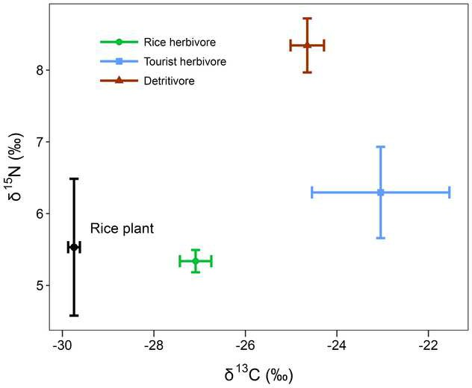

Figure S2a [Click here to access/download;Figure;Figure S2a.tiff [](https://www2.cloud.editorialmanager.com/agee/download.aspx?id=1207433%26guid=0c697c1b-77c5-4b30-993b-f85a73e95ac7%26scheme=1)](https://www2.cloud.editorialmanager.com/agee/download.aspx?id=1207433&guid=0c697c1b-77c5-4b30-993b-f85a73e95ac7&scheme=1)

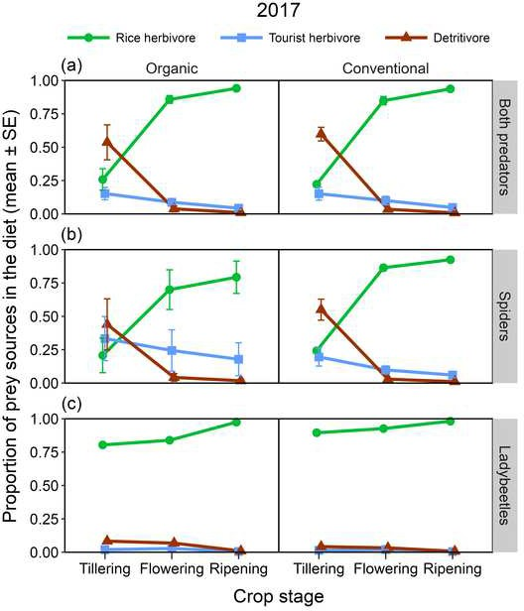

Figure S2b [Click here to access/download;Figure;Figure S2b.tiff [](https://www2.cloud.editorialmanager.com/agee/download.aspx?id=1207435%26guid=aca6695f-6695-4b3a-a884-a316f84ec6be%26scheme=1)](https://www2.cloud.editorialmanager.com/agee/download.aspx?id=1207435&guid=aca6695f-6695-4b3a-a884-a316f84ec6be&scheme=1)

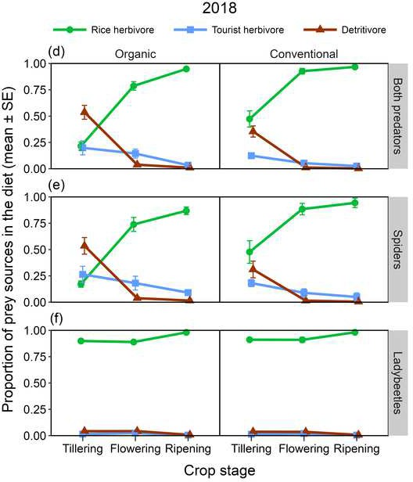

Figure S2c [Click here to access/download;Figure;Figure S2c.tiff [](https://www2.cloud.editorialmanager.com/agee/download.aspx?id=1207436%26guid=ab4cf221-6f76-410e-91b8-0411c9b42fb9%26scheme=1)](https://www2.cloud.editorialmanager.com/agee/download.aspx?id=1207436&guid=ab4cf221-6f76-410e-91b8-0411c9b42fb9&scheme=1)

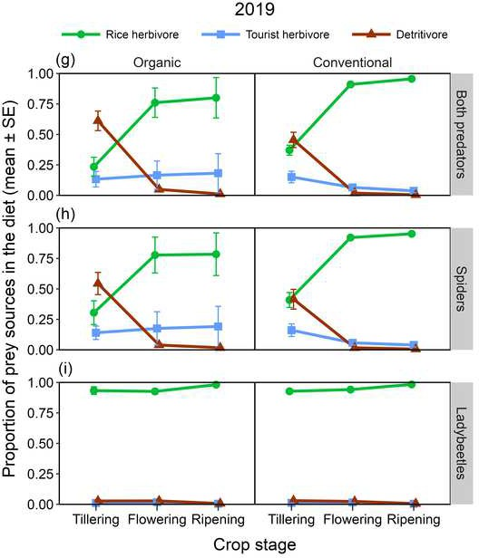

Figure S3 [Click here to access/download;Figure;Figure S3.tiff [](https://www2.cloud.editorialmanager.com/agee/download.aspx?id=1207446%26guid=265eac5c-164b-4a65-a1e2-24a258558900%26scheme=1)](https://www2.cloud.editorialmanager.com/agee/download.aspx?id=1207446&guid=265eac5c-164b-4a65-a1e2-24a258558900&scheme=1)

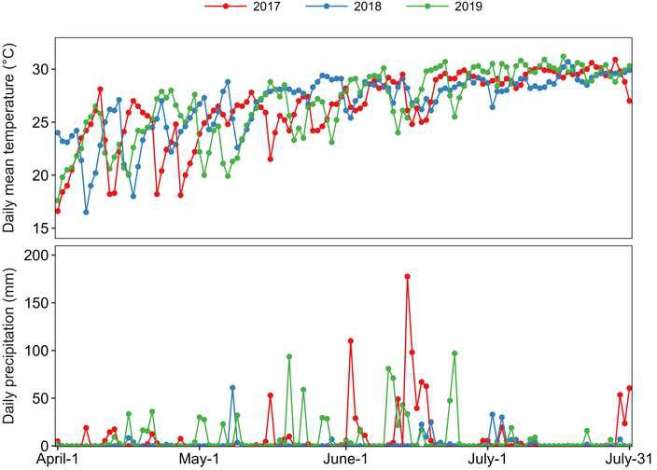

Supplementary Material for publication online only [Click here to access/download;Supplementary Material for [](https://www2.cloud.editorialmanager.com/agee/download.aspx?id=1207439%26guid=718751b7-5bc2-4503-89f6-400e26a7ca25%26scheme=1)](https://www2.cloud.editorialmanager.com/agee/download.aspx?id=1207439&guid=718751b7-5bc2-4503-89f6-400e26a7ca25&scheme=1)

[publication online only;Manuscript to AEE 2023-1204](https://www2.cloud.editorialmanager.com/agee/download.aspx?id=1207439&guid=718751b7-5bc2-4503-89f6-400e26a7ca25&scheme=1)

1. **Appendix A.**

# A predator in need is a predator indeed: generalist predators (spiders and

1. **ladybeetles) specialize in pest consumption at the late growth stage of rice**

4

5 Gen-Chang Hsu1, Jia-Ang Ou2,3, Min-Hsuan Ni2, Zheng-Hong Lin2 and Chuan-Kai Ho1,2* 6

1. 1Department of Life Science, National Taiwan University, Taipei 106, Taiwan
2. 2Institute of Ecology and Evolutionary Biology, National Taiwan University, Taipei 106, Taiwan
3. 3Department of Zoology, University of British Columbia, Vancouver, BC, V6T 1Z4, Canada 10
4. * Corresponding author.
5. ORCiD ID: <http://orcid.org/0000-0002-6437-0073>
6. Address: Institute of Ecology and Evolutionary Biology, National Taiwan University, Taipei 106,
7. Taiwan
8. Email: [ckho@ntu.edu.tw](mailto:ckho@ntu.edu.tw) / Telephone number: 886-2-33662466 / Fax number: 886-2-23686750
9. **Table S1**. The taxonomic information and trophic guilds of the arthropod samples in the three
10. study years.
11. (a) Year 2017

Trophic guild Order Family/Genus

Predators Araneae Araneidae

Araneae Clubionidae

Araneae Oxyopidae

Araneae Tetragnathidae/*Tetragnatha*

Araneae Thomisidae

Coleoptera Carabidae

Coleoptera Coccinellidae

Rice herbivores Hemiptera Cicadellidae/*Nephotettix*

Hemiptera Delphacidae/*Nilaparvata*

Hemiptera Lygaeidae/*Pachybrachius*

Hemiptera Pentatomidae/*Scotinophara*

Lepidoptera Hesperiidae

Lepidoptera Pyralidae

Lepidoptera Nymphalidae

Orthoptera Pyrgomorphidae/*Atractomorpha* Tourist herbivores Coleoptera Chrysomelidae

Orthoptera Acrididae Detritivores Diptera Chironomidae

Diptera Chloropidae

Diptera Ephydridae

Diptera Muscidae

Diptera Sphaeroceridae

Diptera Stratiomyidae

Diptera Tephritidae

Orthoptera Tetrigidae

19

20 (b) Year 2018

Trophic guild Order Family/Genus

Predators Araneae Araneidae

Araneae Clubionidae

Araneae Oxyopidae

Araneae Tetragnathidae/*Tetragnatha*

Araneae Thomisidae

Coleoptera Coccinellidae

Rice herbivores Hemiptera Alydidae/*Leptocorisa*

Hemiptera Cicadellidae/*Nephotettix*

Hemiptera Delphacidae/*Nilaparvata*

Hemiptera Lygaeidae/*Pachybrachius*

Hemiptera Pentatomidae/*Scotinophara*

Lepidoptera Hesperiidae

Lepidoptera Pyralidae

Orthoptera Pyrgomorphidae/*Atractomorpha* Tourist herbivores Coleoptera Chrysomelidae

Orthoptera Acrididae

Detritivores Diptera Chironomidae

Diptera Chloropidae

Diptera Ephydridae

Diptera Muscidae

Diptera Sciomyzidae

Diptera Stratiomyidae

Orthoptera Tetrigidae

21

22 (c) Year 2019

|  |  |  |
| --- | --- | --- |
| Trophic guild | Order | Family/Genus |
| Predators | Araneae  Araneae | Araneidae  Clubionidae |
|  | Araneae | Oxyopidae |
|  | Araneae | Tetragnathidae/*Tetragnatha* |
|  | Araneae | Thomisidae |
|  | Coleoptera | Coccinellidae |
| Rice herbivores | Diptera | Agromyzidae |
|  | Hemiptera | Alydidae/*Leptocorisa* |
|  | Hemiptera | Cicadellidae/*Nephotettix* |
|  | Hemiptera | Coreidae |
|  | Hemiptera | Delphacidae/*Nilaparvata* |
|  | Hemiptera | Lygaeidae/*Pachybrachius* |
|  | Hemiptera | Miridae |
|  | Hemiptera | Pentatomidae/*Scotinophara* |
|  | Hemiptera | Ricaniidae |
|  | Lepidoptera | Hesperiidae |
|  | Lepidoptera | Nymphalidae |
|  | Lepidoptera | Pyralidae |
|  | Orthoptera | Pyrgomorphidae/*Atractomorpha* |
| Tourist herbivores | Coleoptera | Chrysomelidae |
|  | Orthoptera | Acrididae |
| Detritivores | Diptera | Calliphoridae |
|  | Diptera | Chironomidae |
|  | Diptera | Chloropidae |
|  | Diptera | Ephydridae |
|  | Diptera | Lauxaniidae |
|  | Diptera | Muscidae |

Diptera Phoridae

Diptera Platystomatidae

Diptera Sarcophagidae

Diptera Sciomyzidae

Diptera Sphaeroceridae

Diptera Stratiomyidae

Diptera Tephritidae

Orthoptera Tetrigidae

Orthoptera Tridactylidae

23

1. **Table S2.** The proportions (mean ± SE) of prey sources (rice herbivores, tourist herbivores, and
2. detritivores) consumed in predators’ diet in organic and conventional rice farms over crop stages
3. in each study year. The mean proportions were computed from the Bayesian posterior medians
4. of diet estimates in replicate farms; *n* represents the number of replicate farms. Note that the
5. differences in *n* within the same study year were due to insufficient predator samples in some
6. replicate farms.

Year Farm type Crop stage Predator

Prey source

*n*

|  |  |  |  |  |  |  |  |
| --- | --- | --- | --- | --- | --- | --- | --- |
|  | | | | Rice herbivore | Tourist herbivore | Detritivore |  |
| 2017 | Organic | Tillering | Both | 0.26 ± 0.08 | 0.15 ± 0.05 | 0.54 ± 0.13 | 3 |
|  |  |  | Spiders | 0.21 ± 0.13 | 0.33 ± 0.17 | 0.44 ± 0.19 | 3 |
|  |  |  | Ladybeetles | 0.80 | 0.02 | 0.08 | 1 |
|  |  | Flowering | Both | 0.86 ± 0.03 | 0.09 ± 0.02 | 0.04 ± 0.02 | 3 |
|  |  |  | Spiders | 0.70 ± 0.15 | 0.24 ± 0.16 | 0.04 ± 0.03 | 3 |
|  |  |  | Ladybeetles | 0.84 | 0.03 | 0.07 | 1 |
|  |  | Ripening | Both | 0.94 ± 0.01 | 0.04 ± 0.01 | 0.01 ± 0.01 | 3 |
|  |  |  | Spiders | 0.79 ± 0.12 | 0.18 ± 0.12 | 0.02 ± 0.01 | 3 |
|  |  |  | Ladybeetles | 0.97 ± 0.01 | 0.01 ± 0.00 | 0.01 ± 0.00 | 3 |
|  | Conventional | Tillering | Both | 0.22 ± 0.02 | 0.15 ± 0.05 | 0.60 ± 0.05 | 3 |
|  |  |  | Spiders | 0.24 ± 0.01 | 0.20 ± 0.07 | 0.55 ± 0.08 | 3 |
|  |  |  | Ladybeetles | 0.90 | 0.01 | 0.04 | 1 |
|  |  | Flowering | Both | 0.85 ± 0.03 | 0.1 ± 0.03 | 0.03 ± 0.01 | 3 |
|  |  |  | Spiders | 0.86 ± 0.02 | 0.1 ± 0.03 | 0.03 ± 0.01 | 3 |
|  |  |  | Ladybeetles | 0.93 ± 0.01 | 0.02 ± 0.00 | 0.03 ± 0.00 | 2 |
|  |  | Ripening | Both | 0.94 ± 0.02 | 0.05 ± 0.02 | 0.01 ± 0.00 | 3 |
|  |  |  | Spiders | 0.92 ± 0.02 | 0.06 ± 0.02 | 0.01 ± 0.00 | 3 |
|  |  |  | Ladybeetles | 0.98 ± 0.00 | 0.00 ± 0.00 | 0.01 ± 0.00 | 2 |
| 2018 | Organic | Tillering | Both | 0.21 ± 0.04 | 0.20 ± 0.07 | 0.54 ± 0.07 | 7 |
|  |  |  | Spiders | 0.17 ± 0.03 | 0.26 ± 0.08 | 0.54 ± 0.08 | 7 |
|  |  |  | Ladybeetles | 0.90 ± 0.02 | 0.01 ± 0.00 | 0.04 ± 0.01 | 6 |
|  |  | Flowering | Both | 0.79 ± 0.04 | 0.14 ± 0.04 | 0.04 ± 0.01 | 6 |
|  |  |  | Spiders | 0.74 ± 0.07 | 0.18 ± 0.07 | 0.04 ± 0.01 | 5 |

|  |  |  |  |  |  |  |  |
| --- | --- | --- | --- | --- | --- | --- | --- |
|  |  |  | Ladybeetles | 0.89 ± 0.01 | 0.02 ± 0.00 | 0.04 ± 0.01 | 3 |
|  |  | Ripening | Both | 0.95 ± 0.01 | 0.03 ± 0.01 | 0.01 ± 0.00 | 5 |
|  |  |  | Spiders | 0.87 ± 0.04 | 0.09 ± 0.02 | 0.02 ± 0.01 | 4 |
|  |  |  | Ladybeetles | 0.98 ± 0.00 | 0.00 ± 0.00 | 0.01 ± 0.00 | 5 |
|  | Conventional | Tillering | Both | 0.47 ± 0.08 | 0.12 ± 0.02 | 0.35 ± 0.05 | 7 |
|  |  |  | Spiders | 0.48 ± 0.11 | 0.18 ± 0.03 | 0.31 ± 0.08 | 7 |
|  |  |  | Ladybeetles | 0.91 ± 0.01 | 0.01 ± 0.00 | 0.04 ± 0.01 | 4 |
|  |  | Flowering | Both | 0.93 ± 0.03 | 0.05 ± 0.02 | 0.01 ± 0.00 | 6 |
|  |  |  | Spiders | 0.88 ± 0.05 | 0.09 ± 0.04 | 0.01 ± 0.01 | 6 |
|  |  |  | Ladybeetles | 0.91 ± 0.03 | 0.02 ± 0.00 | 0.04 ± 0.01 | 2 |
|  |  | Ripening | Both | 0.97 ± 0.01 | 0.03 ± 0.01 | 0.00 ± 0.00 | 7 |
|  |  |  | Spiders | 0.94 ± 0.04 | 0.05 ± 0.04 | 0.00 ± 0.00 | 2 |
|  |  |  | Ladybeetles | 0.98 ± 0.00 | 0.00 ± 0.00 | 0.01 ± 0.00 | 5 |
| 2019 | Organic | Tillering | Both | 0.23 ± 0.08 | 0.13 ± 0.06 | 0.61 ± 0.08 | 7 |
|  |  |  | Spiders | 0.30 ± 0.10 | 0.14 ± 0.05 | 0.54 ± 0.09 | 7 |
|  |  |  | Ladybeetles | 0.93 ± 0.03 | 0.01 ± 0.00 | 0.03 ± 0.01 | 3 |
|  |  | Flowering | Both | 0.76 ± 0.12 | 0.17 ± 0.12 | 0.05 ± 0.01 | 7 |
|  |  |  | Spiders | 0.78 ± 0.15 | 0.18 ± 0.14 | 0.04 ± 0.01 | 6 |
|  |  |  | Ladybeetles | 0.93 ± 0.02 | 0.02 ± 0.00 | 0.03 ± 0.01 | 3 |
|  |  | Ripening | Both | 0.80 ± 0.17 | 0.18 ± 0.16 | 0.01 ± 0.00 | 5 |
|  |  |  | Spiders | 0.78 ± 0.17 | 0.19 ± 0.16 | 0.02 ± 0.01 | 5 |
|  |  |  | Ladybeetles | 0.98 ± 0.00 | 0.00 ± 0.00 | 0.01 ± 0.00 | 5 |
|  | Conventional | Tillering | Both | 0.37 ± 0.04 | 0.15 ± 0.05 | 0.46 ± 0.06 | 7 |
|  |  |  | Spiders | 0.41 ± 0.06 | 0.16 ± 0.05 | 0.42 ± 0.08 | 7 |
|  |  |  | Ladybeetles | 0.93 ± 0.00 | 0.01 ± 0.00 | 0.03 ± 0.00 | 2 |
|  |  | Flowering | Both | 0.91 ± 0.02 | 0.06 ± 0.02 | 0.02 ± 0.00 | 7 |
|  |  |  | Spiders | 0.92 ± 0.02 | 0.06 ± 0.02 | 0.02 ± 0.01 | 7 |
|  |  |  | Ladybeetles | 0.94 ± 0.00 | 0.02 ± 0.00 | 0.02 ± 0.00 | 6 |
|  |  | Ripening | Both | 0.96 ± 0.01 | 0.04 ± 0.01 | 0.00 ± 0.00 | 5 |
|  |  |  | Spiders | 0.95 ± 0.02 | 0.04 ± 0.02 | 0.01 ± 0.00 | 5 |
|  |  |  | Ladybeetles | 0.98 ± 0.00 | 0.00 ± 0.00 | 0.01 ± 0.00 | 3 |
| 30 |  |  |  |  |  |  |  |

1. **Table S3.** The relative abundance of the major families/genera in rice herbivore guild at the
2. flowering and ripening stages in the three study years. Samples were pooled across replicate
3. farms.

|  |  |  |  |  |  |
| --- | --- | --- | --- | --- | --- |
| 34 | (a) Flowering stage |  | | | |
|  | Family/Genus | Year 2017 | Year 2018 | Year 2019 |  |
|  | Cicadellidae/*Nephotettix* | 7.6% | 22.5% | 69.7% |  |
|  | Delphacidae/*Nilaparvata* | 88.2% | 71.9% | 25.4% |  |
|  | Lygaeidae/*Pachybrachius* | *NA* | 0.8% | 1.3% |  |
|  | Pentatomidae/*Scotinophara* | 0.8% | 2.9% | 0.8% |  |
|  | Others | 3.4% | 1.9% | 2.8% |  |
|  | *Total* | 100% | 100% | 100% |  |
| 35 |  |  |  |  | |
| 36 | (b) Ripening stage |  |  |  | |
|  | Family/Genus | Year 2017 | Year 2018 | Year 2019 | |
|  | Cicadellidae/*Nephotettix* | 69.4% | 74.9% | 83.5% | |
|  | Delphacidae/*Nilaparvata* | 28.9% | 13.4% | 6.2% | |
|  | Lygaeidae/*Pachybrachius* | *NA* | 0.2% | 4.1% | |
|  | Pentatomidae/*Scotinophara* | 1.7% | 10.4% | 4.5% | |
|  | Others | *NA* | 1.1% | 1.7% | |
|  | *Total* | 100% | 100% | 100% | |
| 37 |  |  |  |  | |

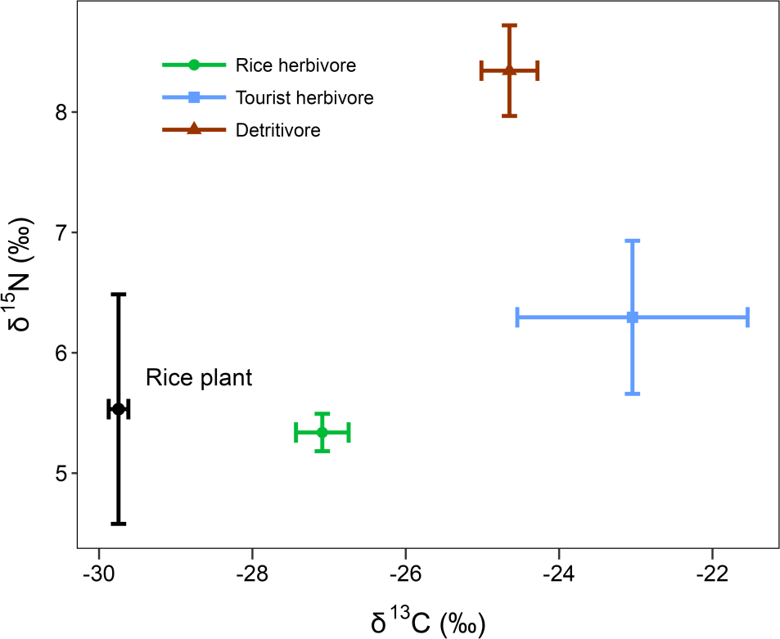

38

1. **Figure S1.** Stable isotope biplot of the rice plant and three prey sources in this study. Error bars
2. represent 95% confidence intervals.

41

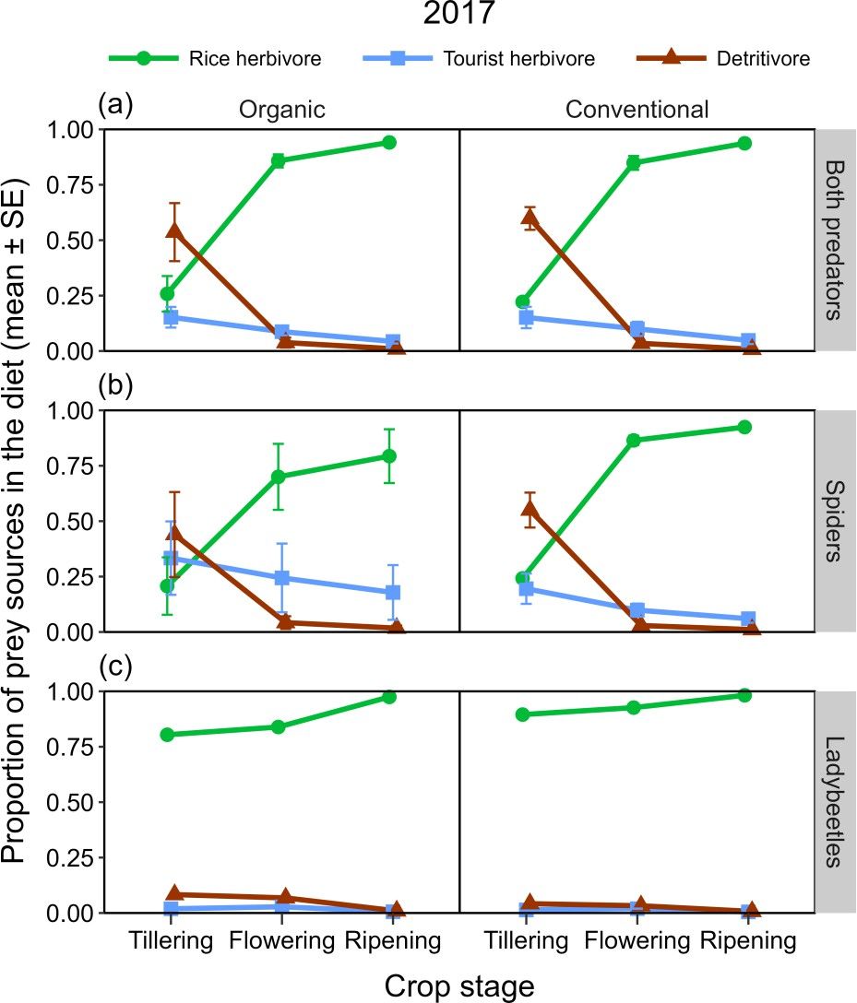42

43

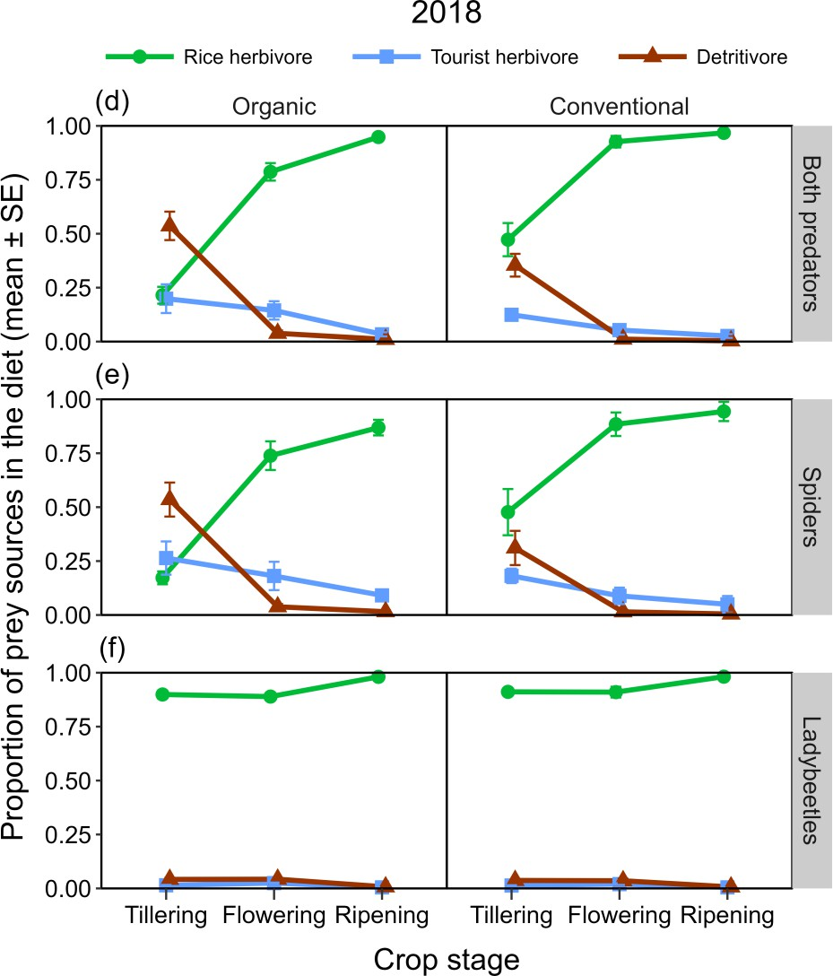44

45

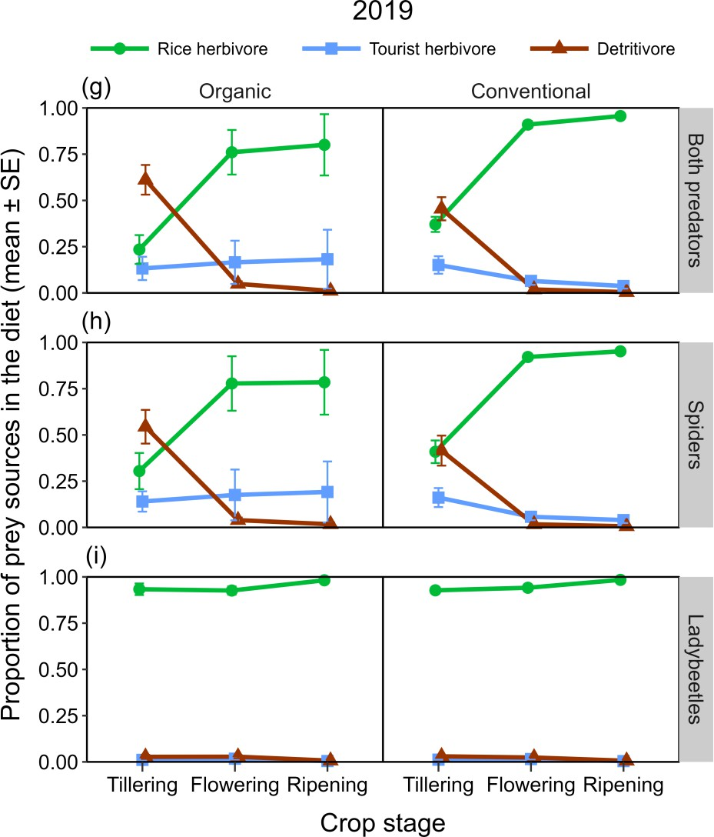46

47

1. **Figure S2**. The proportions (mean ± SE) of prey sources (rice herbivores, tourist herbivores,
2. detritivores) consumed in the diet of predators in organic and conventional rice farms over crop
3. stages in each study year: (a), (d), and (g) indicate both predators (spiders and ladybeetles) as a
4. whole feeding guild; (b), (e), and (h) indicate spiders; (c), (f), and (i) indicate ladybeetles. The
5. proportions were computed from the Bayesian posterior medians of diet estimates in replicate
6. farms.

54

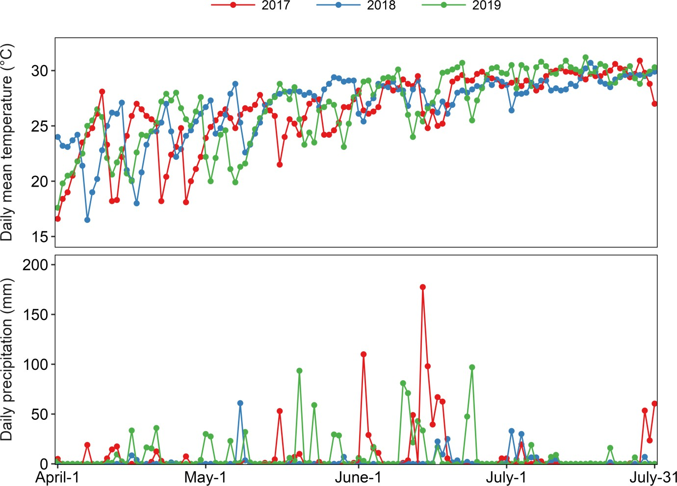55

56 **Figure S3.** Daily mean temperature and precipitation of the study sites during the rice growth

57 season (April to July) of the three study years. Observation data from the closest local weather

58 station (Yuanli station) to the study farms were retrieved from the Central Weather Bureau

59 Observation Data Inquire System (https://e-service.cwb.gov.tw/HistoryDataQuery/index.jsp).

Supplementary Material for publication online only [Click here to access/download;Supplementary Material for [](https://www2.cloud.editorialmanager.com/agee/download.aspx?id=1207447%26guid=9937a3ef-6573-4ded-97bd-d33485a77d73%26scheme=1)](https://www2.cloud.editorialmanager.com/agee/download.aspx?id=1207447&guid=9937a3ef-6573-4ded-97bd-d33485a77d73&scheme=1)

[publication online only;Manuscript to AEE 2023-1204](https://www2.cloud.editorialmanager.com/agee/download.aspx?id=1207447&guid=9937a3ef-6573-4ded-97bd-d33485a77d73&scheme=1)

|  |  |  |  |  |  |  |  |  |  |
| --- | --- | --- | --- | --- | --- | --- | --- | --- | --- |
| Year | Predat or | Farm_I D | Stage | Source | Mean | SD | Median | Lower 95% credible interval limit | Upper 95% credible interval limit |
| 2017 | Both | LC1 | Tillering | Rice herbivore | 0.263 | 0.068 | 0.258 | 0.149 | 0.418 |
| 2017 | Both | LC1 | Tillering | Tourist herbivore | 0.172 | 0.104 | 0.145 | 0.038 | 0.406 |
| 2017 | Both | LC1 | Tillering | Detritivore | 0.564 | 0.133 | 0.581 | 0.299 | 0.781 |
| 2017 | Both | LC1 | Flowering | Rice herbivore | 0.871 | 0.057 | 0.879 | 0.736 | 0.956 |
| 2017 | Both | LC1 | Flowering | Tourist herbivore | 0.097 | 0.055 | 0.084 | 0.026 | 0.229 |
| 2017 | Both | LC1 | Flowering | Detritivore | 0.032 | 0.02 | 0.028 | 0.007 | 0.085 |
| 2017 | Both | LC1 | Ripening | Rice herbivore | 0.945 | 0.028 | 0.95 | 0.879 | 0.984 |
| 2017 | Both | LC1 | Ripening | Tourist herbivore | 0.045 | 0.025 | 0.039 | 0.012 | 0.109 |
| 2017 | Both | LC1 | Ripening | Detritivore | 0.009 | 0.009 | 0.006 | 0.001 | 0.036 |
| 2017 | Both | LO1 | Tillering | Rice herbivore | 0.408 | 0.166 | 0.397 | 0.123 | 0.758 |
| 2017 | Both | LO1 | Tillering | Tourist herbivore | 0.196 | 0.136 | 0.174 | 0.012 | 0.494 |
| 2017 | Both | LO1 | Tillering | Detritivore | 0.396 | 0.208 | 0.372 | 0.067 | 0.829 |
| 2017 | Both | LO1 | Flowering | Rice herbivore | 0.9 | 0.065 | 0.913 | 0.745 | 0.985 |
| 2017 | Both | LO1 | Flowering | Tourist herbivore | 0.081 | 0.062 | 0.065 | 0.006 | 0.227 |
| 2017 | Both | LO1 | Flowering | Detritivore | 0.02 | 0.022 | 0.012 | 0.001 | 0.088 |
| 2017 | Both | LO1 | Ripening | Rice herbivore | 0.956 | 0.033 | 0.964 | 0.87 | 0.996 |
| 2017 | Both | LO1 | Ripening | Tourist herbivore | 0.038 | 0.032 | 0.03 | 0.003 | 0.122 |
| 2017 | Both | LO1 | Ripening | Detritivore | 0.006 | 0.009 | 0.003 | 0 | 0.029 |
| 2017 | Both | MC1 | Tillering | Rice herbivore | 0.221 | 0.128 | 0.199 | 0.036 | 0.513 |
| 2017 | Both | MC1 | Tillering | Tourist herbivore | 0.253 | 0.155 | 0.238 | 0.018 | 0.598 |
| 2017 | Both | MC1 | Tillering | Detritivore | 0.526 | 0.2 | 0.519 | 0.154 | 0.915 |
| 2017 | Both | MC1 | Flowering | Rice herbivore | 0.771 | 0.127 | 0.786 | 0.478 | 0.962 |
| 2017 | Both | MC1 | Flowering | Tourist herbivore | 0.18 | 0.117 | 0.162 | 0.017 | 0.467 |
| 2017 | Both | MC1 | Flowering | Detritivore | 0.049 | 0.055 | 0.03 | 0.003 | 0.214 |
| 2017 | Both | MC1 | Ripening | Rice herbivore | 0.883 | 0.086 | 0.905 | 0.671 | 0.988 |
| 2017 | Both | MC1 | Ripening | Tourist herbivore | 0.1 | 0.08 | 0.08 | 0.008 | 0.304 |
| 2017 | Both | MC1 | Ripening | Detritivore | 0.017 | 0.029 | 0.007 | 0 | 0.104 |
| 2017 | Both | MO1 | Tillering | Rice herbivore | 0.281 | 0.173 | 0.258 | 0.035 | 0.652 |
| 2017 | Both | MO1 | Tillering | Tourist herbivore | 0.274 | 0.209 | 0.22 | 0.016 | 0.766 |
| 2017 | Both | MO1 | Tillering | Detritivore | 0.445 | 0.194 | 0.442 | 0.094 | 0.824 |
| 2017 | Both | MO1 | Flowering | Rice herbivore | 0.767 | 0.206 | 0.848 | 0.302 | 0.984 |
| 2017 | Both | MO1 | Flowering | Tourist herbivore | 0.203 | 0.197 | 0.12 | 0.006 | 0.656 |
| 2017 | Both | MO1 | Flowering | Detritivore | 0.03 | 0.033 | 0.019 | 0.002 | 0.119 |
| 2017 | Both | MO1 | Ripening | Rice herbivore | 0.88 | 0.126 | 0.93 | 0.545 | 0.994 |
| 2017 | Both | MO1 | Ripening | Tourist herbivore | 0.11 | 0.122 | 0.06 | 0.003 | 0.442 |
| 2017 | Both | MO1 | Ripening | Detritivore | 0.01 | 0.015 | 0.005 | 0 | 0.051 |
| 2017 | Both | SC1 | Tillering | Rice herbivore | 0.219 | 0.115 | 0.208 | 0.043 | 0.47 |
| 2017 | Both | SC1 | Tillering | Tourist herbivore | 0.095 | 0.087 | 0.071 | 0.007 | 0.324 |
| 2017 | Both | SC1 | Tillering | Detritivore | 0.685 | 0.146 | 0.694 | 0.37 | 0.933 |
| 2017 | Both | SC1 | Flowering | Rice herbivore | 0.862 | 0.089 | 0.881 | 0.636 | 0.976 |

|  |  |  |  |  |  |  |  |  |  |
| --- | --- | --- | --- | --- | --- | --- | --- | --- | --- |
| 2017 | Both | SC1 | Flowering | Tourist herbivore | 0.075 | 0.068 | 0.054 | 0.006 | 0.245 |
| 2017 | Both | SC1 | Flowering | Detritivore | 0.063 | 0.056 | 0.046 | 0.008 | 0.216 |
| 2017 | Both | SC1 | Ripening | Rice herbivore | 0.943 | 0.049 | 0.956 | 0.809 | 0.994 |
| 2017 | Both | SC1 | Ripening | Tourist herbivore | 0.037 | 0.038 | 0.025 | 0.002 | 0.142 |
| 2017 | Both | SC1 | Ripening | Detritivore | 0.02 | 0.029 | 0.01 | 0.001 | 0.102 |
| 2017 | Both | SO1 | Tillering | Rice herbivore | 0.133 | 0.083 | 0.119 | 0.018 | 0.331 |
| 2017 | Both | SO1 | Tillering | Tourist herbivore | 0.086 | 0.078 | 0.063 | 0.006 | 0.284 |
| 2017 | Both | SO1 | Tillering | Detritivore | 0.781 | 0.12 | 0.795 | 0.522 | 0.962 |
| 2017 | Both | SO1 | Flowering | Rice herbivore | 0.784 | 0.134 | 0.812 | 0.46 | 0.959 |
| 2017 | Both | SO1 | Flowering | Tourist herbivore | 0.103 | 0.087 | 0.077 | 0.008 | 0.328 |
| 2017 | Both | SO1 | Flowering | Detritivore | 0.114 | 0.1 | 0.083 | 0.014 | 0.404 |
| 2017 | Both | SO1 | Ripening | Rice herbivore | 0.911 | 0.067 | 0.929 | 0.747 | 0.989 |
| 2017 | Both | SO1 | Ripening | Tourist herbivore | 0.053 | 0.048 | 0.039 | 0.004 | 0.179 |
| 2017 | Both | SO1 | Ripening | Detritivore | 0.036 | 0.043 | 0.02 | 0.002 | 0.159 |
| 2017 | Spider | LC1 | Tillering | Rice herbivore | 0.248 | 0.05 | 0.245 | 0.163 | 0.356 |
| 2017 | Spider | LC1 | Tillering | Tourist herbivore | 0.283 | 0.074 | 0.288 | 0.116 | 0.417 |
| 2017 | Spider | LC1 | Tillering | Detritivore | 0.469 | 0.091 | 0.46 | 0.316 | 0.685 |
| 2017 | Spider | LC1 | Flowering | Rice herbivore | 0.829 | 0.05 | 0.832 | 0.721 | 0.916 |
| 2017 | Spider | LC1 | Flowering | Tourist herbivore | 0.145 | 0.047 | 0.142 | 0.066 | 0.247 |
| 2017 | Spider | LC1 | Flowering | Detritivore | 0.026 | 0.018 | 0.022 | 0.005 | 0.071 |
| 2017 | Spider | LC1 | Ripening | Rice herbivore | 0.897 | 0.039 | 0.902 | 0.806 | 0.961 |
| 2017 | Spider | LC1 | Ripening | Tourist herbivore | 0.091 | 0.037 | 0.087 | 0.032 | 0.177 |
| 2017 | Spider | LC1 | Ripening | Detritivore | 0.012 | 0.013 | 0.008 | 0.001 | 0.048 |
| 2017 | Spider | LO1 | Tillering | Rice herbivore | 0.464 | 0.127 | 0.466 | 0.215 | 0.71 |
| 2017 | Spider | LO1 | Tillering | Tourist herbivore | 0.28 | 0.107 | 0.283 | 0.055 | 0.486 |
| 2017 | Spider | LO1 | Tillering | Detritivore | 0.256 | 0.157 | 0.223 | 0.046 | 0.662 |
| 2017 | Spider | LO1 | Flowering | Rice herbivore | 0.905 | 0.04 | 0.909 | 0.816 | 0.969 |
| 2017 | Spider | LO1 | Flowering | Tourist herbivore | 0.086 | 0.039 | 0.082 | 0.022 | 0.172 |
| 2017 | Spider | LO1 | Flowering | Detritivore | 0.009 | 0.01 | 0.006 | 0.001 | 0.04 |
| 2017 | Spider | LO1 | Ripening | Rice herbivore | 0.943 | 0.03 | 0.948 | 0.872 | 0.986 |
| 2017 | Spider | LO1 | Ripening | Tourist herbivore | 0.052 | 0.029 | 0.048 | 0.01 | 0.122 |
| 2017 | Spider | LO1 | Ripening | Detritivore | 0.004 | 0.007 | 0.002 | 0 | 0.023 |
| 2017 | Spider | MC1 | Tillering | Rice herbivore | 0.271 | 0.106 | 0.265 | 0.09 | 0.494 |
| 2017 | Spider | MC1 | Tillering | Tourist herbivore | 0.24 | 0.111 | 0.236 | 0.043 | 0.474 |
| 2017 | Spider | MC1 | Tillering | Detritivore | 0.488 | 0.171 | 0.483 | 0.169 | 0.836 |
| 2017 | Spider | MC1 | Flowering | Rice herbivore | 0.85 | 0.061 | 0.856 | 0.712 | 0.949 |
| 2017 | Spider | MC1 | Flowering | Tourist herbivore | 0.119 | 0.055 | 0.112 | 0.032 | 0.244 |
| 2017 | Spider | MC1 | Flowering | Detritivore | 0.031 | 0.031 | 0.022 | 0.003 | 0.115 |
| 2017 | Spider | MC1 | Ripening | Rice herbivore | 0.91 | 0.047 | 0.918 | 0.802 | 0.977 |
| 2017 | Spider | MC1 | Ripening | Tourist herbivore | 0.075 | 0.041 | 0.068 | 0.016 | 0.173 |
| 2017 | Spider | MC1 | Ripening | Detritivore | 0.015 | 0.022 | 0.008 | 0 | 0.078 |
| 2017 | Spider | MO1 | Tillering | Rice herbivore | 0.074 | 0.042 | 0.065 | 0.019 | 0.175 |

|  |  |  |  |  |  |  |  |  |  |
| --- | --- | --- | --- | --- | --- | --- | --- | --- | --- |
| 2017 | Spider | MO1 | Tillering | Tourist herbivore | 0.618 | 0.179 | 0.642 | 0.23 | 0.892 |
| 2017 | Spider | MO1 | Tillering | Detritivore | 0.308 | 0.189 | 0.274 | 0.039 | 0.732 |
| 2017 | Spider | MO1 | Flowering | Rice herbivore | 0.412 | 0.107 | 0.412 | 0.204 | 0.622 |
| 2017 | Spider | MO1 | Flowering | Tourist herbivore | 0.556 | 0.104 | 0.554 | 0.358 | 0.761 |
| 2017 | Spider | MO1 | Flowering | Detritivore | 0.032 | 0.034 | 0.022 | 0.002 | 0.117 |
| 2017 | Spider | MO1 | Ripening | Rice herbivore | 0.551 | 0.116 | 0.554 | 0.316 | 0.767 |
| 2017 | Spider | MO1 | Ripening | Tourist herbivore | 0.43 | 0.114 | 0.425 | 0.22 | 0.663 |
| 2017 | Spider | MO1 | Ripening | Detritivore | 0.019 | 0.024 | 0.01 | 0.001 | 0.089 |
| 2017 | Spider | SC1 | Tillering | Rice herbivore | 0.221 | 0.109 | 0.216 | 0.042 | 0.446 |
| 2017 | Spider | SC1 | Tillering | Tourist herbivore | 0.073 | 0.051 | 0.062 | 0.01 | 0.202 |
| 2017 | Spider | SC1 | Tillering | Detritivore | 0.705 | 0.125 | 0.707 | 0.457 | 0.924 |
| 2017 | Spider | SC1 | Flowering | Rice herbivore | 0.885 | 0.077 | 0.905 | 0.687 | 0.975 |
| 2017 | Spider | SC1 | Flowering | Tourist herbivore | 0.054 | 0.044 | 0.042 | 0.006 | 0.165 |
| 2017 | Spider | SC1 | Flowering | Detritivore | 0.062 | 0.055 | 0.044 | 0.007 | 0.217 |
| 2017 | Spider | SC1 | Ripening | Rice herbivore | 0.932 | 0.065 | 0.953 | 0.743 | 0.992 |
| 2017 | Spider | SC1 | Ripening | Tourist herbivore | 0.034 | 0.033 | 0.025 | 0.003 | 0.123 |
| 2017 | Spider | SC1 | Ripening | Detritivore | 0.033 | 0.05 | 0.016 | 0.001 | 0.181 |
| 2017 | Spider | SO1 | Tillering | Rice herbivore | 0.105 | 0.066 | 0.091 | 0.018 | 0.27 |
| 2017 | Spider | SO1 | Tillering | Tourist herbivore | 0.086 | 0.056 | 0.075 | 0.01 | 0.224 |
| 2017 | Spider | SO1 | Tillering | Detritivore | 0.809 | 0.096 | 0.822 | 0.6 | 0.958 |
| 2017 | Spider | SO1 | Flowering | Rice herbivore | 0.759 | 0.128 | 0.779 | 0.463 | 0.946 |
| 2017 | Spider | SO1 | Flowering | Tourist herbivore | 0.112 | 0.074 | 0.096 | 0.015 | 0.286 |
| 2017 | Spider | SO1 | Flowering | Detritivore | 0.13 | 0.103 | 0.099 | 0.015 | 0.408 |
| 2017 | Spider | SO1 | Ripening | Rice herbivore | 0.86 | 0.09 | 0.878 | 0.645 | 0.977 |
| 2017 | Spider | SO1 | Ripening | Tourist herbivore | 0.075 | 0.055 | 0.062 | 0.009 | 0.214 |
| 2017 | Spider | SO1 | Ripening | Detritivore | 0.066 | 0.07 | 0.04 | 0.003 | 0.259 |
| 2017 | adybeet | LC1 | Flowering | Rice herbivore | 0.902 | 0.131 | 0.934 | 0.456 | 0.991 |
| 2017 | adybeet | LC1 | Flowering | Tourist herbivore | 0.054 | 0.124 | 0.02 | 0 | 0.498 |
| 2017 | adybeet | LC1 | Flowering | Detritivore | 0.045 | 0.041 | 0.033 | 0.001 | 0.151 |
| 2017 | adybeet | LC1 | Ripening | Rice herbivore | 0.955 | 0.137 | 0.984 | 0.498 | 0.998 |
| 2017 | adybeet | LC1 | Ripening | Tourist herbivore | 0.033 | 0.135 | 0.005 | 0 | 0.472 |
| 2017 | adybeet | LC1 | Ripening | Detritivore | 0.012 | 0.014 | 0.007 | 0 | 0.049 |
| 2017 | adybeet | LO1 | Ripening | Rice herbivore | 0.944 | 0.143 | 0.984 | 0.474 | 0.999 |
| 2017 | adybeet | LO1 | Ripening | Tourist herbivore | 0.038 | 0.138 | 0.004 | 0 | 0.518 |
| 2017 | adybeet | LO1 | Ripening | Detritivore | 0.018 | 0.032 | 0.006 | 0 | 0.11 |
| 2017 | adybeet | MC1 | Tillering | Rice herbivore | 0.803 | 0.228 | 0.895 | 0.139 | 0.998 |
| 2017 | adybeet | MC1 | Tillering | Tourist herbivore | 0.08 | 0.165 | 0.014 | 0 | 0.657 |
| 2017 | adybeet | MC1 | Tillering | Detritivore | 0.118 | 0.165 | 0.042 | 0 | 0.605 |
| 2017 | adybeet | MO1 | Tillering | Rice herbivore | 0.74 | 0.239 | 0.804 | 0.153 | 0.998 |
| 2017 | adybeet | MO1 | Tillering | Tourist herbivore | 0.086 | 0.162 | 0.019 | 0 | 0.622 |
| 2017 | adybeet | MO1 | Tillering | Detritivore | 0.173 | 0.198 | 0.083 | 0 | 0.656 |
| 2017 | adybeet | MO1 | Flowering | Rice herbivore | 0.792 | 0.188 | 0.839 | 0.311 | 0.996 |

|  |  |  |  |  |  |  |  |  |  |
| --- | --- | --- | --- | --- | --- | --- | --- | --- | --- |
| 2017 | adybeet | MO1 | Flowering | Tourist herbivore | 0.085 | 0.141 | 0.028 | 0 | 0.53 |
| 2017 | adybeet | MO1 | Flowering | Detritivore | 0.123 | 0.138 | 0.068 | 0.001 | 0.484 |
| 2017 | adybeet | MO1 | Ripening | Rice herbivore | 0.914 | 0.141 | 0.959 | 0.515 | 0.999 |
| 2017 | adybeet | MO1 | Ripening | Tourist herbivore | 0.046 | 0.128 | 0.008 | 0 | 0.442 |
| 2017 | adybeet | MO1 | Ripening | Detritivore | 0.04 | 0.059 | 0.015 | 0 | 0.222 |
| 2017 | adybeet | SC1 | Flowering | Rice herbivore | 0.863 | 0.16 | 0.919 | 0.407 | 0.997 |
| 2017 | adybeet | SC1 | Flowering | Tourist herbivore | 0.069 | 0.133 | 0.019 | 0 | 0.5 |
| 2017 | adybeet | SC1 | Flowering | Detritivore | 0.068 | 0.091 | 0.032 | 0.001 | 0.324 |
| 2017 | adybeet | SC1 | Ripening | Rice herbivore | 0.94 | 0.138 | 0.98 | 0.565 | 0.999 |
| 2017 | adybeet | SC1 | Ripening | Tourist herbivore | 0.039 | 0.131 | 0.005 | 0 | 0.394 |
| 2017 | adybeet | SC1 | Ripening | Detritivore | 0.022 | 0.039 | 0.007 | 0 | 0.136 |
| 2017 | adybeet | SO1 | Ripening | Rice herbivore | 0.938 | 0.143 | 0.981 | 0.521 | 0.999 |
| 2017 | adybeet | SO1 | Ripening | Tourist herbivore | 0.039 | 0.134 | 0.005 | 0 | 0.477 |
| 2017 | adybeet | SO1 | Ripening | Detritivore | 0.023 | 0.044 | 0.007 | 0 | 0.165 |
| 2018 | Both | LC1 | Tillering | Rice herbivore | 0.389 | 0.194 | 0.383 | 0.053 | 0.773 |
| 2018 | Both | LC1 | Tillering | Tourist herbivore | 0.178 | 0.168 | 0.117 | 0.008 | 0.594 |
| 2018 | Both | LC1 | Tillering | Detritivore | 0.432 | 0.225 | 0.398 | 0.077 | 0.911 |
| 2018 | Both | LC1 | Flowering | Rice herbivore | 0.883 | 0.114 | 0.923 | 0.559 | 0.991 |
| 2018 | Both | LC1 | Flowering | Tourist herbivore | 0.087 | 0.1 | 0.049 | 0.004 | 0.38 |
| 2018 | Both | LC1 | Flowering | Detritivore | 0.03 | 0.053 | 0.013 | 0.001 | 0.183 |
| 2018 | Both | LC1 | Ripening | Rice herbivore | 0.952 | 0.049 | 0.969 | 0.826 | 0.997 |
| 2018 | Both | LC1 | Ripening | Tourist herbivore | 0.04 | 0.046 | 0.024 | 0.002 | 0.161 |
| 2018 | Both | LC1 | Ripening | Detritivore | 0.008 | 0.013 | 0.003 | 0 | 0.045 |
| 2018 | Both | LC2 | Tillering | Rice herbivore | 0.309 | 0.174 | 0.288 | 0.045 | 0.694 |
| 2018 | Both | LC2 | Tillering | Tourist herbivore | 0.174 | 0.144 | 0.139 | 0.009 | 0.544 |
| 2018 | Both | LC2 | Tillering | Detritivore | 0.517 | 0.213 | 0.524 | 0.107 | 0.902 |
| 2018 | Both | LC2 | Ripening | Rice herbivore | 0.932 | 0.073 | 0.956 | 0.732 | 0.995 |
| 2018 | Both | LC2 | Ripening | Tourist herbivore | 0.056 | 0.067 | 0.033 | 0.002 | 0.244 |
| 2018 | Both | LC2 | Ripening | Detritivore | 0.012 | 0.021 | 0.005 | 0 | 0.071 |
| 2018 | Both | LC3 | Tillering | Rice herbivore | 0.669 | 0.108 | 0.671 | 0.445 | 0.876 |
| 2018 | Both | LC3 | Tillering | Tourist herbivore | 0.09 | 0.075 | 0.069 | 0.007 | 0.281 |
| 2018 | Both | LC3 | Tillering | Detritivore | 0.241 | 0.11 | 0.234 | 0.057 | 0.475 |
| 2018 | Both | LC3 | Flowering | Rice herbivore | 0.969 | 0.028 | 0.977 | 0.901 | 0.995 |
| 2018 | Both | LC3 | Flowering | Tourist herbivore | 0.025 | 0.027 | 0.016 | 0.002 | 0.092 |
| 2018 | Both | LC3 | Flowering | Detritivore | 0.006 | 0.006 | 0.005 | 0.001 | 0.022 |
| 2018 | Both | LC3 | Ripening | Rice herbivore | 0.987 | 0.012 | 0.991 | 0.955 | 0.999 |
| 2018 | Both | LC3 | Ripening | Tourist herbivore | 0.011 | 0.012 | 0.007 | 0.001 | 0.042 |
| 2018 | Both | LC3 | Ripening | Detritivore | 0.002 | 0.002 | 0.001 | 0 | 0.008 |
| 2018 | Both | LO1 | Tillering | Rice herbivore | 0.315 | 0.136 | 0.31 | 0.058 | 0.59 |
| 2018 | Both | LO1 | Tillering | Tourist herbivore | 0.283 | 0.152 | 0.277 | 0.023 | 0.593 |
| 2018 | Both | LO1 | Tillering | Detritivore | 0.402 | 0.172 | 0.387 | 0.106 | 0.79 |
| 2018 | Both | LO1 | Flowering | Rice herbivore | 0.817 | 0.139 | 0.851 | 0.431 | 0.976 |

|  |  |  |  |  |  |  |  |  |  |
| --- | --- | --- | --- | --- | --- | --- | --- | --- | --- |
| 2018 | Both | LO1 | Flowering | Tourist herbivore | 0.159 | 0.132 | 0.126 | 0.012 | 0.527 |
| 2018 | Both | LO1 | Flowering | Detritivore | 0.024 | 0.029 | 0.015 | 0.002 | 0.104 |
| 2018 | Both | LO1 | Ripening | Rice herbivore | 0.905 | 0.103 | 0.936 | 0.584 | 0.991 |
| 2018 | Both | LO1 | Ripening | Tourist herbivore | 0.088 | 0.1 | 0.057 | 0.005 | 0.399 |
| 2018 | Both | LO1 | Ripening | Detritivore | 0.007 | 0.011 | 0.004 | 0 | 0.037 |
| 2018 | Both | LO2 | Tillering | Rice herbivore | 0.295 | 0.143 | 0.288 | 0.058 | 0.606 |
| 2018 | Both | LO2 | Tillering | Tourist herbivore | 0.139 | 0.13 | 0.097 | 0.007 | 0.489 |
| 2018 | Both | LO2 | Tillering | Detritivore | 0.565 | 0.187 | 0.567 | 0.184 | 0.896 |
| 2018 | Both | LO2 | Flowering | Rice herbivore | 0.877 | 0.096 | 0.906 | 0.611 | 0.982 |
| 2018 | Both | LO2 | Flowering | Tourist herbivore | 0.082 | 0.083 | 0.055 | 0.005 | 0.31 |
| 2018 | Both | LO2 | Flowering | Detritivore | 0.04 | 0.045 | 0.026 | 0.004 | 0.169 |
| 2018 | Both | LO2 | Ripening | Rice herbivore | 0.949 | 0.047 | 0.964 | 0.817 | 0.995 |
| 2018 | Both | LO2 | Ripening | Tourist herbivore | 0.039 | 0.042 | 0.025 | 0.002 | 0.159 |
| 2018 | Both | LO2 | Ripening | Detritivore | 0.012 | 0.017 | 0.006 | 0 | 0.058 |
| 2018 | Both | LO3 | Tillering | Rice herbivore | 0.364 | 0.174 | 0.365 | 0.06 | 0.706 |
| 2018 | Both | LO3 | Tillering | Tourist herbivore | 0.101 | 0.145 | 0.046 | 0.005 | 0.568 |
| 2018 | Both | LO3 | Tillering | Detritivore | 0.536 | 0.198 | 0.527 | 0.143 | 0.906 |
| 2018 | Both | LO3 | Ripening | Rice herbivore | 0.966 | 0.043 | 0.981 | 0.838 | 0.998 |
| 2018 | Both | LO3 | Ripening | Tourist herbivore | 0.025 | 0.04 | 0.011 | 0.001 | 0.144 |
| 2018 | Both | LO3 | Ripening | Detritivore | 0.01 | 0.015 | 0.005 | 0 | 0.049 |
| 2018 | Both | MC1 | Tillering | Rice herbivore | 0.691 | 0.168 | 0.722 | 0.276 | 0.926 |
| 2018 | Both | MC1 | Tillering | Tourist herbivore | 0.075 | 0.073 | 0.056 | 0.006 | 0.255 |
| 2018 | Both | MC1 | Tillering | Detritivore | 0.234 | 0.171 | 0.188 | 0.027 | 0.659 |
| 2018 | Both | MC1 | Flowering | Rice herbivore | 0.971 | 0.034 | 0.98 | 0.897 | 0.997 |
| 2018 | Both | MC1 | Flowering | Tourist herbivore | 0.022 | 0.031 | 0.013 | 0.001 | 0.087 |
| 2018 | Both | MC1 | Flowering | Detritivore | 0.007 | 0.011 | 0.004 | 0 | 0.033 |
| 2018 | Both | MC1 | Ripening | Rice herbivore | 0.988 | 0.02 | 0.992 | 0.956 | 0.999 |
| 2018 | Both | MC1 | Ripening | Tourist herbivore | 0.01 | 0.018 | 0.006 | 0.001 | 0.04 |
| 2018 | Both | MC1 | Ripening | Detritivore | 0.002 | 0.005 | 0.001 | 0 | 0.011 |
| 2018 | Both | MC2 | Tillering | Rice herbivore | 0.599 | 0.217 | 0.646 | 0.108 | 0.908 |
| 2018 | Both | MC2 | Tillering | Tourist herbivore | 0.114 | 0.107 | 0.083 | 0.007 | 0.408 |
| 2018 | Both | MC2 | Tillering | Detritivore | 0.287 | 0.219 | 0.221 | 0.033 | 0.829 |
| 2018 | Both | MC2 | Flowering | Rice herbivore | 0.944 | 0.072 | 0.966 | 0.752 | 0.996 |
| 2018 | Both | MC2 | Flowering | Tourist herbivore | 0.042 | 0.062 | 0.024 | 0.002 | 0.199 |
| 2018 | Both | MC2 | Flowering | Detritivore | 0.014 | 0.029 | 0.005 | 0 | 0.087 |
| 2018 | Both | MC2 | Ripening | Rice herbivore | 0.976 | 0.039 | 0.987 | 0.874 | 0.999 |
| 2018 | Both | MC2 | Ripening | Tourist herbivore | 0.02 | 0.033 | 0.01 | 0.001 | 0.108 |
| 2018 | Both | MC2 | Ripening | Detritivore | 0.004 | 0.014 | 0.001 | 0 | 0.026 |
| 2018 | Both | MC3 | Tillering | Rice herbivore | 0.233 | 0.139 | 0.214 | 0.031 | 0.547 |
| 2018 | Both | MC3 | Tillering | Tourist herbivore | 0.248 | 0.159 | 0.235 | 0.014 | 0.591 |
| 2018 | Both | MC3 | Tillering | Detritivore | 0.518 | 0.206 | 0.509 | 0.138 | 0.915 |
| 2018 | Both | MC3 | Flowering | Rice herbivore | 0.773 | 0.15 | 0.807 | 0.417 | 0.971 |

|  |  |  |  |  |  |  |  |  |  |
| --- | --- | --- | --- | --- | --- | --- | --- | --- | --- |
| 2018 | Both | MC3 | Flowering | Tourist herbivore | 0.178 | 0.134 | 0.148 | 0.011 | 0.506 |
| 2018 | Both | MC3 | Flowering | Detritivore | 0.049 | 0.066 | 0.027 | 0.003 | 0.239 |
| 2018 | Both | MC3 | Ripening | Rice herbivore | 0.886 | 0.099 | 0.915 | 0.625 | 0.99 |
| 2018 | Both | MC3 | Ripening | Tourist herbivore | 0.098 | 0.09 | 0.07 | 0.006 | 0.334 |
| 2018 | Both | MC3 | Ripening | Detritivore | 0.016 | 0.03 | 0.007 | 0 | 0.097 |
| 2018 | Both | MO1 | Tillering | Rice herbivore | 0.225 | 0.207 | 0.165 | 0.007 | 0.72 |
| 2018 | Both | MO1 | Tillering | Tourist herbivore | 0.172 | 0.177 | 0.109 | 0.005 | 0.659 |
| 2018 | Both | MO1 | Tillering | Detritivore | 0.602 | 0.278 | 0.618 | 0.097 | 0.984 |
| 2018 | Both | MO1 | Flowering | Rice herbivore | 0.719 | 0.226 | 0.788 | 0.246 | 0.985 |
| 2018 | Both | MO1 | Flowering | Tourist herbivore | 0.148 | 0.145 | 0.101 | 0.006 | 0.554 |
| 2018 | Both | MO1 | Flowering | Detritivore | 0.133 | 0.183 | 0.036 | 0.002 | 0.619 |
| 2018 | Both | MO1 | Ripening | Rice herbivore | 0.872 | 0.119 | 0.913 | 0.573 | 0.994 |
| 2018 | Both | MO1 | Ripening | Tourist herbivore | 0.087 | 0.094 | 0.055 | 0.003 | 0.352 |
| 2018 | Both | MO1 | Ripening | Detritivore | 0.041 | 0.066 | 0.011 | 0 | 0.237 |
| 2018 | Both | MO2 | Tillering | Rice herbivore | 0.161 | 0.115 | 0.135 | 0.023 | 0.431 |
| 2018 | Both | MO2 | Tillering | Tourist herbivore | 0.452 | 0.241 | 0.507 | 0.007 | 0.831 |
| 2018 | Both | MO2 | Tillering | Detritivore | 0.387 | 0.271 | 0.306 | 0.051 | 0.955 |
| 2018 | Both | MO2 | Flowering | Rice herbivore | 0.629 | 0.188 | 0.656 | 0.215 | 0.921 |
| 2018 | Both | MO2 | Flowering | Tourist herbivore | 0.322 | 0.201 | 0.296 | 0.019 | 0.754 |
| 2018 | Both | MO2 | Flowering | Detritivore | 0.049 | 0.08 | 0.019 | 0.002 | 0.303 |
| 2018 | Both | MO3 | Tillering | Rice herbivore | 0.157 | 0.112 | 0.132 | 0.02 | 0.429 |
| 2018 | Both | MO3 | Tillering | Tourist herbivore | 0.324 | 0.199 | 0.324 | 0.012 | 0.726 |
| 2018 | Both | MO3 | Tillering | Detritivore | 0.519 | 0.236 | 0.5 | 0.102 | 0.946 |
| 2018 | Both | MO3 | Flowering | Rice herbivore | 0.661 | 0.181 | 0.68 | 0.247 | 0.939 |
| 2018 | Both | MO3 | Flowering | Tourist herbivore | 0.272 | 0.175 | 0.247 | 0.022 | 0.691 |
| 2018 | Both | MO3 | Flowering | Detritivore | 0.066 | 0.085 | 0.033 | 0.003 | 0.336 |
| 2018 | Both | SC1 | Tillering | Rice herbivore | 0.385 | 0.162 | 0.384 | 0.091 | 0.709 |
| 2018 | Both | SC1 | Tillering | Tourist herbivore | 0.191 | 0.129 | 0.17 | 0.013 | 0.486 |
| 2018 | Both | SC1 | Tillering | Detritivore | 0.424 | 0.198 | 0.404 | 0.094 | 0.831 |
| 2018 | Both | SC1 | Flowering | Rice herbivore | 0.884 | 0.088 | 0.907 | 0.651 | 0.986 |
| 2018 | Both | SC1 | Flowering | Tourist herbivore | 0.091 | 0.078 | 0.07 | 0.006 | 0.298 |
| 2018 | Both | SC1 | Flowering | Detritivore | 0.025 | 0.037 | 0.014 | 0.002 | 0.116 |
| 2018 | Both | SC1 | Ripening | Rice herbivore | 0.948 | 0.046 | 0.963 | 0.819 | 0.996 |
| 2018 | Both | SC1 | Ripening | Tourist herbivore | 0.045 | 0.043 | 0.031 | 0.003 | 0.168 |
| 2018 | Both | SC1 | Ripening | Detritivore | 0.007 | 0.014 | 0.003 | 0 | 0.039 |
| 2018 | Both | SO1 | Tillering | Rice herbivore | 0.121 | 0.069 | 0.108 | 0.027 | 0.287 |
| 2018 | Both | SO1 | Tillering | Tourist herbivore | 0.041 | 0.035 | 0.032 | 0.004 | 0.132 |
| 2018 | Both | SO1 | Tillering | Detritivore | 0.838 | 0.082 | 0.85 | 0.651 | 0.96 |
| 2018 | Both | SO1 | Flowering | Rice herbivore | 0.822 | 0.097 | 0.84 | 0.586 | 0.957 |
| 2018 | Both | SO1 | Flowering | Tourist herbivore | 0.058 | 0.052 | 0.042 | 0.005 | 0.189 |
| 2018 | Both | SO1 | Flowering | Detritivore | 0.12 | 0.08 | 0.101 | 0.021 | 0.325 |
| 2018 | Both | SO1 | Ripening | Rice herbivore | 0.932 | 0.054 | 0.947 | 0.793 | 0.991 |

|  |  |  |  |  |  |  |  |  |  |
| --- | --- | --- | --- | --- | --- | --- | --- | --- | --- |
| 2018 | Both | SO1 | Ripening | Tourist herbivore | 0.03 | 0.03 | 0.02 | 0.002 | 0.111 |
| 2018 | Both | SO1 | Ripening | Detritivore | 0.038 | 0.042 | 0.024 | 0.002 | 0.157 |
| 2018 | Spider | LC1 | Tillering | Rice herbivore | 0.12 | 0.104 | 0.088 | 0.007 | 0.373 |
| 2018 | Spider | LC1 | Tillering | Tourist herbivore | 0.262 | 0.152 | 0.247 | 0.027 | 0.607 |
| 2018 | Spider | LC1 | Tillering | Detritivore | 0.618 | 0.194 | 0.617 | 0.227 | 0.953 |
| 2018 | Spider | LC1 | Flowering | Rice herbivore | 0.606 | 0.222 | 0.642 | 0.163 | 0.927 |
| 2018 | Spider | LC1 | Flowering | Tourist herbivore | 0.282 | 0.173 | 0.249 | 0.04 | 0.684 |
| 2018 | Spider | LC1 | Flowering | Detritivore | 0.112 | 0.139 | 0.053 | 0.006 | 0.521 |
| 2018 | Spider | LC2 | Tillering | Rice herbivore | 0.297 | 0.162 | 0.285 | 0.034 | 0.65 |
| 2018 | Spider | LC2 | Tillering | Tourist herbivore | 0.205 | 0.134 | 0.182 | 0.025 | 0.541 |
| 2018 | Spider | LC2 | Tillering | Detritivore | 0.498 | 0.207 | 0.499 | 0.111 | 0.884 |
| 2018 | Spider | LC3 | Tillering | Rice herbivore | 0.717 | 0.101 | 0.72 | 0.516 | 0.907 |
| 2018 | Spider | LC3 | Tillering | Tourist herbivore | 0.094 | 0.062 | 0.081 | 0.014 | 0.243 |
| 2018 | Spider | LC3 | Tillering | Detritivore | 0.189 | 0.101 | 0.178 | 0.031 | 0.413 |
| 2018 | Spider | LC3 | Flowering | Rice herbivore | 0.975 | 0.017 | 0.978 | 0.935 | 0.996 |
| 2018 | Spider | LC3 | Flowering | Tourist herbivore | 0.02 | 0.016 | 0.016 | 0.002 | 0.06 |
| 2018 | Spider | LC3 | Flowering | Detritivore | 0.004 | 0.005 | 0.003 | 0 | 0.016 |
| 2018 | Spider | LO1 | Tillering | Rice herbivore | 0.191 | 0.107 | 0.173 | 0.039 | 0.443 |
| 2018 | Spider | LO1 | Tillering | Tourist herbivore | 0.38 | 0.14 | 0.372 | 0.119 | 0.677 |
| 2018 | Spider | LO1 | Tillering | Detritivore | 0.429 | 0.177 | 0.424 | 0.103 | 0.787 |
| 2018 | Spider | LO1 | Flowering | Rice herbivore | 0.708 | 0.14 | 0.729 | 0.38 | 0.915 |
| 2018 | Spider | LO1 | Flowering | Tourist herbivore | 0.256 | 0.127 | 0.236 | 0.07 | 0.551 |
| 2018 | Spider | LO1 | Flowering | Detritivore | 0.036 | 0.043 | 0.024 | 0.002 | 0.144 |
| 2018 | Spider | LO1 | Ripening | Rice herbivore | 0.806 | 0.116 | 0.83 | 0.522 | 0.956 |
| 2018 | Spider | LO1 | Ripening | Tourist herbivore | 0.175 | 0.106 | 0.153 | 0.037 | 0.432 |
| 2018 | Spider | LO1 | Ripening | Detritivore | 0.019 | 0.033 | 0.009 | 0 | 0.088 |
| 2018 | Spider | LO2 | Tillering | Rice herbivore | 0.332 | 0.115 | 0.328 | 0.115 | 0.568 |
| 2018 | Spider | LO2 | Tillering | Tourist herbivore | 0.204 | 0.096 | 0.199 | 0.034 | 0.411 |
| 2018 | Spider | LO2 | Tillering | Detritivore | 0.464 | 0.16 | 0.455 | 0.174 | 0.8 |
| 2018 | Spider | LO2 | Flowering | Rice herbivore | 0.887 | 0.055 | 0.896 | 0.755 | 0.968 |
| 2018 | Spider | LO2 | Flowering | Tourist herbivore | 0.088 | 0.047 | 0.08 | 0.018 | 0.195 |
| 2018 | Spider | LO2 | Flowering | Detritivore | 0.025 | 0.026 | 0.017 | 0.002 | 0.097 |
| 2018 | Spider | LO2 | Ripening | Rice herbivore | 0.934 | 0.038 | 0.941 | 0.842 | 0.985 |
| 2018 | Spider | LO2 | Ripening | Tourist herbivore | 0.054 | 0.033 | 0.048 | 0.009 | 0.137 |
| 2018 | Spider | LO2 | Ripening | Detritivore | 0.012 | 0.016 | 0.006 | 0 | 0.055 |
| 2018 | Spider | LO3 | Tillering | Rice herbivore | 0.215 | 0.112 | 0.201 | 0.04 | 0.458 |
| 2018 | Spider | LO3 | Tillering | Tourist herbivore | 0.171 | 0.105 | 0.156 | 0.018 | 0.416 |
| 2018 | Spider | LO3 | Tillering | Detritivore | 0.614 | 0.169 | 0.624 | 0.273 | 0.914 |
| 2018 | Spider | LO3 | Ripening | Rice herbivore | 0.9 | 0.07 | 0.917 | 0.71 | 0.982 |
| 2018 | Spider | LO3 | Ripening | Tourist herbivore | 0.072 | 0.051 | 0.06 | 0.01 | 0.2 |
| 2018 | Spider | LO3 | Ripening | Detritivore | 0.029 | 0.043 | 0.013 | 0.001 | 0.159 |
| 2018 | Spider | MC1 | Tillering | Rice herbivore | 0.757 | 0.099 | 0.764 | 0.549 | 0.929 |

|  |  |  |  |  |  |  |  |  |  |
| --- | --- | --- | --- | --- | --- | --- | --- | --- | --- |
| 2018 | Spider | MC1 | Tillering | Tourist herbivore | 0.12 | 0.08 | 0.104 | 0.015 | 0.307 |
| 2018 | Spider | MC1 | Tillering | Detritivore | 0.123 | 0.077 | 0.107 | 0.021 | 0.316 |
| 2018 | Spider | MC1 | Flowering | Rice herbivore | 0.972 | 0.022 | 0.977 | 0.915 | 0.996 |
| 2018 | Spider | MC1 | Flowering | Tourist herbivore | 0.025 | 0.022 | 0.02 | 0.003 | 0.081 |
| 2018 | Spider | MC1 | Flowering | Detritivore | 0.003 | 0.003 | 0.002 | 0 | 0.011 |
| 2018 | Spider | MC1 | Ripening | Rice herbivore | 0.984 | 0.015 | 0.988 | 0.946 | 0.998 |
| 2018 | Spider | MC1 | Ripening | Tourist herbivore | 0.015 | 0.015 | 0.011 | 0.001 | 0.052 |
| 2018 | Spider | MC1 | Ripening | Detritivore | 0.001 | 0.002 | 0.001 | 0 | 0.007 |
| 2018 | Spider | MC2 | Tillering | Rice herbivore | 0.773 | 0.104 | 0.787 | 0.54 | 0.936 |
| 2018 | Spider | MC2 | Tillering | Tourist herbivore | 0.111 | 0.075 | 0.096 | 0.014 | 0.288 |
| 2018 | Spider | MC2 | Tillering | Detritivore | 0.116 | 0.088 | 0.095 | 0.018 | 0.347 |
| 2018 | Spider | MC2 | Flowering | Rice herbivore | 0.974 | 0.021 | 0.98 | 0.92 | 0.996 |
| 2018 | Spider | MC2 | Flowering | Tourist herbivore | 0.023 | 0.021 | 0.018 | 0.002 | 0.075 |
| 2018 | Spider | MC2 | Flowering | Detritivore | 0.003 | 0.004 | 0.002 | 0 | 0.012 |
| 2018 | Spider | MC3 | Tillering | Rice herbivore | 0.251 | 0.119 | 0.241 | 0.056 | 0.515 |
| 2018 | Spider | MC3 | Tillering | Tourist herbivore | 0.283 | 0.123 | 0.279 | 0.057 | 0.541 |
| 2018 | Spider | MC3 | Tillering | Detritivore | 0.465 | 0.181 | 0.457 | 0.137 | 0.839 |
| 2018 | Spider | MC3 | Flowering | Rice herbivore | 0.808 | 0.098 | 0.824 | 0.564 | 0.947 |
| 2018 | Spider | MC3 | Flowering | Tourist herbivore | 0.158 | 0.084 | 0.144 | 0.035 | 0.358 |
| 2018 | Spider | MC3 | Flowering | Detritivore | 0.035 | 0.042 | 0.022 | 0.002 | 0.153 |
| 2018 | Spider | MC3 | Ripening | Rice herbivore | 0.881 | 0.073 | 0.899 | 0.695 | 0.975 |
| 2018 | Spider | MC3 | Ripening | Tourist herbivore | 0.102 | 0.065 | 0.088 | 0.018 | 0.257 |
| 2018 | Spider | MC3 | Ripening | Detritivore | 0.017 | 0.028 | 0.008 | 0 | 0.096 |
| 2018 | Spider | MO1 | Tillering | Rice herbivore | 0.167 | 0.194 | 0.072 | 0.004 | 0.655 |
| 2018 | Spider | MO1 | Tillering | Tourist herbivore | 0.181 | 0.185 | 0.109 | 0.006 | 0.658 |
| 2018 | Spider | MO1 | Tillering | Detritivore | 0.652 | 0.306 | 0.754 | 0.086 | 0.987 |
| 2018 | Spider | MO1 | Flowering | Rice herbivore | 0.607 | 0.26 | 0.61 | 0.188 | 0.974 |
| 2018 | Spider | MO1 | Flowering | Tourist herbivore | 0.166 | 0.126 | 0.138 | 0.016 | 0.501 |
| 2018 | Spider | MO1 | Flowering | Detritivore | 0.227 | 0.246 | 0.074 | 0.001 | 0.709 |
| 2018 | Spider | MO1 | Ripening | Rice herbivore | 0.746 | 0.2 | 0.787 | 0.272 | 0.985 |
| 2018 | Spider | MO1 | Ripening | Tourist herbivore | 0.129 | 0.106 | 0.103 | 0.009 | 0.388 |
| 2018 | Spider | MO1 | Ripening | Detritivore | 0.125 | 0.175 | 0.033 | 0 | 0.612 |
| 2018 | Spider | MO2 | Tillering | Rice herbivore | 0.147 | 0.078 | 0.135 | 0.03 | 0.33 |
| 2018 | Spider | MO2 | Tillering | Tourist herbivore | 0.649 | 0.119 | 0.649 | 0.424 | 0.877 |
| 2018 | Spider | MO2 | Tillering | Detritivore | 0.204 | 0.115 | 0.19 | 0.032 | 0.455 |
| 2018 | Spider | MO2 | Flowering | Rice herbivore | 0.558 | 0.156 | 0.576 | 0.203 | 0.81 |
| 2018 | Spider | MO2 | Flowering | Tourist herbivore | 0.427 | 0.153 | 0.409 | 0.182 | 0.767 |
| 2018 | Spider | MO2 | Flowering | Detritivore | 0.016 | 0.018 | 0.01 | 0.001 | 0.06 |
| 2018 | Spider | MO3 | Tillering | Rice herbivore | 0.165 | 0.107 | 0.147 | 0.019 | 0.419 |
| 2018 | Spider | MO3 | Tillering | Tourist herbivore | 0.327 | 0.153 | 0.316 | 0.052 | 0.663 |
| 2018 | Spider | MO3 | Tillering | Detritivore | 0.509 | 0.189 | 0.506 | 0.152 | 0.877 |
| 2018 | Spider | SC1 | Tillering | Rice herbivore | 0.439 | 0.155 | 0.453 | 0.102 | 0.715 |

|  |  |  |  |  |  |  |  |  |  |
| --- | --- | --- | --- | --- | --- | --- | --- | --- | --- |
| 2018 | Spider | SC1 | Tillering | Tourist herbivore | 0.287 | 0.125 | 0.281 | 0.066 | 0.554 |
| 2018 | Spider | SC1 | Tillering | Detritivore | 0.274 | 0.19 | 0.222 | 0.041 | 0.773 |
| 2018 | Spider | SC1 | Flowering | Rice herbivore | 0.883 | 0.08 | 0.905 | 0.67 | 0.973 |
| 2018 | Spider | SC1 | Flowering | Tourist herbivore | 0.103 | 0.071 | 0.085 | 0.02 | 0.281 |
| 2018 | Spider | SC1 | Flowering | Detritivore | 0.014 | 0.03 | 0.006 | 0.001 | 0.089 |
| 2018 | Spider | SO1 | Tillering | Rice herbivore | 0.162 | 0.077 | 0.15 | 0.046 | 0.337 |
| 2018 | Spider | SO1 | Tillering | Tourist herbivore | 0.056 | 0.039 | 0.047 | 0.007 | 0.152 |
| 2018 | Spider | SO1 | Tillering | Detritivore | 0.782 | 0.091 | 0.793 | 0.581 | 0.931 |
| 2018 | Spider | SO1 | Flowering | Rice herbivore | 0.869 | 0.069 | 0.882 | 0.707 | 0.966 |
| 2018 | Spider | SO1 | Flowering | Tourist herbivore | 0.051 | 0.037 | 0.042 | 0.007 | 0.144 |
| 2018 | Spider | SO1 | Flowering | Detritivore | 0.079 | 0.055 | 0.065 | 0.013 | 0.215 |
| 2018 | adybeet | LC1 | Tillering | Rice herbivore | 0.859 | 0.191 | 0.931 | 0.189 | 0.998 |
| 2018 | adybeet | LC1 | Tillering | Tourist herbivore | 0.067 | 0.159 | 0.012 | 0 | 0.671 |
| 2018 | adybeet | LC1 | Tillering | Detritivore | 0.074 | 0.109 | 0.03 | 0 | 0.389 |
| 2018 | adybeet | LC1 | Ripening | Rice herbivore | 0.95 | 0.138 | 0.986 | 0.51 | 0.999 |
| 2018 | adybeet | LC1 | Ripening | Tourist herbivore | 0.036 | 0.135 | 0.004 | 0 | 0.476 |
| 2018 | adybeet | LC1 | Ripening | Detritivore | 0.014 | 0.024 | 0.005 | 0 | 0.083 |
| 2018 | adybeet | LC2 | Ripening | Rice herbivore | 0.936 | 0.147 | 0.982 | 0.457 | 0.999 |
| 2018 | adybeet | LC2 | Ripening | Tourist herbivore | 0.042 | 0.139 | 0.005 | 0 | 0.501 |
| 2018 | adybeet | LC2 | Ripening | Detritivore | 0.023 | 0.045 | 0.006 | 0 | 0.152 |
| 2018 | adybeet | LC3 | Tillering | Rice herbivore | 0.854 | 0.187 | 0.924 | 0.197 | 0.998 |
| 2018 | adybeet | LC3 | Tillering | Tourist herbivore | 0.066 | 0.152 | 0.013 | 0 | 0.604 |
| 2018 | adybeet | LC3 | Tillering | Detritivore | 0.081 | 0.112 | 0.032 | 0 | 0.405 |
| 2018 | adybeet | LC3 | Flowering | Rice herbivore | 0.888 | 0.148 | 0.935 | 0.421 | 0.997 |
| 2018 | adybeet | LC3 | Flowering | Tourist herbivore | 0.06 | 0.129 | 0.016 | 0 | 0.51 |
| 2018 | adybeet | LC3 | Flowering | Detritivore | 0.052 | 0.069 | 0.026 | 0.001 | 0.253 |
| 2018 | adybeet | LC3 | Ripening | Rice herbivore | 0.948 | 0.14 | 0.985 | 0.388 | 0.999 |
| 2018 | adybeet | LC3 | Ripening | Tourist herbivore | 0.037 | 0.136 | 0.004 | 0 | 0.588 |
| 2018 | adybeet | LC3 | Ripening | Detritivore | 0.015 | 0.026 | 0.006 | 0 | 0.087 |
| 2018 | adybeet | LO1 | Tillering | Rice herbivore | 0.77 | 0.216 | 0.825 | 0.21 | 0.998 |
| 2018 | adybeet | LO1 | Tillering | Tourist herbivore | 0.094 | 0.162 | 0.021 | 0 | 0.589 |
| 2018 | adybeet | LO1 | Tillering | Detritivore | 0.135 | 0.159 | 0.07 | 0 | 0.543 |
| 2018 | adybeet | LO1 | Flowering | Rice herbivore | 0.816 | 0.18 | 0.869 | 0.322 | 0.995 |
| 2018 | adybeet | LO1 | Flowering | Tourist herbivore | 0.091 | 0.149 | 0.029 | 0 | 0.578 |
| 2018 | adybeet | LO1 | Flowering | Detritivore | 0.093 | 0.111 | 0.053 | 0.001 | 0.411 |
| 2018 | adybeet | LO1 | Ripening | Rice herbivore | 0.92 | 0.153 | 0.968 | 0.347 | 0.999 |
| 2018 | adybeet | LO1 | Ripening | Tourist herbivore | 0.052 | 0.145 | 0.008 | 0 | 0.611 |
| 2018 | adybeet | LO1 | Ripening | Detritivore | 0.028 | 0.046 | 0.012 | 0 | 0.154 |
| 2018 | adybeet | LO2 | Tillering | Rice herbivore | 0.827 | 0.228 | 0.925 | 0.11 | 0.998 |
| 2018 | adybeet | LO2 | Tillering | Tourist herbivore | 0.07 | 0.17 | 0.013 | 0 | 0.782 |
| 2018 | adybeet | LO2 | Tillering | Detritivore | 0.103 | 0.163 | 0.031 | 0 | 0.591 |
| 2018 | adybeet | LO2 | Ripening | Rice herbivore | 0.94 | 0.144 | 0.983 | 0.497 | 0.999 |

|  |  |  |  |  |  |  |  |  |  |
| --- | --- | --- | --- | --- | --- | --- | --- | --- | --- |
| 2018 | adybeet | LO2 | Ripening | Tourist herbivore | 0.039 | 0.137 | 0.004 | 0 | 0.461 |
| 2018 | adybeet | LO2 | Ripening | Detritivore | 0.021 | 0.041 | 0.006 | 0 | 0.136 |
| 2018 | adybeet | LO3 | Tillering | Rice herbivore | 0.831 | 0.212 | 0.915 | 0.115 | 0.998 |
| 2018 | adybeet | LO3 | Tillering | Tourist herbivore | 0.063 | 0.159 | 0.012 | 0 | 0.681 |
| 2018 | adybeet | LO3 | Tillering | Detritivore | 0.106 | 0.148 | 0.038 | 0 | 0.524 |
| 2018 | adybeet | LO3 | Ripening | Rice herbivore | 0.944 | 0.144 | 0.983 | 0.437 | 0.999 |
| 2018 | adybeet | LO3 | Ripening | Tourist herbivore | 0.036 | 0.138 | 0.004 | 0 | 0.533 |
| 2018 | adybeet | LO3 | Ripening | Detritivore | 0.02 | 0.034 | 0.007 | 0 | 0.116 |
| 2018 | adybeet | MC1 | Tillering | Rice herbivore | 0.829 | 0.223 | 0.921 | 0.127 | 0.998 |
| 2018 | adybeet | MC1 | Tillering | Tourist herbivore | 0.068 | 0.166 | 0.012 | 0 | 0.767 |
| 2018 | adybeet | MC1 | Tillering | Detritivore | 0.102 | 0.157 | 0.034 | 0 | 0.596 |
| 2018 | adybeet | MC2 | Ripening | Rice herbivore | 0.932 | 0.147 | 0.981 | 0.474 | 0.999 |
| 2018 | adybeet | MC2 | Ripening | Tourist herbivore | 0.043 | 0.134 | 0.005 | 0 | 0.465 |
| 2018 | adybeet | MC2 | Ripening | Detritivore | 0.025 | 0.054 | 0.007 | 0 | 0.169 |
| 2018 | adybeet | MO1 | Ripening | Rice herbivore | 0.935 | 0.145 | 0.981 | 0.465 | 0.999 |
| 2018 | adybeet | MO1 | Ripening | Tourist herbivore | 0.042 | 0.136 | 0.005 | 0 | 0.486 |
| 2018 | adybeet | MO1 | Ripening | Detritivore | 0.023 | 0.046 | 0.007 | 0 | 0.163 |
| 2018 | adybeet | MO2 | Tillering | Rice herbivore | 0.806 | 0.231 | 0.903 | 0.1 | 0.998 |
| 2018 | adybeet | MO2 | Tillering | Tourist herbivore | 0.084 | 0.176 | 0.015 | 0 | 0.719 |
| 2018 | adybeet | MO2 | Tillering | Detritivore | 0.11 | 0.161 | 0.041 | 0 | 0.609 |
| 2018 | adybeet | MO2 | Flowering | Rice herbivore | 0.847 | 0.185 | 0.914 | 0.262 | 0.997 |
| 2018 | adybeet | MO2 | Flowering | Tourist herbivore | 0.077 | 0.155 | 0.02 | 0 | 0.598 |
| 2018 | adybeet | MO2 | Flowering | Detritivore | 0.076 | 0.105 | 0.033 | 0.001 | 0.389 |
| 2018 | adybeet | MO3 | Tillering | Rice herbivore | 0.767 | 0.255 | 0.871 | 0.083 | 0.998 |
| 2018 | adybeet | MO3 | Tillering | Tourist herbivore | 0.1 | 0.188 | 0.017 | 0 | 0.75 |
| 2018 | adybeet | MO3 | Tillering | Detritivore | 0.133 | 0.188 | 0.051 | 0 | 0.697 |
| 2018 | adybeet | MO3 | Flowering | Rice herbivore | 0.806 | 0.209 | 0.885 | 0.209 | 0.996 |
| 2018 | adybeet | MO3 | Flowering | Tourist herbivore | 0.096 | 0.164 | 0.025 | 0 | 0.617 |
| 2018 | adybeet | MO3 | Flowering | Detritivore | 0.098 | 0.135 | 0.042 | 0.001 | 0.506 |
| 2018 | adybeet | SC1 | Tillering | Rice herbivore | 0.788 | 0.222 | 0.869 | 0.191 | 0.998 |
| 2018 | adybeet | SC1 | Tillering | Tourist herbivore | 0.08 | 0.156 | 0.017 | 0 | 0.614 |
| 2018 | adybeet | SC1 | Tillering | Detritivore | 0.131 | 0.17 | 0.052 | 0 | 0.613 |
| 2018 | adybeet | SC1 | Flowering | Rice herbivore | 0.834 | 0.168 | 0.885 | 0.384 | 0.996 |
| 2018 | adybeet | SC1 | Flowering | Tourist herbivore | 0.075 | 0.127 | 0.024 | 0 | 0.473 |
| 2018 | adybeet | SC1 | Flowering | Detritivore | 0.091 | 0.112 | 0.045 | 0.001 | 0.396 |
| 2018 | adybeet | SC1 | Ripening | Rice herbivore | 0.93 | 0.136 | 0.974 | 0.523 | 0.999 |
| 2018 | adybeet | SC1 | Ripening | Tourist herbivore | 0.042 | 0.126 | 0.006 | 0 | 0.413 |
| 2018 | adybeet | SC1 | Ripening | Detritivore | 0.028 | 0.043 | 0.01 | 0 | 0.16 |
| 2018 | adybeet | SO1 | Tillering | Rice herbivore | 0.865 | 0.235 | 0.955 | 0.064 | 0.998 |
| 2018 | adybeet | SO1 | Tillering | Tourist herbivore | 0.056 | 0.167 | 0.009 | 0 | 0.836 |
| 2018 | adybeet | SO1 | Tillering | Detritivore | 0.079 | 0.172 | 0.02 | 0 | 0.724 |
| 2018 | adybeet | SO1 | Ripening | Rice herbivore | 0.948 | 0.148 | 0.989 | 0.395 | 1 |

|  |  |  |  |  |  |  |  |  |  |
| --- | --- | --- | --- | --- | --- | --- | --- | --- | --- |
| 2018 | adybeet | SO1 | Ripening | Tourist herbivore | 0.035 | 0.14 | 0.003 | 0 | 0.483 |
| 2018 | adybeet | SO1 | Ripening | Detritivore | 0.017 | 0.044 | 0.004 | 0 | 0.148 |
| 2019 | Both | LC1 | Tillering | Rice herbivore | 0.443 | 0.108 | 0.447 | 0.225 | 0.654 |
| 2019 | Both | LC1 | Tillering | Tourist herbivore | 0.273 | 0.105 | 0.274 | 0.061 | 0.475 |
| 2019 | Both | LC1 | Tillering | Detritivore | 0.284 | 0.136 | 0.267 | 0.076 | 0.61 |
| 2019 | Both | LC1 | Flowering | Rice herbivore | 0.882 | 0.068 | 0.894 | 0.724 | 0.975 |
| 2019 | Both | LC1 | Flowering | Tourist herbivore | 0.107 | 0.067 | 0.094 | 0.017 | 0.26 |
| 2019 | Both | LC1 | Flowering | Detritivore | 0.011 | 0.013 | 0.008 | 0.001 | 0.045 |
| 2019 | Both | LC1 | Ripening | Rice herbivore | 0.946 | 0.037 | 0.955 | 0.852 | 0.99 |
| 2019 | Both | LC1 | Ripening | Tourist herbivore | 0.051 | 0.036 | 0.043 | 0.008 | 0.143 |
| 2019 | Both | LC1 | Ripening | Detritivore | 0.003 | 0.004 | 0.002 | 0 | 0.014 |
| 2019 | Both | LC2 | Tillering | Rice herbivore | 0.384 | 0.124 | 0.386 | 0.132 | 0.62 |
| 2019 | Both | LC2 | Tillering | Tourist herbivore | 0.104 | 0.09 | 0.082 | 0.008 | 0.349 |
| 2019 | Both | LC2 | Tillering | Detritivore | 0.511 | 0.142 | 0.511 | 0.226 | 0.801 |
| 2019 | Both | LC2 | Flowering | Rice herbivore | 0.925 | 0.061 | 0.943 | 0.765 | 0.987 |
| 2019 | Both | LC2 | Flowering | Tourist herbivore | 0.05 | 0.054 | 0.033 | 0.003 | 0.194 |
| 2019 | Both | LC2 | Flowering | Detritivore | 0.025 | 0.023 | 0.019 | 0.004 | 0.089 |
| 2019 | Both | LC3 | Tillering | Rice herbivore | 0.281 | 0.102 | 0.28 | 0.087 | 0.483 |
| 2019 | Both | LC3 | Tillering | Tourist herbivore | 0.074 | 0.058 | 0.059 | 0.007 | 0.219 |
| 2019 | Both | LC3 | Tillering | Detritivore | 0.645 | 0.116 | 0.645 | 0.42 | 0.878 |
| 2019 | Both | LC3 | Flowering | Rice herbivore | 0.91 | 0.06 | 0.925 | 0.757 | 0.98 |
| 2019 | Both | LC3 | Flowering | Tourist herbivore | 0.047 | 0.044 | 0.034 | 0.004 | 0.166 |
| 2019 | Both | LC3 | Flowering | Detritivore | 0.042 | 0.036 | 0.032 | 0.007 | 0.139 |
| 2019 | Both | LC3 | Ripening | Rice herbivore | 0.966 | 0.028 | 0.974 | 0.885 | 0.995 |
| 2019 | Both | LC3 | Ripening | Tourist herbivore | 0.022 | 0.022 | 0.015 | 0.002 | 0.083 |
| 2019 | Both | LC3 | Ripening | Detritivore | 0.012 | 0.015 | 0.007 | 0.001 | 0.051 |
| 2019 | Both | LO1 | Tillering | Rice herbivore | 0.629 | 0.135 | 0.64 | 0.33 | 0.867 |
| 2019 | Both | LO1 | Tillering | Tourist herbivore | 0.134 | 0.102 | 0.113 | 0.01 | 0.382 |
| 2019 | Both | LO1 | Tillering | Detritivore | 0.237 | 0.133 | 0.216 | 0.042 | 0.545 |
| 2019 | Both | LO1 | Flowering | Rice herbivore | 0.951 | 0.045 | 0.964 | 0.83 | 0.995 |
| 2019 | Both | LO1 | Flowering | Tourist herbivore | 0.041 | 0.043 | 0.029 | 0.002 | 0.159 |
| 2019 | Both | LO1 | Flowering | Detritivore | 0.007 | 0.01 | 0.004 | 0.001 | 0.03 |
| 2019 | Both | LO1 | Ripening | Rice herbivore | 0.98 | 0.02 | 0.986 | 0.925 | 0.998 |
| 2019 | Both | LO1 | Ripening | Tourist herbivore | 0.018 | 0.019 | 0.013 | 0.001 | 0.072 |
| 2019 | Both | LO1 | Ripening | Detritivore | 0.002 | 0.003 | 0.001 | 0 | 0.009 |
| 2019 | Both | LO2 | Tillering | Rice herbivore | 0.28 | 0.114 | 0.278 | 0.073 | 0.507 |
| 2019 | Both | LO2 | Tillering | Tourist herbivore | 0.096 | 0.077 | 0.078 | 0.007 | 0.287 |
| 2019 | Both | LO2 | Tillering | Detritivore | 0.623 | 0.131 | 0.621 | 0.37 | 0.875 |
| 2019 | Both | LO2 | Flowering | Rice herbivore | 0.894 | 0.082 | 0.915 | 0.679 | 0.98 |
| 2019 | Both | LO2 | Flowering | Tourist herbivore | 0.064 | 0.068 | 0.044 | 0.005 | 0.238 |
| 2019 | Both | LO2 | Flowering | Detritivore | 0.042 | 0.038 | 0.031 | 0.007 | 0.147 |
| 2019 | Both | LO3 | Tillering | Rice herbivore | 0.368 | 0.272 | 0.268 | 0.067 | 0.944 |

|  |  |  |  |  |  |  |  |  |  |
| --- | --- | --- | --- | --- | --- | --- | --- | --- | --- |
| 2019 | Both | LO3 | Tillering | Tourist herbivore | 0.039 | 0.034 | 0.029 | 0.004 | 0.128 |
| 2019 | Both | LO3 | Tillering | Detritivore | 0.593 | 0.278 | 0.69 | 0.026 | 0.911 |
| 2019 | Both | LO3 | Flowering | Rice herbivore | 0.93 | 0.059 | 0.944 | 0.773 | 0.997 |
| 2019 | Both | LO3 | Flowering | Tourist herbivore | 0.026 | 0.03 | 0.017 | 0.001 | 0.111 |
| 2019 | Both | LO3 | Flowering | Detritivore | 0.044 | 0.044 | 0.033 | 0 | 0.16 |
| 2019 | Both | LO3 | Ripening | Rice herbivore | 0.976 | 0.023 | 0.983 | 0.915 | 0.999 |
| 2019 | Both | LO3 | Ripening | Tourist herbivore | 0.012 | 0.015 | 0.007 | 0.001 | 0.05 |
| 2019 | Both | LO3 | Ripening | Detritivore | 0.011 | 0.014 | 0.007 | 0 | 0.05 |
| 2019 | Both | MC1 | Tillering | Rice herbivore | 0.554 | 0.163 | 0.564 | 0.207 | 0.841 |
| 2019 | Both | MC1 | Tillering | Tourist herbivore | 0.134 | 0.109 | 0.104 | 0.01 | 0.408 |
| 2019 | Both | MC1 | Tillering | Detritivore | 0.311 | 0.169 | 0.283 | 0.055 | 0.707 |
| 2019 | Both | MC1 | Flowering | Rice herbivore | 0.943 | 0.048 | 0.958 | 0.819 | 0.993 |
| 2019 | Both | MC1 | Flowering | Tourist herbivore | 0.046 | 0.045 | 0.031 | 0.003 | 0.164 |
| 2019 | Both | MC1 | Flowering | Detritivore | 0.011 | 0.014 | 0.007 | 0.001 | 0.05 |
| 2019 | Both | MC1 | Ripening | Rice herbivore | 0.975 | 0.025 | 0.983 | 0.908 | 0.998 |
| 2019 | Both | MC1 | Ripening | Tourist herbivore | 0.021 | 0.023 | 0.014 | 0.001 | 0.086 |
| 2019 | Both | MC1 | Ripening | Detritivore | 0.003 | 0.005 | 0.002 | 0 | 0.018 |
| 2019 | Both | MC2 | Tillering | Rice herbivore | 0.379 | 0.136 | 0.366 | 0.149 | 0.684 |
| 2019 | Both | MC2 | Tillering | Tourist herbivore | 0.084 | 0.074 | 0.063 | 0.007 | 0.273 |
| 2019 | Both | MC2 | Tillering | Detritivore | 0.537 | 0.156 | 0.548 | 0.189 | 0.805 |
| 2019 | Both | MC2 | Flowering | Rice herbivore | 0.938 | 0.036 | 0.945 | 0.852 | 0.986 |
| 2019 | Both | MC2 | Flowering | Tourist herbivore | 0.036 | 0.03 | 0.028 | 0.003 | 0.115 |
| 2019 | Both | MC2 | Flowering | Detritivore | 0.026 | 0.019 | 0.021 | 0.004 | 0.077 |
| 2019 | Both | MC3 | Tillering | Rice herbivore | 0.298 | 0.115 | 0.293 | 0.095 | 0.538 |
| 2019 | Both | MC3 | Tillering | Tourist herbivore | 0.374 | 0.131 | 0.38 | 0.093 | 0.622 |
| 2019 | Both | MC3 | Tillering | Detritivore | 0.328 | 0.161 | 0.305 | 0.077 | 0.707 |
| 2019 | Both | MC3 | Flowering | Rice herbivore | 0.782 | 0.119 | 0.803 | 0.503 | 0.958 |
| 2019 | Both | MC3 | Flowering | Tourist herbivore | 0.2 | 0.116 | 0.18 | 0.029 | 0.473 |
| 2019 | Both | MC3 | Flowering | Detritivore | 0.018 | 0.02 | 0.012 | 0.002 | 0.077 |
| 2019 | Both | MC3 | Ripening | Rice herbivore | 0.893 | 0.065 | 0.906 | 0.735 | 0.979 |
| 2019 | Both | MC3 | Ripening | Tourist herbivore | 0.101 | 0.064 | 0.089 | 0.017 | 0.256 |
| 2019 | Both | MC3 | Ripening | Detritivore | 0.005 | 0.008 | 0.003 | 0 | 0.026 |
| 2019 | Both | MO1 | Tillering | Rice herbivore | 0.2 | 0.121 | 0.185 | 0.027 | 0.478 |
| 2019 | Both | MO1 | Tillering | Tourist herbivore | 0.141 | 0.115 | 0.113 | 0.008 | 0.42 |
| 2019 | Both | MO1 | Tillering | Detritivore | 0.659 | 0.177 | 0.674 | 0.245 | 0.949 |
| 2019 | Both | MO1 | Flowering | Rice herbivore | 0.812 | 0.117 | 0.833 | 0.539 | 0.968 |
| 2019 | Both | MO1 | Flowering | Tourist herbivore | 0.115 | 0.09 | 0.092 | 0.008 | 0.337 |
| 2019 | Both | MO1 | Flowering | Detritivore | 0.072 | 0.081 | 0.046 | 0.006 | 0.303 |
| 2019 | Both | MO1 | Ripening | Rice herbivore | 0.914 | 0.075 | 0.936 | 0.713 | 0.991 |
| 2019 | Both | MO1 | Ripening | Tourist herbivore | 0.059 | 0.053 | 0.045 | 0.004 | 0.203 |
| 2019 | Both | MO1 | Ripening | Detritivore | 0.027 | 0.049 | 0.01 | 0.001 | 0.175 |
| 2019 | Both | MO2 | Tillering | Rice herbivore | 0.066 | 0.044 | 0.055 | 0.013 | 0.182 |

|  |  |  |  |  |  |  |  |  |  |
| --- | --- | --- | --- | --- | --- | --- | --- | --- | --- |
| 2019 | Both | MO2 | Tillering | Tourist herbivore | 0.296 | 0.378 | 0.021 | 0.002 | 0.931 |
| 2019 | Both | MO2 | Tillering | Detritivore | 0.639 | 0.387 | 0.901 | 0.025 | 0.974 |
| 2019 | Both | MO2 | Flowering | Rice herbivore | 0.625 | 0.242 | 0.717 | 0.086 | 0.904 |
| 2019 | Both | MO2 | Flowering | Tourist herbivore | 0.243 | 0.305 | 0.06 | 0.006 | 0.901 |
| 2019 | Both | MO2 | Flowering | Detritivore | 0.132 | 0.113 | 0.122 | 0.002 | 0.371 |
| 2019 | Both | MO3 | Tillering | Rice herbivore | 0.008 | 0.006 | 0.006 | 0.001 | 0.023 |
| 2019 | Both | MO3 | Tillering | Tourist herbivore | 0.534 | 0.195 | 0.502 | 0.227 | 0.961 |
| 2019 | Both | MO3 | Tillering | Detritivore | 0.458 | 0.195 | 0.492 | 0.033 | 0.766 |
| 2019 | Both | MO3 | Flowering | Rice herbivore | 0.072 | 0.044 | 0.062 | 0.015 | 0.182 |
| 2019 | Both | MO3 | Flowering | Tourist herbivore | 0.856 | 0.067 | 0.864 | 0.71 | 0.962 |
| 2019 | Both | MO3 | Flowering | Detritivore | 0.072 | 0.048 | 0.063 | 0.006 | 0.19 |
| 2019 | Both | MO3 | Ripening | Rice herbivore | 0.146 | 0.063 | 0.139 | 0.043 | 0.285 |
| 2019 | Both | MO3 | Ripening | Tourist herbivore | 0.816 | 0.069 | 0.82 | 0.669 | 0.936 |
| 2019 | Both | MO3 | Ripening | Detritivore | 0.038 | 0.036 | 0.028 | 0.002 | 0.135 |
| 2019 | Both | SC1 | Tillering | Rice herbivore | 0.26 | 0.099 | 0.258 | 0.079 | 0.458 |
| 2019 | Both | SC1 | Tillering | Tourist herbivore | 0.113 | 0.084 | 0.095 | 0.008 | 0.31 |
| 2019 | Both | SC1 | Tillering | Detritivore | 0.627 | 0.124 | 0.626 | 0.384 | 0.865 |
| 2019 | Both | SC1 | Flowering | Rice herbivore | 0.883 | 0.076 | 0.902 | 0.676 | 0.975 |
| 2019 | Both | SC1 | Flowering | Tourist herbivore | 0.074 | 0.065 | 0.055 | 0.006 | 0.256 |
| 2019 | Both | SC1 | Flowering | Detritivore | 0.043 | 0.034 | 0.032 | 0.007 | 0.136 |
| 2019 | Both | SC1 | Ripening | Rice herbivore | 0.949 | 0.047 | 0.963 | 0.82 | 0.994 |
| 2019 | Both | SC1 | Ripening | Tourist herbivore | 0.038 | 0.041 | 0.025 | 0.003 | 0.157 |
| 2019 | Both | SC1 | Ripening | Detritivore | 0.013 | 0.018 | 0.007 | 0.001 | 0.06 |
| 2019 | Both | SO1 | Tillering | Rice herbivore | 0.232 | 0.129 | 0.211 | 0.051 | 0.536 |
| 2019 | Both | SO1 | Tillering | Tourist herbivore | 0.1 | 0.096 | 0.072 | 0.006 | 0.364 |
| 2019 | Both | SO1 | Tillering | Detritivore | 0.667 | 0.165 | 0.687 | 0.301 | 0.921 |
| 2019 | Both | SO1 | Flowering | Rice herbivore | 0.869 | 0.088 | 0.888 | 0.654 | 0.978 |
| 2019 | Both | SO1 | Flowering | Tourist herbivore | 0.073 | 0.067 | 0.053 | 0.005 | 0.252 |
| 2019 | Both | SO1 | Flowering | Detritivore | 0.059 | 0.053 | 0.043 | 0.006 | 0.198 |
| 2019 | Both | SO1 | Ripening | Rice herbivore | 0.946 | 0.047 | 0.959 | 0.827 | 0.994 |
| 2019 | Both | SO1 | Ripening | Tourist herbivore | 0.036 | 0.038 | 0.025 | 0.002 | 0.141 |
| 2019 | Both | SO1 | Ripening | Detritivore | 0.018 | 0.025 | 0.009 | 0.001 | 0.085 |
| 2019 | Spider | LC1 | Tillering | Rice herbivore | 0.502 | 0.084 | 0.505 | 0.33 | 0.655 |
| 2019 | Spider | LC1 | Tillering | Tourist herbivore | 0.294 | 0.073 | 0.293 | 0.154 | 0.44 |
| 2019 | Spider | LC1 | Tillering | Detritivore | 0.203 | 0.1 | 0.19 | 0.047 | 0.448 |
| 2019 | Spider | LC1 | Flowering | Rice herbivore | 0.908 | 0.038 | 0.915 | 0.816 | 0.965 |
| 2019 | Spider | LC1 | Flowering | Tourist herbivore | 0.085 | 0.037 | 0.079 | 0.031 | 0.173 |
| 2019 | Spider | LC1 | Flowering | Detritivore | 0.007 | 0.007 | 0.005 | 0.001 | 0.024 |
| 2019 | Spider | LC1 | Ripening | Rice herbivore | 0.945 | 0.027 | 0.951 | 0.878 | 0.982 |
| 2019 | Spider | LC1 | Ripening | Tourist herbivore | 0.051 | 0.026 | 0.047 | 0.016 | 0.116 |
| 2019 | Spider | LC1 | Ripening | Detritivore | 0.003 | 0.004 | 0.002 | 0 | 0.014 |
| 2019 | Spider | LC2 | Tillering | Rice herbivore | 0.457 | 0.101 | 0.46 | 0.251 | 0.657 |

|  |  |  |  |  |  |  |  |  |  |
| --- | --- | --- | --- | --- | --- | --- | --- | --- | --- |
| 2019 | Spider | LC2 | Tillering | Tourist herbivore | 0.127 | 0.068 | 0.117 | 0.024 | 0.284 |
| 2019 | Spider | LC2 | Tillering | Detritivore | 0.416 | 0.122 | 0.411 | 0.191 | 0.67 |
| 2019 | Spider | LC2 | Flowering | Rice herbivore | 0.942 | 0.032 | 0.948 | 0.865 | 0.985 |
| 2019 | Spider | LC2 | Flowering | Tourist herbivore | 0.042 | 0.027 | 0.036 | 0.007 | 0.111 |
| 2019 | Spider | LC2 | Flowering | Detritivore | 0.016 | 0.015 | 0.011 | 0.002 | 0.054 |
| 2019 | Spider | LC3 | Tillering | Rice herbivore | 0.307 | 0.092 | 0.311 | 0.114 | 0.482 |
| 2019 | Spider | LC3 | Tillering | Tourist herbivore | 0.05 | 0.031 | 0.044 | 0.008 | 0.126 |
| 2019 | Spider | LC3 | Tillering | Detritivore | 0.643 | 0.099 | 0.638 | 0.452 | 0.848 |
| 2019 | Spider | LC3 | Flowering | Rice herbivore | 0.939 | 0.038 | 0.947 | 0.838 | 0.984 |
| 2019 | Spider | LC3 | Flowering | Tourist herbivore | 0.025 | 0.019 | 0.02 | 0.004 | 0.076 |
| 2019 | Spider | LC3 | Flowering | Detritivore | 0.036 | 0.029 | 0.028 | 0.006 | 0.112 |
| 2019 | Spider | LC3 | Ripening | Rice herbivore | 0.968 | 0.025 | 0.975 | 0.9 | 0.995 |
| 2019 | Spider | LC3 | Ripening | Tourist herbivore | 0.015 | 0.013 | 0.012 | 0.002 | 0.048 |
| 2019 | Spider | LC3 | Ripening | Detritivore | 0.016 | 0.019 | 0.01 | 0.001 | 0.072 |
| 2019 | Spider | LO1 | Tillering | Rice herbivore | 0.74 | 0.089 | 0.744 | 0.556 | 0.9 |
| 2019 | Spider | LO1 | Tillering | Tourist herbivore | 0.115 | 0.065 | 0.105 | 0.021 | 0.265 |
| 2019 | Spider | LO1 | Tillering | Detritivore | 0.146 | 0.085 | 0.132 | 0.028 | 0.351 |
| 2019 | Spider | LO1 | Flowering | Rice herbivore | 0.973 | 0.018 | 0.976 | 0.928 | 0.995 |
| 2019 | Spider | LO1 | Flowering | Tourist herbivore | 0.024 | 0.017 | 0.02 | 0.003 | 0.068 |
| 2019 | Spider | LO1 | Flowering | Detritivore | 0.003 | 0.003 | 0.002 | 0 | 0.012 |
| 2019 | Spider | LO1 | Ripening | Rice herbivore | 0.984 | 0.011 | 0.987 | 0.955 | 0.998 |
| 2019 | Spider | LO1 | Ripening | Tourist herbivore | 0.014 | 0.011 | 0.011 | 0.002 | 0.043 |
| 2019 | Spider | LO1 | Ripening | Detritivore | 0.002 | 0.002 | 0.001 | 0 | 0.007 |
| 2019 | Spider | LO2 | Tillering | Rice herbivore | 0.311 | 0.097 | 0.312 | 0.118 | 0.497 |
| 2019 | Spider | LO2 | Tillering | Tourist herbivore | 0.066 | 0.041 | 0.059 | 0.011 | 0.166 |
| 2019 | Spider | LO2 | Tillering | Detritivore | 0.623 | 0.11 | 0.621 | 0.413 | 0.843 |
| 2019 | Spider | LO2 | Flowering | Rice herbivore | 0.932 | 0.04 | 0.942 | 0.825 | 0.982 |
| 2019 | Spider | LO2 | Flowering | Tourist herbivore | 0.033 | 0.024 | 0.027 | 0.005 | 0.092 |
| 2019 | Spider | LO2 | Flowering | Detritivore | 0.035 | 0.03 | 0.026 | 0.005 | 0.118 |
| 2019 | Spider | LO3 | Tillering | Rice herbivore | 0.555 | 0.097 | 0.556 | 0.36 | 0.746 |
| 2019 | Spider | LO3 | Tillering | Tourist herbivore | 0.126 | 0.07 | 0.117 | 0.02 | 0.288 |
| 2019 | Spider | LO3 | Tillering | Detritivore | 0.319 | 0.116 | 0.316 | 0.102 | 0.56 |
| 2019 | Spider | LO3 | Flowering | Rice herbivore | 0.956 | 0.024 | 0.961 | 0.896 | 0.988 |
| 2019 | Spider | LO3 | Flowering | Tourist herbivore | 0.034 | 0.022 | 0.03 | 0.005 | 0.094 |
| 2019 | Spider | LO3 | Flowering | Detritivore | 0.009 | 0.008 | 0.007 | 0.001 | 0.031 |
| 2019 | Spider | LO3 | Ripening | Rice herbivore | 0.975 | 0.016 | 0.979 | 0.934 | 0.995 |
| 2019 | Spider | LO3 | Ripening | Tourist herbivore | 0.02 | 0.015 | 0.017 | 0.003 | 0.058 |
| 2019 | Spider | LO3 | Ripening | Detritivore | 0.004 | 0.005 | 0.003 | 0 | 0.02 |
| 2019 | Spider | MC1 | Tillering | Rice herbivore | 0.704 | 0.109 | 0.707 | 0.474 | 0.899 |
| 2019 | Spider | MC1 | Tillering | Tourist herbivore | 0.098 | 0.066 | 0.084 | 0.014 | 0.26 |
| 2019 | Spider | MC1 | Tillering | Detritivore | 0.199 | 0.11 | 0.183 | 0.034 | 0.454 |
| 2019 | Spider | MC1 | Flowering | Rice herbivore | 0.974 | 0.017 | 0.978 | 0.931 | 0.995 |

|  |  |  |  |  |  |  |  |  |  |
| --- | --- | --- | --- | --- | --- | --- | --- | --- | --- |
| 2019 | Spider | MC1 | Flowering | Tourist herbivore | 0.021 | 0.017 | 0.017 | 0.003 | 0.064 |
| 2019 | Spider | MC1 | Flowering | Detritivore | 0.005 | 0.005 | 0.003 | 0 | 0.018 |
| 2019 | Spider | MC1 | Ripening | Rice herbivore | 0.985 | 0.011 | 0.988 | 0.956 | 0.998 |
| 2019 | Spider | MC1 | Ripening | Tourist herbivore | 0.013 | 0.011 | 0.01 | 0.001 | 0.04 |
| 2019 | Spider | MC1 | Ripening | Detritivore | 0.002 | 0.003 | 0.001 | 0 | 0.011 |
| 2019 | Spider | MC2 | Tillering | Rice herbivore | 0.323 | 0.114 | 0.315 | 0.128 | 0.565 |
| 2019 | Spider | MC2 | Tillering | Tourist herbivore | 0.101 | 0.063 | 0.089 | 0.016 | 0.251 |
| 2019 | Spider | MC2 | Tillering | Detritivore | 0.576 | 0.136 | 0.58 | 0.297 | 0.824 |
| 2019 | Spider | MC2 | Flowering | Rice herbivore | 0.924 | 0.039 | 0.93 | 0.832 | 0.979 |
| 2019 | Spider | MC2 | Flowering | Tourist herbivore | 0.047 | 0.031 | 0.04 | 0.007 | 0.125 |
| 2019 | Spider | MC2 | Flowering | Detritivore | 0.03 | 0.023 | 0.024 | 0.004 | 0.089 |
| 2019 | Spider | MC3 | Tillering | Rice herbivore | 0.333 | 0.095 | 0.336 | 0.152 | 0.516 |
| 2019 | Spider | MC3 | Tillering | Tourist herbivore | 0.415 | 0.088 | 0.41 | 0.252 | 0.609 |
| 2019 | Spider | MC3 | Tillering | Detritivore | 0.252 | 0.117 | 0.237 | 0.064 | 0.518 |
| 2019 | Spider | MC3 | Flowering | Rice herbivore | 0.82 | 0.074 | 0.832 | 0.646 | 0.93 |
| 2019 | Spider | MC3 | Flowering | Tourist herbivore | 0.169 | 0.07 | 0.157 | 0.064 | 0.334 |
| 2019 | Spider | MC3 | Flowering | Detritivore | 0.012 | 0.013 | 0.008 | 0.001 | 0.044 |
| 2019 | Spider | MC3 | Ripening | Rice herbivore | 0.888 | 0.054 | 0.899 | 0.758 | 0.963 |
| 2019 | Spider | MC3 | Ripening | Tourist herbivore | 0.106 | 0.052 | 0.096 | 0.034 | 0.234 |
| 2019 | Spider | MC3 | Ripening | Detritivore | 0.006 | 0.008 | 0.003 | 0 | 0.026 |
| 2019 | Spider | MO1 | Tillering | Rice herbivore | 0.217 | 0.114 | 0.199 | 0.055 | 0.498 |
| 2019 | Spider | MO1 | Tillering | Tourist herbivore | 0.123 | 0.085 | 0.107 | 0.014 | 0.333 |
| 2019 | Spider | MO1 | Tillering | Detritivore | 0.66 | 0.169 | 0.685 | 0.236 | 0.912 |
| 2019 | Spider | MO1 | Flowering | Rice herbivore | 0.865 | 0.066 | 0.875 | 0.711 | 0.964 |
| 2019 | Spider | MO1 | Flowering | Tourist herbivore | 0.078 | 0.046 | 0.071 | 0.014 | 0.189 |
| 2019 | Spider | MO1 | Flowering | Detritivore | 0.057 | 0.052 | 0.042 | 0.004 | 0.192 |
| 2019 | Spider | MO1 | Ripening | Rice herbivore | 0.923 | 0.047 | 0.935 | 0.8 | 0.984 |
| 2019 | Spider | MO1 | Ripening | Tourist herbivore | 0.048 | 0.031 | 0.042 | 0.007 | 0.125 |
| 2019 | Spider | MO1 | Ripening | Detritivore | 0.029 | 0.037 | 0.014 | 0.001 | 0.142 |
| 2019 | Spider | MO2 | Tillering | Rice herbivore | 0.139 | 0.064 | 0.132 | 0.04 | 0.283 |
| 2019 | Spider | MO2 | Tillering | Tourist herbivore | 0.053 | 0.038 | 0.044 | 0.006 | 0.149 |
| 2019 | Spider | MO2 | Tillering | Detritivore | 0.808 | 0.081 | 0.814 | 0.629 | 0.939 |
| 2019 | Spider | MO2 | Flowering | Rice herbivore | 0.854 | 0.072 | 0.866 | 0.687 | 0.959 |
| 2019 | Spider | MO2 | Flowering | Tourist herbivore | 0.053 | 0.037 | 0.044 | 0.009 | 0.15 |
| 2019 | Spider | MO2 | Flowering | Detritivore | 0.092 | 0.062 | 0.078 | 0.014 | 0.246 |
| 2019 | Spider | MO3 | Tillering | Rice herbivore | 0.005 | 0.003 | 0.004 | 0.001 | 0.013 |
| 2019 | Spider | MO3 | Tillering | Tourist herbivore | 0.497 | 0.186 | 0.464 | 0.218 | 0.947 |
| 2019 | Spider | MO3 | Tillering | Detritivore | 0.498 | 0.186 | 0.531 | 0.048 | 0.779 |
| 2019 | Spider | MO3 | Flowering | Rice herbivore | 0.054 | 0.03 | 0.048 | 0.014 | 0.126 |
| 2019 | Spider | MO3 | Flowering | Tourist herbivore | 0.857 | 0.059 | 0.861 | 0.729 | 0.957 |
| 2019 | Spider | MO3 | Flowering | Detritivore | 0.089 | 0.052 | 0.081 | 0.009 | 0.21 |
| 2019 | Spider | MO3 | Ripening | Rice herbivore | 0.092 | 0.044 | 0.086 | 0.026 | 0.193 |

|  |  |  |  |  |  |  |  |  |  |
| --- | --- | --- | --- | --- | --- | --- | --- | --- | --- |
| 2019 | Spider | MO3 | Ripening | Tourist herbivore | 0.842 | 0.068 | 0.851 | 0.683 | 0.951 |
| 2019 | Spider | MO3 | Ripening | Detritivore | 0.066 | 0.058 | 0.049 | 0.003 | 0.214 |
| 2019 | Spider | SC1 | Tillering | Rice herbivore | 0.229 | 0.093 | 0.229 | 0.057 | 0.412 |
| 2019 | Spider | SC1 | Tillering | Tourist herbivore | 0.1 | 0.059 | 0.092 | 0.016 | 0.237 |
| 2019 | Spider | SC1 | Tillering | Detritivore | 0.671 | 0.117 | 0.667 | 0.443 | 0.896 |
| 2019 | Spider | SC1 | Flowering | Rice herbivore | 0.882 | 0.071 | 0.899 | 0.703 | 0.97 |
| 2019 | Spider | SC1 | Flowering | Tourist herbivore | 0.066 | 0.046 | 0.054 | 0.011 | 0.186 |
| 2019 | Spider | SC1 | Flowering | Detritivore | 0.052 | 0.048 | 0.038 | 0.007 | 0.181 |
| 2019 | Spider | SC1 | Ripening | Rice herbivore | 0.933 | 0.051 | 0.947 | 0.798 | 0.989 |
| 2019 | Spider | SC1 | Ripening | Tourist herbivore | 0.041 | 0.032 | 0.033 | 0.005 | 0.126 |
| 2019 | Spider | SC1 | Ripening | Detritivore | 0.025 | 0.034 | 0.014 | 0.001 | 0.121 |
| 2019 | Spider | SO1 | Tillering | Rice herbivore | 0.202 | 0.116 | 0.185 | 0.036 | 0.462 |
| 2019 | Spider | SO1 | Tillering | Tourist herbivore | 0.101 | 0.074 | 0.085 | 0.012 | 0.286 |
| 2019 | Spider | SO1 | Tillering | Detritivore | 0.698 | 0.145 | 0.71 | 0.391 | 0.929 |
| 2019 | Spider | SO1 | Ripening | Rice herbivore | 0.917 | 0.066 | 0.936 | 0.747 | 0.988 |
| 2019 | Spider | SO1 | Ripening | Tourist herbivore | 0.05 | 0.047 | 0.037 | 0.005 | 0.172 |
| 2019 | Spider | SO1 | Ripening | Detritivore | 0.032 | 0.041 | 0.018 | 0.001 | 0.157 |
| 2019 | adybeet | LC1 | Tillering | Rice herbivore | 0.849 | 0.204 | 0.93 | 0.171 | 0.998 |
| 2019 | adybeet | LC1 | Tillering | Tourist herbivore | 0.071 | 0.164 | 0.012 | 0 | 0.716 |
| 2019 | adybeet | LC1 | Tillering | Detritivore | 0.08 | 0.126 | 0.028 | 0 | 0.472 |
| 2019 | adybeet | LC1 | Flowering | Rice herbivore | 0.884 | 0.16 | 0.94 | 0.406 | 0.997 |
| 2019 | adybeet | LC1 | Flowering | Tourist herbivore | 0.064 | 0.142 | 0.016 | 0 | 0.502 |
| 2019 | adybeet | LC1 | Flowering | Detritivore | 0.052 | 0.074 | 0.024 | 0 | 0.264 |
| 2019 | adybeet | LC1 | Ripening | Rice herbivore | 0.948 | 0.144 | 0.985 | 0.378 | 0.999 |
| 2019 | adybeet | LC1 | Ripening | Tourist herbivore | 0.037 | 0.141 | 0.004 | 0 | 0.611 |
| 2019 | adybeet | LC1 | Ripening | Detritivore | 0.014 | 0.025 | 0.006 | 0 | 0.083 |
| 2019 | adybeet | LC2 | Tillering | Rice herbivore | 0.831 | 0.225 | 0.925 | 0.112 | 0.999 |
| 2019 | adybeet | LC2 | Tillering | Tourist herbivore | 0.067 | 0.167 | 0.012 | 0 | 0.814 |
| 2019 | adybeet | LC2 | Tillering | Detritivore | 0.102 | 0.157 | 0.032 | 0 | 0.575 |
| 2019 | adybeet | LC2 | Flowering | Rice herbivore | 0.872 | 0.171 | 0.935 | 0.3 | 0.997 |
| 2019 | adybeet | LC2 | Flowering | Tourist herbivore | 0.063 | 0.142 | 0.016 | 0 | 0.588 |
| 2019 | adybeet | LC2 | Flowering | Detritivore | 0.065 | 0.096 | 0.027 | 0 | 0.346 |
| 2019 | adybeet | LC3 | Flowering | Rice herbivore | 0.88 | 0.16 | 0.935 | 0.344 | 0.997 |
| 2019 | adybeet | LC3 | Flowering | Tourist herbivore | 0.064 | 0.139 | 0.016 | 0 | 0.577 |
| 2019 | adybeet | LC3 | Flowering | Detritivore | 0.057 | 0.078 | 0.026 | 0 | 0.286 |
| 2019 | adybeet | LC3 | Ripening | Rice herbivore | 0.946 | 0.143 | 0.984 | 0.471 | 0.999 |
| 2019 | adybeet | LC3 | Ripening | Tourist herbivore | 0.038 | 0.139 | 0.004 | 0 | 0.473 |
| 2019 | adybeet | LC3 | Ripening | Detritivore | 0.017 | 0.028 | 0.006 | 0 | 0.099 |
| 2019 | adybeet | LO1 | Ripening | Rice herbivore | 0.94 | 0.138 | 0.981 | 0.46 | 0.999 |
| 2019 | adybeet | LO1 | Ripening | Tourist herbivore | 0.04 | 0.131 | 0.005 | 0 | 0.5 |
| 2019 | adybeet | LO1 | Ripening | Detritivore | 0.02 | 0.035 | 0.007 | 0 | 0.122 |
| 2019 | adybeet | LO3 | Tillering | Rice herbivore | 0.901 | 0.215 | 0.969 | 0.049 | 0.999 |

|  |  |  |  |  |  |  |  |  |  |
| --- | --- | --- | --- | --- | --- | --- | --- | --- | --- |
| 2019 | adybeet | LO3 | Tillering | Tourist herbivore | 0.054 | 0.179 | 0.007 | 0 | 0.891 |
| 2019 | adybeet | LO3 | Tillering | Detritivore | 0.045 | 0.121 | 0.015 | 0 | 0.493 |
| 2019 | adybeet | LO3 | Ripening | Rice herbivore | 0.958 | 0.154 | 0.993 | 0.242 | 1 |
| 2019 | adybeet | LO3 | Ripening | Tourist herbivore | 0.034 | 0.152 | 0.002 | 0 | 0.74 |
| 2019 | adybeet | LO3 | Ripening | Detritivore | 0.008 | 0.018 | 0.003 | 0 | 0.049 |
| 2019 | adybeet | MC2 | Flowering | Rice herbivore | 0.92 | 0.152 | 0.961 | 0.222 | 0.997 |
| 2019 | adybeet | MC2 | Flowering | Tourist herbivore | 0.05 | 0.146 | 0.011 | 0 | 0.708 |
| 2019 | adybeet | MC2 | Flowering | Detritivore | 0.03 | 0.037 | 0.017 | 0 | 0.137 |
| 2019 | adybeet | MC3 | Flowering | Rice herbivore | 0.872 | 0.163 | 0.93 | 0.352 | 0.997 |
| 2019 | adybeet | MC3 | Flowering | Tourist herbivore | 0.073 | 0.147 | 0.019 | 0 | 0.581 |
| 2019 | adybeet | MC3 | Flowering | Detritivore | 0.055 | 0.071 | 0.027 | 0 | 0.265 |
| 2019 | adybeet | MC3 | Ripening | Rice herbivore | 0.943 | 0.143 | 0.983 | 0.504 | 0.999 |
| 2019 | adybeet | MC3 | Ripening | Tourist herbivore | 0.04 | 0.139 | 0.005 | 0 | 0.466 |
| 2019 | adybeet | MC3 | Ripening | Detritivore | 0.017 | 0.029 | 0.006 | 0 | 0.1 |
| 2019 | adybeet | MO1 | Ripening | Rice herbivore | 0.92 | 0.165 | 0.98 | 0.346 | 0.999 |
| 2019 | adybeet | MO1 | Ripening | Tourist herbivore | 0.044 | 0.139 | 0.005 | 0 | 0.488 |
| 2019 | adybeet | MO1 | Ripening | Detritivore | 0.036 | 0.084 | 0.007 | 0 | 0.307 |
| 2019 | adybeet | MO2 | Tillering | Rice herbivore | 0.88 | 0.229 | 0.96 | 0.044 | 0.998 |
| 2019 | adybeet | MO2 | Tillering | Tourist herbivore | 0.081 | 0.219 | 0.008 | 0 | 0.917 |
| 2019 | adybeet | MO2 | Tillering | Detritivore | 0.039 | 0.068 | 0.018 | 0 | 0.185 |
| 2019 | adybeet | MO2 | Flowering | Rice herbivore | 0.901 | 0.185 | 0.964 | 0.142 | 0.998 |
| 2019 | adybeet | MO2 | Flowering | Tourist herbivore | 0.069 | 0.178 | 0.01 | 0 | 0.82 |
| 2019 | adybeet | MO2 | Flowering | Detritivore | 0.03 | 0.048 | 0.014 | 0 | 0.149 |
| 2019 | adybeet | MO3 | Tillering | Rice herbivore | 0.781 | 0.236 | 0.871 | 0.13 | 0.998 |
| 2019 | adybeet | MO3 | Tillering | Tourist herbivore | 0.092 | 0.179 | 0.018 | 0 | 0.736 |
| 2019 | adybeet | MO3 | Tillering | Detritivore | 0.126 | 0.172 | 0.049 | 0 | 0.625 |
| 2019 | adybeet | MO3 | Flowering | Rice herbivore | 0.826 | 0.185 | 0.886 | 0.271 | 0.996 |
| 2019 | adybeet | MO3 | Flowering | Tourist herbivore | 0.088 | 0.156 | 0.024 | 0 | 0.639 |
| 2019 | adybeet | MO3 | Flowering | Detritivore | 0.085 | 0.109 | 0.042 | 0 | 0.406 |
| 2019 | adybeet | MO3 | Ripening | Rice herbivore | 0.926 | 0.157 | 0.973 | 0.258 | 0.999 |
| 2019 | adybeet | MO3 | Ripening | Tourist herbivore | 0.05 | 0.151 | 0.007 | 0 | 0.665 |
| 2019 | adybeet | MO3 | Ripening | Detritivore | 0.024 | 0.037 | 0.01 | 0 | 0.129 |
| 2019 | adybeet | SC1 | Flowering | Rice herbivore | 0.892 | 0.161 | 0.947 | 0.297 | 0.997 |
| 2019 | adybeet | SC1 | Flowering | Tourist herbivore | 0.061 | 0.145 | 0.014 | 0 | 0.648 |
| 2019 | adybeet | SC1 | Flowering | Detritivore | 0.047 | 0.068 | 0.02 | 0 | 0.238 |
| 2019 | adybeet | SO1 | Flowering | Rice herbivore | 0.875 | 0.155 | 0.929 | 0.432 | 0.997 |
| 2019 | adybeet | SO1 | Flowering | Tourist herbivore | 0.065 | 0.133 | 0.018 | 0 | 0.475 |
| 2019 | adybeet | SO1 | Flowering | Detritivore | 0.06 | 0.079 | 0.028 | 0 | 0.287 |
| 2019 | adybeet | SO1 | Ripening | Rice herbivore | 0.943 | 0.139 | 0.982 | 0.546 | 0.999 |
| 2019 | adybeet | SO1 | Ripening | Tourist herbivore | 0.038 | 0.132 | 0.004 | 0 | 0.433 |
| 2019 | adybeet | SO1 | Ripening | Detritivore | 0.019 | 0.035 | 0.006 | 0 | 0.12 |

Declaration of Interest Statement

**Declaration of interests**

☒The authors declare that they have no known competing financial interests or personal relationships that could have appeared to influence the work reported in this paper.

☐The authors declare the following financial interests/personal relationships which may be considered as potential competing interests:

REVISED Manuscript (text UNmarked) [Click here to view linked References [](https://www2.cloud.editorialmanager.com/agee/viewRCResults.aspx?pdf=1%26docID=70379%26rev=1%26fileID=1207423%26msid=00965957-f659-4096-b02d-abb84cfe4af8)](https://www2.cloud.editorialmanager.com/agee/viewRCResults.aspx?pdf=1&docID=70379&rev=1&fileID=1207423&msid=00965957-f659-4096-b02d-abb84cfe4af8)

1 *Submission type: Research article*

2

# 3 A predator in need is a predator indeed: generalist predators (spiders and

4 **ladybeetles) specialize in pest consumption at the late growth stage of rice**

5

6 Gen-Chang Hsu1, Jia-Ang Ou2,3, Min-Hsuan Ni2, Zheng-Hong Lin2 and Chuan-Kai Ho1,2* 7

1. 1Department of Life Science, National Taiwan University, Taipei 106, Taiwan
2. 2Institute of Ecology and Evolutionary Biology, National Taiwan University, Taipei 106, Taiwan
3. 3Department of Zoology, University of British Columbia, Vancouver, BC, V6T 1Z4, Canada 11
4. * Corresponding author.
5. ORCiD ID: <http://orcid.org/0000-0002-6437-0073>
6. Address: Institute of Ecology and Evolutionary Biology, National Taiwan University, Taipei 106,
7. Taiwan
8. Email: [ckho@ntu.edu.tw](mailto:ckho@ntu.edu.tw)
9. Telephone number: 886-2-33662466 / Fax number: 886-2-23686750

# Abstract

1. Biocontrol, using natural enemies for pest control, has a long history in agriculture. It has
2. received a surge of interest in the recent Anthropocene because of its potential as a valuable tool
3. for sustainable agriculture. To solve a long-standing puzzle in biocontrol—how well the
4. ubiquitous generalist arthropod predators (GAPs) function as biocontrol agents—this study
5. aimed to 1) quantify the diet composition of GAPs (spiders and ladybeetles) at different crop
6. stages using stable isotope analysis, 2) examine the consistency of GAPs in pest consumption
7. over years, and 3) investigate how abiotic and biotic factors affect pest consumption by GAPs.
8. Specifically, we sampled arthropod prey and GAPs in sub-tropical organic and conventional rice
9. farms over crop stages (seedling, tillering, flowering, and ripening) in three consecutive years.
10. Among our field-collected samples, 352 arthropod predator and 828 prey isotope samples were
11. analyzed to infer predator-prey interactions. Our results show the following: a) The proportion
12. of rice pests in GAPs’ diets in both organic and conventional rice farms increased over the crop
13. season, from 21-47% at the tillering stage to 80-97% at the ripening stage, across the three study
14. years. The high percentage in pest consumption at late crop stages (flowering and ripening)
15. suggests that GAPs can function as specialists in pest management during the critical period of
16. crop production. Regarding individual predator groups, spiders and ladybeetles exhibited
17. distinct dietary patterns over crop stages. b) The high pest consumption by GAPs at late crop
18. stages was similar across years despite variable climatic conditions and prey availability,
19. suggesting a consistency in GAP feeding habits and biocontrol value. c) The proportion of rice
20. pests in GAPs’ diets varied with farm type and crop stage (e.g., higher in conventional farms and
21. during flowering/ripening stages). By quantifying the diet composition of GAPs over crop
22. stages, farm types, and years, this study reveals that generalist predators have potential to
23. produce a stable, predictable top-down effect on pests in rice agro-ecosystems. As sustainable
24. agriculture has become increasingly important, incorporating the ubiquitous generalist predators
25. into pest management will likely open a promising avenue towards this goal.

44

1. *Keywords: biocontrol, trophic interactions, generalist predators, rice paddy, organic and*
2. *conventional farms, stable isotope analysis*

## 1. Introduction

1. Using natural arthropod enemies for pest control has a long history in agriculture. The
2. earliest record of biocontrol was documented in the book *Plants of the Southern Regions* (*ca.* 304
3. A.D.): people sold ants and their nests in the markets to control citrus insect pests (Huang and
4. Yang, 1987). While synthetic pesticides have become the main method for controlling pests in
5. the past century, this comes at a cost, such as posing risks to people, reducing biodiversity and
6. hampering ecosystem functions (Geiger *et al.*, 2010; Kehoe *et al.*, 2017). As agriculture has
7. become the largest land use type worldwide and a major driver for the global biodiversity crisis
8. in Anthropocene (Campbell *et al.*, 2017), a shift from synthetic pesticides to environmentally
9. friendly practices (e.g., biocontrol) is urgently needed to make agriculture more sustainable
10. (Gomiero *et al.*, 2011). For example, the European Commission has announced its plan to
11. reduce the use of chemical pesticides in European Union agricultural systems by 50% by 2030
12. (European Commission, 2020). To achieve this ambitious sustainability goal, biocontrol by
13. natural enemies has been considered a key approach and has regained importance in modern
14. agriculture.
15. Natural enemies used for pest control can be classified into two major groups based on
16. their prey range: specialist and generalist predators. While specialist predators (e.g., parasitoid
17. wasps) have been widely advocated in agriculture because they target specific pest species and
18. produce less undesirable non-target effects (Stiling and Cornelissen, 2005), generalist predators
19. (e.g., spiders) have been increasingly appreciated for their conspicuous existence and consistent
20. biocontrol effect on pests (Symondson *et al.*, 2002; Stiling and Cornelissen, 2005; Michalko *et*
21. *al.*, 2019; Hsu *et al.*, 2021; Gajski *et al.*, 2023). For example, generalist predators were
22. commonly reported in various agro-ecosystems and significantly reduced pest abundance in
23. approximately 75% of cases in 181 field manipulative studies (Symondson *et al.*, 2002).
24. Moreover, a meta-analysis suggests that generalist predators may exert stronger biocontrol
25. effects on pest populations over time compared to specialists (Stiling and Cornelissen, 2005).
26. While the value of generalist predators has been increasingly appreciated, a few
27. fundamental knowledge gaps need to be filled to validate their biocontrol potential and the
28. underlying mechanisms in agro-ecosystems. For example, while studies have qualitatively
29. analyzed the diets of generalist predators (e.g., using molecular gut content analysis to identify
30. prey species) (Eitzinger and Traugott, 2011; Ingrao *et al.*, 2017; Albertini *et al.*, 2018), very few
31. have quantified their diet composition over a growth season in the field (knowledge gap 1) (Hsu
32. *et al.*, 2021; Otieno *et al.*, 2023). Quantifying their diet composition will help address the
33. concern that generalist predators may switch their diet from pests to alternative prey and thus
34. reduce their pest control effectiveness (Michalko *et al.*, 2019). For instance, if generalist
35. predators still consume a high proportion of pests in their diet with the presence of alternative
36. prey in the field, this result would help end a long debate on whether generalist predators serve
37. well as biocontrol agents (Symondson *et al.*, 2002; Krey *et al.*, 2017; Michalko *et al.*, 2019).
38. Moreover, examining the consistency of generalist predators in pest consumption in the field
39. over years is important to assess the reliability of these predators as biocontrol agents in
40. agriculture, although this information is lacking (knowledge gap 2). Given that temporal
41. dynamics in population density or species composition commonly occur in agro-ecosystems
42. (Settle *et al.*, 1996; Dominik *et al.*, 2018), a consistently high pest consumption by generalist
43. predators over years, if it occurs, will provide strong support for applying these predators in pest
44. management programs.
45. To understand the underlying mechanisms for the biocontrol effect of generalist predators,
46. we also need to examine how various abiotic and biotic factors affect the diet composition of
47. generalist predators in agro-ecosystems (knowledge gap 3). First, arthropod community
48. composition (e.g., pest vs. alternative prey density) may vary with crop stages and affect
49. predator-prey trophic interactions (Roubinet *et al.*, 2017). Therefore, we should examine how
50. crop stage affects the pest consumption by generalist predators within a growth season. Second,
51. we should examine whether farming practices (e.g., organic and conventional) influence the diet
52. composition of predators (e.g., pest consumption) (Birkhofer *et al.*, 2011). This will demonstrate
53. whether generalist predators provide varying biocontrol values in specific farm types. Third, we
54. should investigate the relationship between the relative prey abundance and the diet composition
55. of their predators. This will clarify whether pest abundance or predator preference mainly
56. explains the pest consumption by predators (Wise *et al.*, 2006; Kuusk and Ekbom, 2012;
57. Roubinet *et al.*, 2017; Eitzinger *et al.*, 2019). Lastly, we should examine how surrounding
58. vegetation (e.g., forest cover) affects the diet composition of generalist predators. While
59. surrounding vegetation reportedly affected arthropod diversity and predator-prey interactions in
60. agro-ecosystems (Altieri and Letourneau, 1982; Altieri, 1999; Barbosa and Castellanos, 2005;
61. Diehl *et al.*, 2013; Lichtenberg *et al.*, 2017), its effect on predators’ diet composition is unclear.
62. Understanding this will provide insights for managing the agricultural landscape and promoting
63. biocontrol services by generalist predators.
64. To address these three knowledge gaps, this study aimed to 1) quantify the diet
65. composition of generalist predators, 2) examine the consistency of predators in pest consumption
66. over years, and 3) investigate how abiotic and biotic factors may affect the diet composition of
67. these predators. Filling these gaps will provide insights for applying generalist predators in
68. biocontrol programs. Specifically, this study sampled arthropod prey and generalist arthropod
69. predators (GAPs) in sub-tropical organic and conventional rice farms over the rice growth season
70. (seedling, tillering, flowering, and ripening stages) in central Taiwan from 2017 to 2019, and
71. quantified the diet composition of GAPs (ladybeetles and spiders) at each rice stage using stable
72. isotope analysis (δ13C and δ15N). Although GAPs may consume various prey items, we expected
73. that GAPs would consistently consume a high proportion of pests in their diet at late crop stages
74. (with high pest densities) regardless of years. We also expected that the diet composition of
75. GAPs would be affected by local abiotic and biotic factors (e.g., farm type, crop stage, percent
76. forest cover, and the relative abundance of pests in the field). Stable isotope analysis has been
77. widely applied in ecology to infer predator-prey trophic interactions and estimate the
78. proportional contribution of different prey sources to predators’ diets (Post, 2002; Boecklen *et al.*,
79. 2011; Layman *et al.*, 2012). This quantification method reflects accumulated prey consumption
80. in predators’ diets, which may not be achieved by some “snap-shot” techniques (e.g., field

128

129

observations and molecular gut content analysis) (Newton, 2016).

## 2. Materials and Methods

1. *2.1. Study system and sample collection*
2. We collected terrestrial arthropods in paired organic and conventional rice farms in

133 subtropical Taiwan (120.656-120.721 °E; 24.364-24.489 °N) from 2017 to 2019 (three farm

1. pairs in 2017 and seven farm pairs each in 2018 and 2019). While farms in the same pair were
2. relatively close to each other (e.g., within a few hundred meters in distance), different farm pairs
3. were at least 1 km apart from each other to reduce confounding effects. The study farms were
4. 0.2 hectares on average and irrigated with surface water. The organic farms were managed with
5. organic fertilizers (manure; 2-3 applications/crop season) and natural pesticides (tea saponins; 1
6. application/crop season during the seedling or tillering stage). The conventional farms were
7. managed with synthetic nitrogen fertilizers (2-3 applications/crop season) and organophosphate
8. pesticides (1 application/crop season during the tillering or flowering stage). At each major rice
9. crop stage (seedling, tillering, flowering, and ripening stages) during the growing season (April -
10. July) in each study year, we collected arthropod samples by sweep-netting (36 cm in diameter
11. with a mesh size of 0.2 × 0.2 mm) the crop canopy 30 times in each of two transects inside a rice
12. field. Each transect (ca 30 m long) was parallel to but 1.5m away from a randomly selected farm
13. ridge. Samples were sealed in bags without chemical preservatives, iced, and transferred to
14. refrigerator (−20ºC) in the laboratory. We identified and counted arthropods under a dissecting
15. scope to the lowest possible taxonomic level (usually species, genus, or family). Main orders,

149

150

families, and genera have been documented in Hsu et al. (Hsu *et al.*, 2021).

1. *2.2. Stable isotope analysis of arthropod samples*
2. After identification, arthropod samples were prepared for stable isotope analysis. First,
3. samples were oven dried (50ºC) for one week, ground, and weighed into individual tin capsules
4. (5 × 9 mm). If necessary, several conspecifics would be pooled into a capsule to meet the
5. minimum weight required for stable isotope analysis (i.e., 2 mg in this study). The number of
6. isotope capsules for each species generally mirrored the arthropod community composition in the
7. field. Stable isotope analysis (352 arthropod predator and 828 prey isotope samples) was
8. conducted at the UC Davis Stable Isotope Facility using a PDZ Europa ANCA-GSL elemental
9. analyzer interfaced to a PDZ Europa 20-20 isotope ratio mass spectrometer (Sercon Ltd.,
10. Cheshire, UK). The standards for carbon and nitrogen stable isotope ratios were Vienna PeeDee
11. Beleminte and atmospheric N2, respectively. The results of our samples were expressed in per
12. mil (‰) relative to the international standards (δ13C and δ15N).

163

1. *2.3. Arthropod trophic guild assignment*
2. A trophic guild represents a group of species using similar resources and forms a basic
3. component of food webs. The concept has been proved to be practical in current ecology
4. because it condenses broad taxonomic information into distinct functional groups in
5. communities (Blondel, 2003). In this study, we classified arthropod samples into four trophic
6. guilds (one predator and three prey guilds): 1) “Predators” consisted of spiders and ladybeetles,
7. which are the primary GAPs in rice farms. 2) “Rice herbivores” consisted of major rice pests,
8. including planthoppers, leafhoppers, and stink bugs. 3) “Tourist herbivores” consisted of
9. herbivorous species without direct trophic association with rice plants, including some
10. grasshoppers and leaf beetles. 4) “Detritivores” consisted of arthropods that feed on decaying
11. organic material or plankton, including various midge and fly species. The classification of prey
12. guilds was based on a combination of literature surveys and k-means clustering of stable isotope
13. signatures of arthropod samples (see Appendix A: Fig. S1 for a stable isotope biplot for the three
14. prey sources). The arthropod families/genera in each trophic guild are detailed in Appendix A:
15. Table S1. This study focused on the trophic interactions between generalist predators and their
16. prey sources and therefore did not consider less abundant trophic guilds (e.g., parasitoids) in

180

181

subsequent analyses.

1. *2.4. Data analyses*
2. To quantify the diet composition of predators, we constructed Bayesian stable isotope
3. mixing models using the R MixSIAR package (Stock *et al.*, 2018) to estimate the proportions of
4. different prey sources (i.e., the three prey guilds including rice herbivores, tourist herbivores, and
5. detritivores) in predators’ diet. In the mixing models, individual farm-year combination and crop
6. stage were included as fixed effects for predator isotope data; isotope data for the three prey
7. guilds were pooled respectively to generate fixed source values because of their high mobility
8. across farms (Mazzi and Dorn, 2012; Sun *et al.*, 2015). Isotope data at the seedling stage for the
9. three study years were omitted from the analysis due to insufficient sample sizes for model
10. estimation. To improve our model estimates, carbon and nitrogen concentration dependencies as
11. well as the residual/process errors were incorporated (Phillips and Koch, 2002; Stock and
12. Semmens, 2016). Trophic discrimination factors (TDFs) were estimated from the diet-dependent
13. discrimination equation proposed by Caut *et al.* (2009). We ran three Markov Chain Monte
14. Carlo (MCMC) chains, each with 50,000 iterations and a burn-in number of 25,000, along with a
15. non-informative Dirichlet prior. Chain convergence was assessed via Gelman-Rubin and
16. Geweke diagnostics. Bayesian posterior median estimates of diet composition (for each year-
17. farm-stage combination) were extracted for further analyses. Bayesian posterior means, SDs,
18. medians, and 95% credible intervals are provided in Appendix B.
19. To examine how local abiotic and biotic factors may affect the pest consumption by
20. GAPs, we fit weighted generalized linear mixed models (GLMMs) with a beta distribution and a
21. logit link function using the R glmmTMB package (Brooks *et al.*, 2017). We included year, farm type,
22. crop stage, percent forest cover, and the relative abundance of rice herbivores as fixed effects,
23. farm ID nested within pair ID as random effects, and the proportion of rice herbivores consumed
24. in predators’ diet as the response (the posterior median estimates of the dietary proportions from rice herbivores
25. were extracted from the mixing model outputs [Appendix B] as the response in the GLMM).
26. Weights were computed based on the number of diet estimates in each year. Model
27. parameters were estimated via the maximum likelihood approach, and their significance was assessed by
28. the likelihood ratio test via the “Anova” function in the R car package (Fox and Weisberg, 2018).
29. Tukey’s post-hoc tests (α = 0.05) were performed for the significant predictors via the “cld”
30. function in the R emmeans package (Length, 2018). The percent forest cover around each study
31. farm was estimated from Google Earth images by manually delimiting the forested areas within a
32. 1-km radius circular buffer surrounding the farm and computing the fraction of these areas in the
33. buffer zone. The 1-km radius was based on previous studies (Rusch et al., 2016; Karp *et al.*,
34. 2018). Because spiders and ladybeetles may have different feeding behavior and preference, we
35. also performed all the aforementioned analyses separately for each of the two predator groups.

216

217

All analyses were conducted in R version 4.0.3 (R Core Team, 2021).

## 3. Results

1. *3.1. Diet composition of predators in rice farms*
2. Across organic and conventional rice farms during 2017-2019, the proportion of rice
3. herbivores in predators’ diet increased over the course of the crop season from 21-47% at the
4. tillering stage to 80-97% at the ripening stage; the proportion of detritivores in predators’ diet
5. decreased from 35-61% at the tillering stage to <1% at the ripening stage; the proportion of
6. tourist herbivores in predators’ diet also decreased from 13-20% at the tillering stage to 3-18% at
7. the ripening stage (Fig. 1a; Appendix A: Table S2, Fig. S2).
8. Regarding individual predator groups, spiders and ladybeetles showed a marked
9. difference in their diet composition over crop stages during 2017-2019. Across organic and
10. conventional farms, spiders consumed a higher proportion of detritivores (31-55%) in their diet
11. in the beginning of crop season (tillering stage) and substantially increased the consumption on
12. rice herbivores to 78-95% in late crop season (ripening stage) (Fig. 1b; Appendix A: Table S2,
13. Fig. S2). In contrast, ladybeetles in both organic and conventional farms consumed a low
14. proportion of detritivores (≤ 8%) and a steadily high proportion of rice herbivores (≥ 80%) in
15. their diet throughout the crop season (Fig. 1c; Appendix A: Table S2, Fig. S2). Tourist
16. herbivores generally did not constitute an important prey source and contributed less than 33% to

235

236

the diet of spiders and ladybeetles (Fig. 1b, 1c; Appendix A: Table S2, Fig. S2).

1. *3.2. Patterns of rice herbivore consumption by predators*
2. We further analyzed rice herbivore consumption by GAPs since these herbivores are the
3. main pests of concern. The patterns of rice herbivore consumption by both predators in organic
4. and conventional rice farms were generally similar across the three study years, suggesting
5. consistency in GAPs’ feeding habits (Fig. 2). Interestingly, spiders and ladybeetles exhibited
6. distinct within-season patterns of rice herbivore consumption. For spiders in organic and
7. conventional farms, the proportion of rice herbivores in their diet increased toward later crop
8. season, ranging from 17-48% (tillering) to 78-95% (ripening) (Fig. 2b; Appendix A: Table S2,
9. Fig. S2), whereas for ladybeetles in organic and conventional farms, the proportion of rice
10. herbivores in their diet remained relatively stable throughout the season, ranging from 80-93%

247

248

(tillering) to 97-98% (ripening) (Fig. 2c; Appendix A: Table S2, Fig. S2).

1. *3.3. Factors associated with rice herbivore consumption by predators*
2. The proportion of rice herbivores in GAPs’ diet differed between organic and
3. conventional farms for both predators (*χ*2 = 7.92, *P* = 0.01) and spiders (*χ*2 = 4.93, *P* = 0.03), but
4. not ladybeetles (*χ*2 = 0.47, *P* = 0.49; Table 1). Specifically, both predators consumed a higher
5. proportion of rice herbivores in their diet in conventional vs. organic farms (Table 2). The
6. proportion of rice herbivores in GAPs’ diet also differed among crop stages (both predators: *χ*2 =
7. 249.84, *P* < 0.001; spiders: *χ*2 = 119.01, *P* < 0.001; ladybeetles: *χ*2 = 184.32, *P* < 0.001; Table 1).
8. Specifically, GAPs consumed higher proportions of rice herbivores in their diet at the flowering
9. and/or ripening stage vs. the tillering stage (Table 3).
10. The proportion of rice herbivores consumed in GAPs’ diet was not associated with the
11. percent forest cover within a 1-km radius buffer surrounding the study farms (both predators: *χ*2

260 = 0.06, *P* = 0.80; spiders: *χ*2 = 0.12, *P* = 0.73; ladybeetles: *χ*2 = 0.34, *P* = 0.56; Table 1).

1. Furthermore, the proportion of rice herbivores consumed was not associated with the relative
2. abundance of rice herbivores in the field (both predators: *χ*2 = 0.56, *P* = 0.46; spiders: *χ*2 = 0.58,
3. *P* = 0.45; ladybeetles: *χ*2 = 0.38, *P* = 0.54; Table 1).

264

## 4. Discussion

1. Because the worldwide demand for environmentally friendly practices in agriculture has
2. increased, we investigated the potential of GAPs (ubiquitous in nature) as biocontrol agents in
3. rice agro-ecosystems. Specifically, we used stable isotopes to quantify the diet composition of
4. GAPs in organic and conventional rice farms during the crop season in three consecutive years.
5. Our main results include the following: 1) Across the three study years, the rice herbivore
6. consumption by GAPs increased in both organic and conventional farms over the crop season,
7. from 20-47% at the tillering stage to 80-97% at the ripening stage. The high percentage at the
8. ripening stage indicates that GAPs could function as pest specialists during critical growth (late
9. crop) stages. Notably, rice herbivore consumption by spiders increased gradually toward the
10. later crop season, whereas the consumption by ladybeetles remained stable throughout the season.
11. 2) Our results revealed similar among-year patterns in rice herbivore consumption by GAPs in
12. organic and conventional rice farms, suggesting a consistency in GAPs’ feeding habits and
13. biocontrol value. 3) The proportion of rice herbivores in GAPs’ diets varied with farm type and
14. crop stage (e.g., higher in conventional farms and during flowering/ripening stages). However,
15. contrary to results from previous studies, pest consumption by GAPs was not associated with
16. percent forest cover or the relative abundance of rice herbivores in the field. We discuss in the
17. following: 1) GAPs function as pest specialists at late crop stages, 2) GAPs exhibit consistent
18. pest consumption patterns over years, 3) factors associated with pest consumption by GAPs, and
19. 4) the potential caveats of this study (e.g., pest suppression and intraguild predation). We finish

285

286

by highlighting the implications of our results for agricultural management.

1. *4.1. Generalist predators function as pest specialists at late crop stages*
2. While biocontrol, a farming practice with a long history, offers a promising solution for
3. sustainable agriculture, the use of GAPs as biocontrol agents remains a concern because GAPs
4. may switch diets between pests and alternative prey (Albajes and Alomar, 1999; Prasad and
5. Snyder, 2006; Roubinet *et al.*, 2018). This study addressed this concern and revealed a
6. consistency in high pest consumption by GAPs at late crop stages over years. The results
7. provide not only strong support for using GAPs in sustainable pest management, but also a novel
8. aspect in biocontrol—generalist predators may function as guild-level specialist predators of
9. pests during the late crop season. Specifically, across the three study years, GAPs in both
10. organic and conventional farms consumed an increasing proportion of rice herbivores over the
11. crop season, reaching 80-97% in predators’ diet at the ripening stage, whereas the proportions of
12. alternative prey (detritivores and tourist herbivores) in their diet gradually decreased below 18%
13. at the ripening stage (Fig. 1; Appendix A: Table S2, Fig. S2). The increase in rice herbivore
14. consumption over time suggests that the biocontrol potential of predators increases toward late
15. crop stages and peaks at the critical stage of crop production. This could be because of a higher
16. herbivore (pest) density at late crop stages, suggested by a correlation between rice herbivore
17. consumption and crop stage (see *Factors associated with pest consumption by predators*).
18. While GAPs consumed a high proportion of pests at late crop stages, the two major
19. predator groups in our study system, spiders and ladybeetles (Table S1), exhibited distinct
20. dietary patterns over the crop season. Specifically, pest consumption by spiders increased
21. substantially, but pest consumption by ladybeetles remained stable over the season (Fig. 2b vs.
22. 2c). This may be because different foraging modes—sit-and-wait (spiders) or actively hunting
23. (ladybeetles)—can lead to different prey capture and thus diet composition (Nyffeler, 1999;
24. Klecka and Boukal, 2013). For example, long-jawed orb-weavers (*Tetragnatha*), the most
25. abundant genus in our spider samples, are sit-and-wait predators. The diet composition of these
26. predators generally reflects prey availability (Nyffeler, 1999). In contrast, ladybeetles are
27. actively hunting predators and may preferentially feed on rice herbivores, resulting in stable pest
28. consumption over time. Because predator foraging modes shape predator-prey-plant interactions
29. (Schmitz, 2008), we encourage future studies to examine different assemblages of sit-and-wait vs.
30. actively hunting predators in field conditions to reveal the most efficient biocontrol practice over

317

318

the entire crop season.

1. *4.2. Generalists exhibit consistent pest consumption patterns over years*
2. Ideal biocontrol agents provide a consistent, predictable effect on pests under various
3. environmental conditions. Accordingly, GAPs in this study showed consistent pest consumption
4. across years, despite various abiotic and biotic environmental conditions. Specifically, regarding
5. the abiotic factors, the daily mean temperature, particularly from April to June, varied
6. substantially among years (Appendix A: Fig. S3). The daily precipitation also fluctuated over
7. the three study years, with multiple high precipitation events in 2017, overall low precipitation in
8. 2018, and relatively uniform precipitation in 2019 (Appendix A: Fig. S3). Regarding the biotic
9. factors, the composition of rice herbivores at the flowering and ripening stages differed
10. substantially among the three years, in particular the two most dominant groups: leafhoppers
11. (Cicadellidae/*Nephotettix*) and planthoppers (Delphacidae/*Nilaparvata*) (Appendix A: Table S3).
12. Although both abiotic and biotic factors varied substantially over the years of our study, pest
13. consumption by GAPs generally remained stable, suggesting that GAPs can be a predictable,

332

333

valuable tool for pest control in sustainable agriculture (but see Eitzinger *et al.*, 2021).

1. *4.3. Factors associated with pest consumption by predators*
2. The proportion of rice pests in GAPs’ diets differed between farm types and among crop
3. stages but was not associated with the percent forest cover surrounding the farms or the relative
4. abundance of rice herbivores in the field. Overall, GAPs in conventional farms consumed a
5. higher proportion of rice pests in their diet compared to those in organic farms. There are two
6. explanations for this: 1) Organic farming may promote arthropod diversity and therefore distract
7. predators from feeding on target pests (Bengtsson *et al.*, 2005; Birkhofer *et al.*, 2008;
8. Lichtenberg *et al.*, 2017). 2) Pest densities may be higher in conventional farms (Porcel *et al.*,
9. 2018), leading to higher predator-prey encounter rates and thus pest consumption by GAPs.
10. Regardless of the potential mechanisms, our results highlight the important but overlooked
11. biocontrol value of GAPs in conventional farming systems.
12. Besides farming practices, crop stages also affected pest consumption. Overall, pest
13. consumption by GAPs increased from early (tillering) to late (ripening) stages, consistent with
14. previous studies where predators consumed more pests in the late crop season (Roubinet *et al.*,
15. 2017; Hsu *et al.*, 2021). This may be because pest populations increased with rice development
16. and eventually predominated, leading to high pest consumption by GAPs at the flowering and
17. ripening stages. These findings indicate a higher biocontrol value of predators when the crop
18. production is most vulnerable to pest damage. Therefore, farming practitioners may want to
19. avoid practices that harm predators (e.g., chemical applications) during this period to maintain
20. healthy predator populations and associated ecosystem services.
21. Complex habitat structure (e.g., surrounding vegetation) has been suggested to promote
22. predator abundance and diversity (Langellotto and Denno, 2004; Diehl *et al.*, 2013), but such
23. higher complexity did not affect predators’ diet composition in our study. This might be because
24. the prey species in our study system were mostly associated with rice plants but not the
25. surrounding vegetation, consistent with a meta-analysis where habitat complexity had no effect
26. on crop herbivore densities (Langellotto and Denno, 2004). Furthermore, although the diet
27. composition of generalist predators may correlate with prey availability in the field (Wise *et al.*,
28. 2006; Hsu *et al.*, 2021), our beta regression models suggest no such correlation between rice
29. herbivores and GAPs. An explanation is that the relative abundance of rice herbivores was
30. highly correlated with crop stage, a significant factor likely associated with various covariates
31. (e.g., rice plant height) and explaining most variations in pest consumption by GAPs . We
32. encourage further experiments, both observational and manipulative, to clarify the link between

366

367

prey availability and generalist predators’ diet composition in the field.

1. *4.4. Potential caveats of this study*
2. Our study demonstrates high pest consumption by GAPs in rice fields over three years
3. and examines the factors influencing GAPs’ diet composition. While our study provides
4. evidence for GAPs’ biocontrol potential, some caveats may exist. First, high pest consumption
5. in GAPs’ diets does not necessarily imply a strong suppression of pest populations in the field,
6. since pest population dynamics depend not only on the per capita effect of predators but also
7. predator density and diversity (Letourneau *et al.*, 2009; Rusch *et al.*, 2016). To unveil the
8. connection between per capita pest consumption and overall pest dynamics, future work may
9. require complementing stable isotope analysis with field observations of predator and pest
10. populations. Furthermore, future work may examine crop damage and production to reveal the
11. effect of GAPs on pest control and crop performance. Second, while intra-guild predation
12. potentially influences the pest control by GAPs (Straub *et al.*, 2008; Michalko *et al.*, 2019), it
13. was not quantified in our diet composition analysis due to the limitation of stable isotope mixing
14. models (Hsu *et al.*, 2021). However, this may not be a major concern in our study because rice
15. plants grow in dense clumps and form a complex structure that could substantially relax intra-
16. guild predation pressure (Finke and Denno, 2006; Janssen *et al.*, 2007). Regardless, we caution
17. that our diet estimates of predators (without predator-predator interference) might not apply to

385

386

systems where intra-guild predation prevails.

## 5. Conclusions

1. While biocontrol has been recognized as a valuable tool for sustainable agriculture,
2. whether generalist predators can serve as effective biocontrol agents in pest management remains
3. unclear. Our study helps solve this long-standing puzzle by using stable isotope analysis to
4. quantify the diet composition of GAPs (spiders and ladybeetles) over the rice growth season and
5. identifying the underlying mechanisms for enemy-pest interactions in rice farms over three
6. consecutive years. The results show a high proportion of rice pests in GAPs’ diets in both
7. organic and conventional rice farms (e.g., 80-97% at the ripening stage), suggesting that these
8. generalist predators function as “pest specialists” at late crop stages (when rice plants are fruiting
9. and pests are abundant). The high pest consumption remained consistent across years regardless
10. of abiotic and biotic conditions, demonstrating the potential that generalist predators may
11. produce a stable, predictable top-down effect on pests. Overall, our study lends support to
12. applying generalist predators as biocontrol agents in both organic and conventional rice farms.
13. As sustainable agriculture has become more important than ever in human history, incorporating
14. the ubiquitous generalist predators into pest management, such as maintaining healthy
15. populations of these predators, will likely open a promising avenue towards this goal.

## Funding

1. This work was supported by the Council of Agriculture, Executive Yuan, Taiwan

405 (106AS-4.2.5-ST-a1, 107AS-4.2.3-ST-a1, 108AS-4.2.2-ST-a1, 109AS-4.2.2-ST-a1) and the

406 National Science and Technology Council (108-2621-B-002-003-MY3, 111-2621-B-002-003-

407

408

MY3).

## 409 Declaration of competing interest

410 The authors declare that they have no known competing financial interests or personal

411

412

relationships that could have appeared to influence the work reported in this paper.

## 413 Data availability

414

415

Data will be made available on request.

## 416 Acknowledgements

417 We thank Steven C. Pennings for constructive comments, and Yu-Pin Lin, Chih-Wei Tsai,

418 Chi-Lun Huang, Su-Chen Chang, Hung-Ju Chen, C.-Y. Ho, F.-J. Sha, Y.-C. Chung, K.-C. Ho,

419 and H.-C. Ho for logistic supports. We appreciate the Miaoli District Agricultural Research and

420

421

Extension Station for field assistance.

## 422 Author contributions

423 All authors conducted the experiments; G.-C. Hsu and C.-K. Ho designed and wrote the

424

425

manuscript; G.-C. Hsu and J.-A. Ou performed the statistical analyses.

## 426 Appendix A and B. Supporting information

427 Supplementary information associated with this article can be found in the online version

428

429

at doi:xxx.

## Reference

1. Albajes, R., Alomar, Ò., 1999. Current and potential use of polyphagous predators. Integrated
2. pest and disease management in greenhouse crops. Springer, pp. 265-275.
3. Albertini, A., Marchi, S., Ratti, C., Burgio, G., Petacchi, R., Magagnoli, S., 2018. Bactrocera
4. oleae pupae predation by Ocypus olens detected by molecular gut content analysis.
5. BioControl 63, 227-239.
6. Altieri, M.A., 1999. The ecological role of biodiversity in agroecosystems. Invertebrate
7. biodiversity as bioindicators of sustainable landscapes. Elsevier, pp. 19-31.
8. Altieri, M.A., Letourneau, D.K., 1982. Vegetation management and biological control in
9. agroecosystems. Crop protection 1, 405-430.
10. Barbosa, P., Castellanos, I., 2005. Ecology of predator-prey interactions. Oxford University
11. Press.
12. Bengtsson, J., Ahnström, J., WEIBULL, A.C., 2005. The effects of organic agriculture on
13. biodiversity and abundance: a meta‐ analysis. Journal of applied ecology 42, 261-269.
14. Birkhofer, K., Fließbach, A., Wise, D.H., Scheu, S., 2011. Arthropod food webs in organic and
15. conventional wheat farming systems of an agricultural long‐ term experiment: a stable
16. isotope approach. Agricultural and Forest Entomology 13, 197-204.
17. Birkhofer, K., Wise, D.H., Scheu, S., 2008. Subsidy from the detrital food web, but not
18. microhabitat complexity, affects the role of generalist predators in an aboveground
19. herbivore food web. Oikos 117, 494-500.
20. Blondel, J., 2003. Guilds or functional groups: does it matter? Oikos 100, 223-231.
21. Boecklen, W.J., Yarnes, C.T., Cook, B.A., James, A.C., 2011. On the use of stable isotopes in
22. trophic ecology. Annual review of ecology, evolution, and systematics 42, 411-440.
23. Brooks, M.E., Kristensen, K., Van Benthem, K.J., Magnusson, A., Berg, C.W., Nielsen, A.,
24. Skaug, H.J., Machler, M., Bolker, B.M., 2017. glmmTMB balances speed and flexibility
25. among packages for zero-inflated generalized linear mixed modeling. The R journal 9,
26. 378-400.
27. Campbell, B.M., Beare, D.J., Bennett, E.M., Hall-Spencer, J.M., Ingram, J.S., Jaramillo, F., Ortiz,
28. R., Ramankutty, N., Sayer, J.A., Shindell, D., 2017. Agriculture production as a major
29. driver of the Earth system exceeding planetary boundaries. Ecology and Society 22.
30. Caut, S., Angulo, E., Courchamp, F., 2009. Variation in discrimination factors (Δ15N and Δ13C):
31. the effect of diet isotopic values and applications for diet reconstruction. Journal of
32. Applied Ecology 46, 443-453.
33. Diehl, E., Mader, V.L., Wolters, V., Birkhofer, K., 2013. Management intensity and vegetation
34. complexity affect web-building spiders and their prey. Oecologia 173, 579-589.
35. Dominik, C., Seppelt, R., Horgan, F.G., Settele, J., Václavík, T., 2018. Landscape composition,
36. configuration, and trophic interactions shape arthropod communities in rice
37. agroecosystems. Journal of applied ecology 55, 2461-2472.
38. Eitzinger, B., Abrego, N., Gravel, D., Huotari, T., Vesterinen, E.J., Roslin, T., 2019. Assessing
39. changes in arthropod predator–prey interactions through DNA‐ based gut content
40. analysis—variable environment, stable diet. Molecular Ecology 28, 266-280.
41. Eitzinger, B., Roslin, T., Vesterinen, E.J., Robinson, S.I., O'Gorman, E.J., 2021. Temperature
42. affects both the Grinnellian and Eltonian dimensions of ecological niches–A tale of two
43. Arctic wolf spiders. Basic and Applied Ecology 50, 132-143.
44. Eitzinger, B., Traugott, M., 2011. Which prey sustains cold‐ adapted invertebrate generalist
45. predators in arable land? Examining prey choices by molecular gut‐ content analysis.
46. Journal of Applied Ecology 48, 591-599.
47. European Commission, 2020. Communication from the commission to the European parliament,
48. the council, the European economic and social committee and the committee of the regions:
49. a farm to fork strategy for a fair, healthy and environmentally-friendly food system
50. COM/2020/381 final.
51. Finke, D.L., Denno, R.F., 2006. Spatial refuge from intraguild predation: implications for prey
52. suppression and trophic cascades. Oecologia 149, 265-275.
53. Fox, J., Weisberg, S., 2018. An R companion to applied regression. Sage publications.
54. Gajski, D., Mifková, T., Košulič, O., Michálek, O., Serbina, L.Š., Michalko, R., Pekár, S., 2023.
55. Brace yourselves, winter is coming: the winter activity, natural diet, and prey preference of
56. winter-active spiders on pear trees. J Pest Sci 1-14.
57. Geiger, F., Bengtsson, J., Berendse, F., Weisser, W.W., Emmerson, M., Morales, M.B.,
58. Ceryngier, P., Liira, J., Tscharntke, T., Winqvist, C., 2010. Persistent negative effects of
59. pesticides on biodiversity and biological control potential on European farmland. Basic and
60. Applied Ecology 11, 97-105.
61. Gomiero, T., Pimentel, D., Paoletti, M.G., 2011. Is there a need for a more sustainable
62. agriculture? Critical reviews in plant sciences 30, 6-23.
63. Hsu, G.-C., Ou, J.-A., Ho, C.-K., 2021. Pest consumption by generalist arthropod predators
64. increases with crop stage in both organic and conventional farms. Ecosphere 12, e03625.
65. Huang, H.T., Yang, P., 1987. The ancient cultured citrus ant. Bioscience 37, 665-671.
66. Ingrao, A.J., Schmidt, J., Jubenville, J., Grode, A., Komondy, L., VanderZee, D., Szendrei, Z.,
67. 2017. Biocontrol on the edge: Field margin habitats in asparagus fields influence natural
68. enemy-pest interactions. Agriculture, Ecosystems & Environment 243, 47-54.
69. Janssen, A., Sabelis, M.W., Magalhães, S., Montserrat, M., Van der Hammen, T., 2007. Habitat
70. structure affects intraguild predation. Ecology 88, 2713-2719.
71. Karp, D.S., Chaplin-Kramer, R., Meehan, T.D., Martin, E.A., DeClerck, F., Grab, H., Gratton, C.,
72. Hunt, L., Larsen, A.E., Martínez-Salinas, A., 2018. Crop pests and predators exhibit
73. inconsistent responses to surrounding landscape composition. Proceedings of the National
74. Academy of Sciences 115, E7863-E7870.
75. Kehoe, L., Romero-Muñoz, A., Polaina, E., Estes, L., Kreft, H., Kuemmerle, T., 2017.
76. Biodiversity at risk under future cropland expansion and intensification. Nature Ecology &
77. Evolution 1, 1129-1135.
78. Klecka, J., Boukal, D.S., 2013. Foraging and vulnerability traits modify predator–prey body
79. mass allometry: freshwater macroinvertebrates as a case study. Journal of Animal Ecology
80. 82, 1031-1041.
81. Krey, K.L., Blubaugh, C.K., Chapman, E.G., Lynch, C.A., Snyder, G.B., Jensen, A.S., Fu, Z.,
82. Prischmann-Voldseth, D.A., Harwood, J.D., Snyder, W.E., 2017. Generalist predators
83. consume spider mites despite the presence of alternative prey. Biological Control 115, 157-
84. 164.
85. Kuusk, A.-K., Ekbom, B., 2012. Feeding habits of lycosid spiders in field habitats. Journal of
86. Pest Science 85, 253-260.
87. Langellotto, G.A., Denno, R.F., 2004. Responses of invertebrate natural enemies to complex-
88. structured habitats: a meta-analytical synthesis. Oecologia 139, 1-10.
89. Layman, C.A., Araujo, M.S., Boucek, R., Hammerschlag‐ Peyer, C.M., Harrison, E., Jud, Z.R.,
90. Matich, P., Rosenblatt, A.E., Vaudo, J.J., Yeager, L.A., 2012. Applying stable isotopes to
91. examine food‐ web structure: an overview of analytical tools. Biological Reviews 87, 545-
92. 562.
93. Lenth, R. 2018. emmeans: Estimated marginal means, aka least-squares means. R package
94. version 1.3.0.
95. Letourneau, D.K., Jedlicka, J.A., Bothwell, S.G., Moreno, C.R., 2009. Effects of natural enemy
96. biodiversity on the suppression of arthropod herbivores in terrestrial ecosystems. Annu
97. Rev Ecol Evol S 40, 573-592.
98. Lichtenberg, E.M., Kennedy, C.M., Kremen, C., Batary, P., Berendse, F., Bommarco, R.,
99. Bosque‐ Pérez, N.A., Carvalheiro, L.G., Snyder, W.E., Williams, N.M., 2017. A global
100. synthesis of the effects of diversified farming systems on arthropod diversity within fields
101. and across agricultural landscapes. Global change biology 23, 4946-4957.
102. Mazzi, D., Dorn, S., 2012. Movement of insect pests in agricultural landscapes. Annals of
103. Applied Biology 160, 97-113.
104. Michalko, R., Pekár, S., Entling, M.H., 2019. An updated perspective on spiders as generalist
105. predators in biological control. Oecologia 189, 21-36.
106. Newton, J., 2016. Stable isotopes as tools in ecological research. eLS, 1-8.
107. Nyffeler, M., 1999. Prey selection of spiders in the field. Journal of Arachnology, 317-324.
108. Otieno, N.E., Butler, M., Pryke, J.S., 2023. Fallow fields and hedgerows mediate enhanced
109. arthropod predation and reduced herbivory on small scale intercropped maize farms–δ13C
110. and δ15N stable isotope evidence. Agriculture, Ecosystems & Environment 349, 108448.
111. Phillips, D.L., Koch, P.L., 2002. Incorporating concentration dependence in stable isotope
112. mixing models. Oecologia 130, 114-125.
113. Porcel, M., Andersson, G.K., Pålsson, J., Tasin, M., 2018. Organic management in apple
114. orchards: higher impacts on biological control than on pollination. Journal of Applied
115. Ecology 55, 2779-2789.
116. Post, D.M., 2002. Using stable isotopes to estimate trophic position: models, methods, and
117. assumptions. Ecology 83, 703-718.
118. Prasad, R., Snyder, W., 2006. Polyphagy complicates conservation biological control that targets
119. generalist predators. Journal of Applied Ecology 43, 343-352.
120. R Core Team, 2021. R: A language and environment for statistical computing. R Foundation for
121. Statistical Computing, Vienna, Austria.
122. Roubinet, E., Birkhofer, K., Malsher, G., Staudacher, K., Ekbom, B., Traugott, M., Jonsson, M.,
123. 2017. Diet of generalist predators reflects effects of cropping period and farming system on
124. extra- and intraguild prey. Ecol Appl 27, 1167-1177.
125. Roubinet, E., Jonsson, T., Malsher, G., Staudacher, K., Traugott, M., Ekbom, B., Jonsson, M.,
126. 2018. High redundancy as well as complementary prey choice characterize generalist
127. predator food webs in agroecosystems. Scientific reports 8, 1-10.
128. Rusch, A., Chaplin-Kramer, R., Gardiner, M.M., Hawro, V., Holland, J., Landis, D., Thies, C.,
129. Tscharntke, T., Weisser, W.W., Winqvist, C., 2016. Agricultural landscape simplification
130. reduces natural pest control: A quantitative synthesis. Agriculture, Ecosystems &
131. Environment 221, 198-204.
132. Schmitz, O.J., 2008. Effects of predator hunting mode on grassland ecosystem function. Science

563 319, 952-954.

1. Settle, W.H., Ariawan, H., Astuti, E.T., Cahyana, W., Hakim, A.L., Hindayana, D., Lestari, A.S.,
2. 1996. Managing tropical rice pests through conservation of generalist natural enemies and
3. alternative prey. Ecology 77, 1975-1988.
4. Stiling, P., Cornelissen, T., 2005. What makes a successful biocontrol agent? A meta-analysis of
5. biological control agent performance. Biological control 34, 236-246.
6. Stock, B.C., Jackson, A.L., Ward, E.J., Parnell, A.C., Phillips, D.L., Semmens, B.X., 2018.
7. Analyzing mixing systems using a new generation of Bayesian tracer mixing models. PeerJ
8. 6, e5096.
9. Stock, B.C., Semmens, B.X., 2016. Unifying error structures in commonly used biotracer mixing

573 models. Ecology 97, 2562-2569.

1. Straub, C.S., Finke, D.L., Snyder, W.E., 2008. Are the conservation of natural enemy
2. biodiversity and biological control compatible goals? Biological control 45, 225-237.
3. Sun, J.-T., Wang, M.-M., Zhang, Y.-K., Chapuis, M.-P., Jiang, X.-Y., Hu, G., Yang, X.-M., Ge,
4. C., Xue, X.-F., Hong, X.-Y., 2015. Evidence for high dispersal ability and mito-nuclear
5. discordance in the small brown planthopper, Laodelphax striatellus. Scientific Reports 5,
6. 1-10.
7. Symondson, W., Sunderland, K., Greenstone, M., 2002. Can generalist predators be effective
8. biocontrol agents? Annual review of entomology 47, 561-594.
9. Wise, D.H., Moldenhauer, D.M., Halaj, J., 2006. Using stable isotopes to reveal shifts in prey
10. consumption by generalist predators. Ecol. Appl. 16, 865-876.

584

585

586 **Table 1.** Statistical results from GLM beta regression models for examining the effects of

587 abiotic and biotic factors on pest consumption by spiders, ladybeetles, and both predators.

588

589

Model Factor *d.f. χ*2 *P*

|  |  |  |  |  |
| --- | --- | --- | --- | --- |
| Both predators | Year | 2 | 8.00 | 0.02 |
|  | Farm type | 1 | 7.29 | 0.01 |
|  | Crop stage | 2 | 249.84 | < 0.001 |
|  | Percent forest cover | 1 | 0.06 | 0.80 |

Relative abundance of rice herbivores

1 0.56 0.46

Spiders Year 2 9.30 0.01

Farm type 1 4.93 0.03

Crop stage 2 119.01 < 0.001

Percent forest cover 1 0.12 0.73

Relative abundance of rice herbivores

1 0.58 0.45

Ladybeetles Year 2 17.29 < 0.001

Farm type 1 0.47 0.49

Crop stage 2 184.32 < 0.001

Percent forest cover 1 0.34 0.56

590

591

Relative abundance of rice herbivores

1 0.38 0.54

592 **Table 2.** Tukey’s post-hoc tests comparing the proportion of rice herbivores consumed in the

593 diet of predators in organic and conventional rice farms. Different superscript letters indicate

594 significant differences in the estimated marginal means (EMMs) of the posterior medians from

595 Bayesian stable isotope mixing models (α = 0.05).

|  |  |  |  |  |  |
| --- | --- | --- | --- | --- | --- |
|  | Model | Farm type | EMMs (± SE) | Lower 2.5% | Upper 2.5% |
| Both predators | Organic | 0.61a (±0.08) | 0.45 | 0.76 |
|  | Conventional | 0.81b (±0.05) | 0.69 | 0.90 |
| Spiders | Organic | 0.55a (±0.10) | 0.35 | 0.73 |
|  | Conventional | 0.79b (±0.07) | 0.63 | 0.90 |
| Ladybeetles | Organic | 0.95a (±0.01) | 0.93 | 0.96 |
|  | Conventional | 0.95a (±0.01) | 0.94 | 0.96 |
| 596 |  |  |  |  |  |
| 597 |  |  |  |  |  |

598 **Table 3.** Tukey’s post-hoc tests comparing the proportion of rice herbivores consumed in the

599 diet of predators at three crop stages (tillering, flowering, and ripening stages). Different

600 superscript letters indicate significant differences in the estimated marginal means (EMMs) of

601 the posterior medians from Bayesian stable isotope mixing models (α = 0.05).

|  |  |  |  |  |  |
| --- | --- | --- | --- | --- | --- |
|  | Model | Crop stage | EMMs (± SE) | Lower 2.5% | Upper 2.5% |
|  | Both predators | Tillering | 0.24a (±0.06) | 0.14 | 0.36 |
|  |  | Flowering | 0.85b (±0.04) | 0.76 | 0.91 |
|  |  | Ripening | 0.91c (±0.03) | 0.85 | 0.95 |
|  | Spiders | Tillering | 0.27a (±0.07) | 0.16 | 0.43 |
|  |  | Flowering | 0.81b (±0.05) | 0.69 | 0.89 |
|  |  | Ripening | 0.86b (±0.04) | 0.75 | 0.93 |
|  | Ladybeetles | Tillering | 0.92a (±0.01) | 0.89 | 0.93 |
|  |  | Flowering | 0.92a (±0.01) | 0.90 | 0.93 |
|  |  | Ripening | 0.98b (±0.01) | 0.98 | 0.99 |
| 602 |  |  |  |  |  |

# Figures (color should be used for Figure 1, 2, and 3)

1. **Figure 1.** The proportions (mean ± SE) of prey sources (rice herbivores, tourist herbivores, and
2. detritivores) consumed in the diet of (a) both predators, (b) spiders, and (c) ladybeetles in organic
3. and conventional rice farms over crop stages. The proportions were computed from the
4. Bayesian posterior medians of diet estimates in replicate farms over the three study years. 608

609 **Figure 2.** The proportion of rice herbivores consumed in the diet of (a) both predators, (b)

610 spiders, and (c) ladybeetles in organic and conventional rice farms over crop stages in the three

611 study years. The proportions were computed from the Bayesian posterior medians of diet

612 estimates in replicate farms. 613

614 **Figure 3.** The relative abundance of prey sources in organic and conventional rice farms over

615 crop stages during the three study years. The relative abundance was determined from the

616 sweep-net samples pooled across replicate farms. 617

618

619

620

## Figure 1.

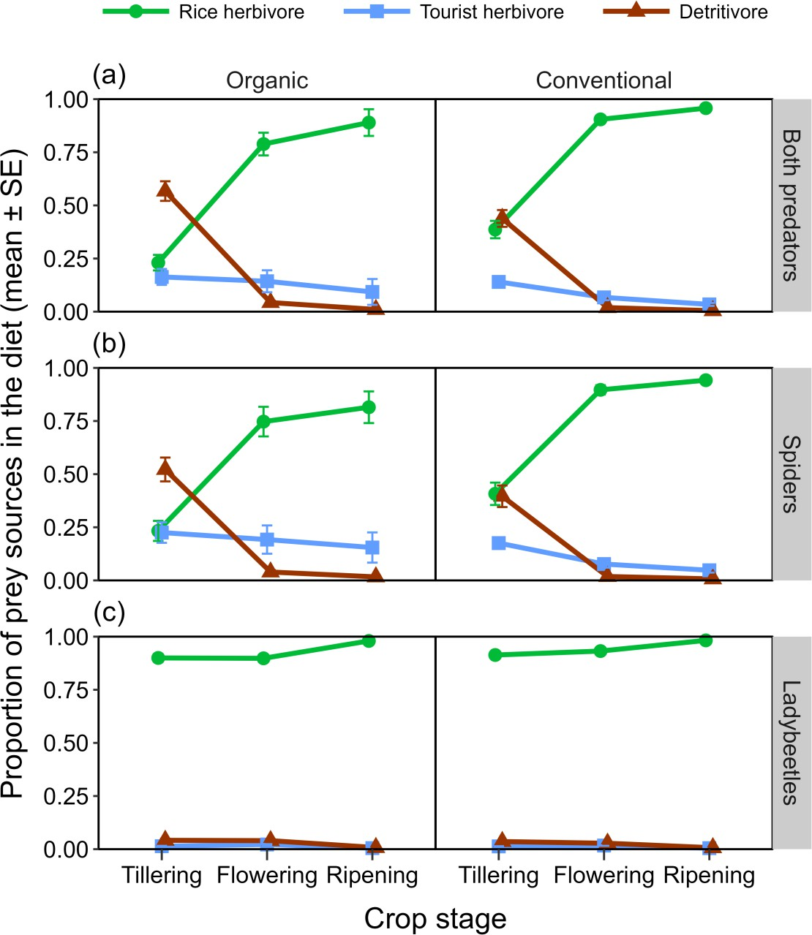

621

622

623

624

## Figure 2.

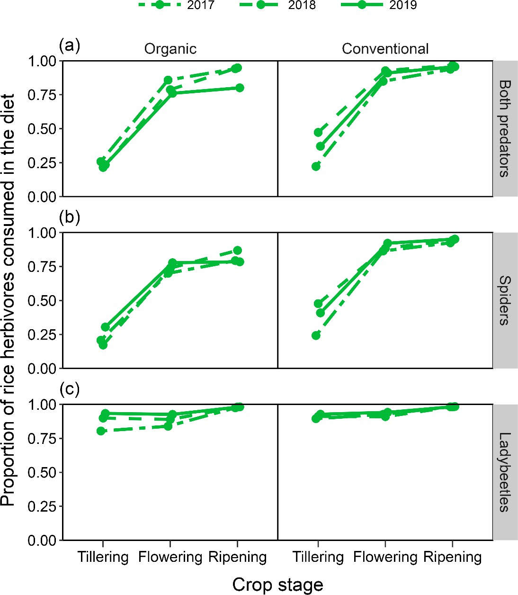

625

626

627

**Figure 3.**

